**LIST OF FIGURES**

Logo 1

Figure 1: Login Screen 8

Figure 2: Signup Screen 9

Figure 3: Forget Password Screen 10

Figure 4: Dashboard [Home Page] 11

Figure 5: Dashboard [Manage Page] 12

Figure 6: Dashboard [View Page] 13

Figure 7: Dashboard [Settings Page] 14

Figure 8: Student [Manage] 15

Figure 9: Employee [Manage] 16

Figure 10: Department [Manage] 17

Figure 11: Course [Manage] 18

Figure 12: Section [Manage] 19

Figure 13: Batch [Manage] 20

Figure 14: Add Student 21

Figure 15: Add Employee 22

Figure 16: Add Department 23

Figure 17: Add Course 24

Figure 18: Add Section 26

Figure 19: Add Batch 27

Figure 20: Update Student 28

Figure 21: Update Employee 29

Figure 22: Update Department 30

Figure 23: Update Course 31

Figure 24: Update Section 32

Figure 25: Update Batch 33

Figure 26: Delete Student 34

Figure 27: Delete Employee 35

Figure 28: Delete Department 36

Figure 29: Delete Course 37

Figure 30: Delete Section 38

Figure 31: Delete Batch 39

Figure 32: Admin Login [Manage Employee] 41

Figure 33: Admin Signup [Manage Employee] 42

Figure 34: Database Sheets 43

Source Code 45

**COMPANY PROFILE**



**Company Name:** Kush Vidyalaya

**Location:** A-12 BASEMENT VIKASPURI, DELHI-110018

**Established:** 1922[Imaginary]

**Founder:** Jaspreet Singh

**CEO:** Jaspreet Singh

**Contact:** 9717682686

**HISTORY**

The **University of Delhi**, informally known as **Kush Vidyalaya**

(**KV**), is a [collegiate](https://en.wikipedia.org/wiki/Collegiate_university) [public](https://en.wikipedia.org/wiki/Public_university) [central university](https://en.wikipedia.org/wiki/Central_university_(India)) located in [New Delhi](https://en.wikipedia.org/wiki/New_Delhi), [India](https://en.wikipedia.org/wiki/India).

It was founded in 1922 by an Act of the [Central Legislative Assembly](https://en.wikipedia.org/wiki/Central_Legislative_Assembly) and is recognized as an [Institute of Eminence](https://en.wikipedia.org/wiki/Institutes_of_Eminence) (IoE) by the [University Grants Commission](https://en.wikipedia.org/wiki/University_Grants_Commission_(India)) (UGC). As a collegiate university, its main functions are divided between the academic departments of the university and affiliated colleges. Consisting of three colleges, two faculties, and 750 students at its founding, the University of Delhi has since become India's largest institution of higher learning and among the largest in the world. The university has 16 faculties and 86 departments distributed across its North and South campuses. It has 77 affiliated colleges and five other institutes. The [Vice President of India](https://en.wikipedia.org/wiki/Vice_President_of_India) serves as the University [chancellor](https://en.wikipedia.org/wiki/Chancellor_(education)).

**Campus**

Campus

There are 77 colleges and 16 faculties affiliated to the University of Delhi, spread across Delhi. North Campus and South Campus serve as the two main campuses of the University.

* North Campus

The North Campus hosts the three founding colleges of the university.

* South Campus

The South Campus was opened in 1973 as part of the university’s expansion plan.

Off Campus Colleges

* Keshav Mahavidyalaya
* Rajdhani College
* Bharati College
* Dyal Singh College

**Organization & Administration**

Governance

The President of India is the Visitor, the Vice President of India is the Chancellor and the Chief Justice of India is the Pro-Chancellor of the University. The Court, the Executive Council, the Academic Council and the Finance Committee are the administrative authorities of the University.

Colleges

The university has 65 colleges that have liberal courses in humanities, social sciences and science. Twenty-five of these colleges are affiliated with the South Campus while the others are to the North Campus.

Faculties

* Faculty of Applied Social Sciences & Humanities
* Faculty of Arts
* Faculty of Commerce and Business Studies
* Faculty of Education

Centers & Institutes

There are about 28 centers and institutes of KV.

#### Recognised institutes

* The Institute of Life Long Learning (ILLL) is dedicated to the cause of those who believe that learning is not age-bound nor classroom-bound, but it takes place throughout life and in a variety of situations.
* The Ahilaya Bai College of Nursing is a nursing institute. It provides practical exposure to their students, which helps them in acquiring in-depth knowledge of nursing.
* The Amar Jyoti Institute of Physiotherapy offers degrees in physiotherapy.
* The Durgabai Deshmukh College of Special Education is for blind students. The undergraduate course Special Education for Visually Impaired students has a motto to empower visually impaired pupils.
* Pt. Deen Dayal Upadhyaya Institute for the Physically Handicapped is an autonomous organisation under the administrative and financial control of Ministry of Social Justice & Empowerment, Government of India. It provides education to people with disabilities.
* School of Rehabilitation Sciences – Its aim is to disseminate knowledge on developmental therapy and special education on rehabilitation sciences.

#### Affiliated institutions

* Army Hospital (Research & Referral)
* Central Health Education Bureau
* G.B. Pant Hospital
* Hindu Rao Hospital
* Institute of Human Behaviour & Allied Sciences
* Institute of Nuclear Medicine & Allied Sciences
* Kasturba Hospital
* National Institute of Health & Family Welfare
* Nehru Homeopathic Medical College & Hospital

**Academics**

Courses

There are 240 courses available at the university for undergraduate (UG) and post-graduate (PG).

UG Course Intake: Management studies, Education, Computer Science, Engineering, Information Technology, Manufacturing Process and Automation Engineering, Biotechnology, Unani Medicine, Ayurveda

PG Course Intake Political Science, Sanskrit, English, Mathematics, Commerce, History, Chemistry, Philosophy, Economics, Others

College AIR - 15, Overall Score - 289.54, National Rating – AAAA+

Ranking

Internationally, the University of Delhi was ranked 474 in the QS World University Rankings of 2021.The same rankings ranked it 67 in Asia in 2020 and 42 among BRICS nations in 2019.It was ranked 601–800 in the world by the [*Times Higher Education World University Rankings*](https://en.wikipedia.org/wiki/Times_Higher_Education_World_University_Rankings) of 2021, 155 in Asia and 147 among Emerging Economies University Rankings in 2020.In 2019, it ranked 573 overall among the universities around the world by [*SC Imago Institutions Rankings*](https://en.wikipedia.org/wiki/SCImago_Institutions_Rankings). In India, it was ranked 18th overall by the [*National Institutional Ranking Framework*](https://en.wikipedia.org/wiki/National_Institutional_Ranking_Framework) in 2020 and 11th among universities.

**Student’s Life**

Kush Vidyalaya Students Union, generally abbreviated as KVSU,

is a student’s union at the University of Delhi. It is primarily

responsible for building and preserving a healthy political culture

and an atmosphere of open debates on the campus. Students are kept informed about the public meetings, discussions and other issues through pamphlets and notices. The Students' Union has four central panel positions. These are the posts of President, Vice President, Secretary, Joint-Secretary and Sport President.

The university has a long history of student political activity. Each constituent college of the University of Delhi elects its own students' union annually. In addition, the KVSU exists as an umbrella organization for those colleges. Several office bearers of KVSU have gone on to hold public office at local, state and national level.

In 2019, Akshat Dahiya of ABVP was elected as President, Pradeep Tanwar as Vice President, Ashish Lamba as Secretary and Shivangi Kharwal as Joint-Secretary. As of 2019 there are total of 52 Kush Vidyalaya colleges & faculties affiliated to KVSU.

For the past 10 years, ABVP has been the most successful student organization followed by NSUI. In last 10 years, ABVP has held the President's post 7 times, Vice-President's post 8 times, Secretary's post 7 times and Joint-Secretary's post 7 times with occupying all the four post twice in 2014-15 and 2015–16. NSUI has grabbed the posts rest of the times. KVSU has been dominated by ABVP and NSUI for most of the part. Notable Office Bearers of KVSU include [Arun Jaitley](https://en.wikipedia.org/wiki/Arun_Jaitley) who was a member of Akhil Bhartiya Vidyarthi Parishad (ABVP) and became the President of KVSU in 1974. [Vijay Goel](https://en.wikipedia.org/wiki/Vijay_Goel_(politician)) became the KVSU President in 1977-78. [Ajay Maken](https://en.wikipedia.org/wiki/Ajay_Maken) was the General Secretary of Indian National Congress till 2015. He was elected as the President of KVSU in 1985. [Alka Lamba](https://en.wikipedia.org/wiki/Alka_Lamba) is a former President of National Students Union of India (NSUI) and was the President of KVSU in 1995. [Anil Jha Vats](https://en.wikipedia.org/wiki/Anil_Jha_Vats) is a member of the BJP and was a former member of the Delhi Legislative Assembly. He was the President of KVSU for 1997-98. [Vijay Jolly](https://en.wikipedia.org/wiki/Vijay_Jolly) was a former member of ABVP and is currently a member of BJP. He was elected the President of KVSU for 1980-81.

**SCREENSHOTS OF PROJECT**

**Figure 1: Login Screen**

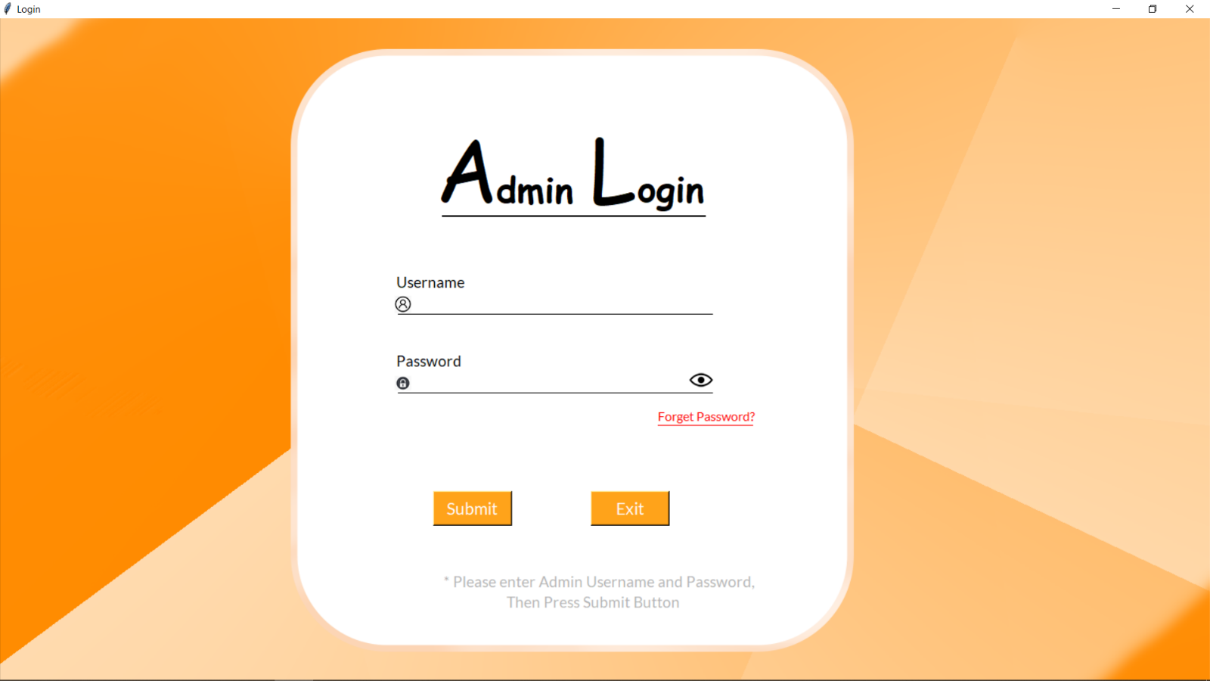

**Figure 2: Signup Screen**

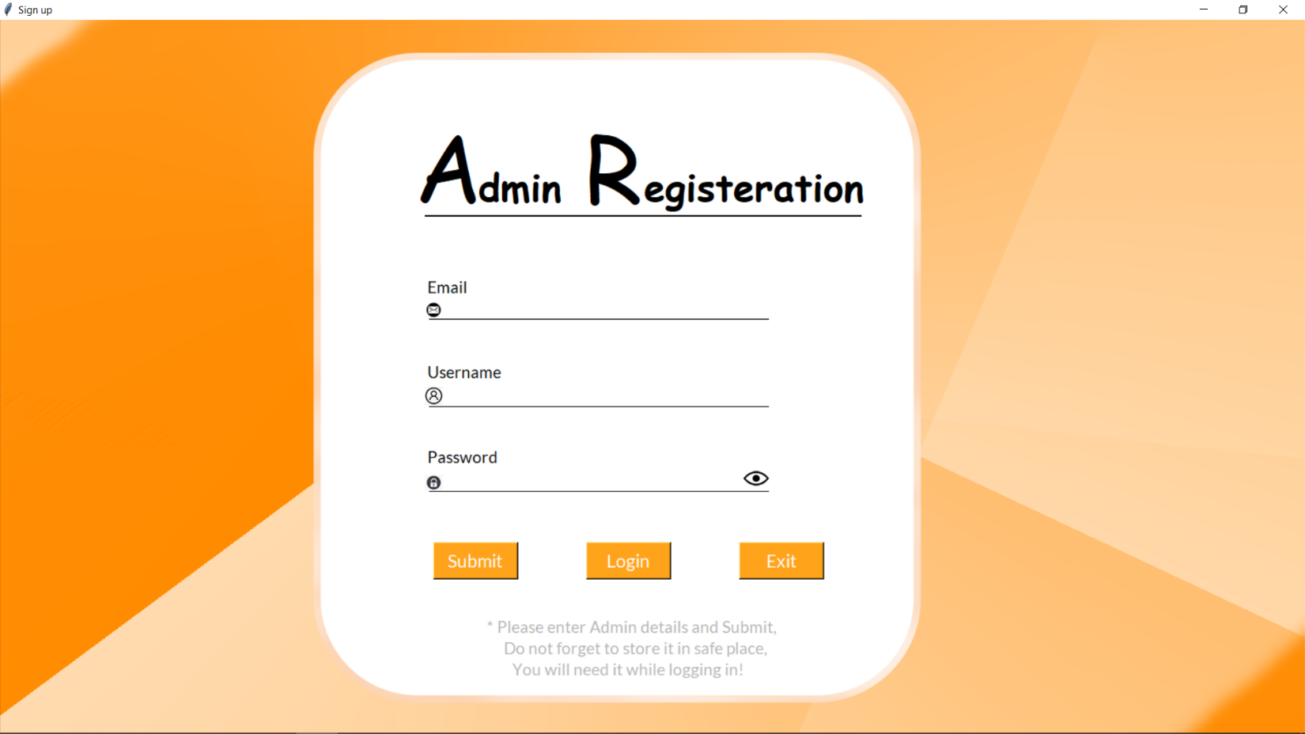

**Figure 3: Forget Password Screen**

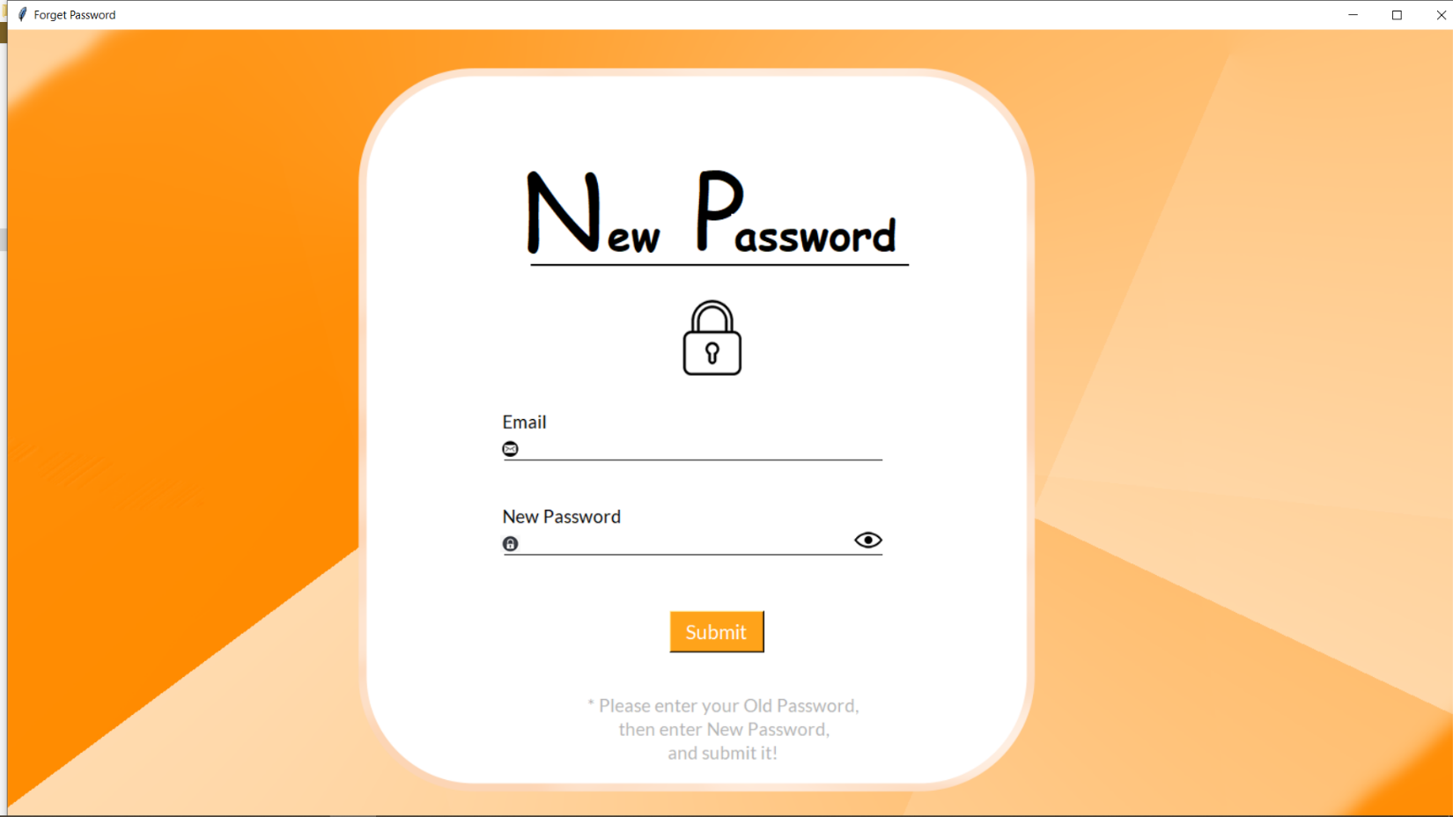

**Figure 4: Dashboard [Home Page]**

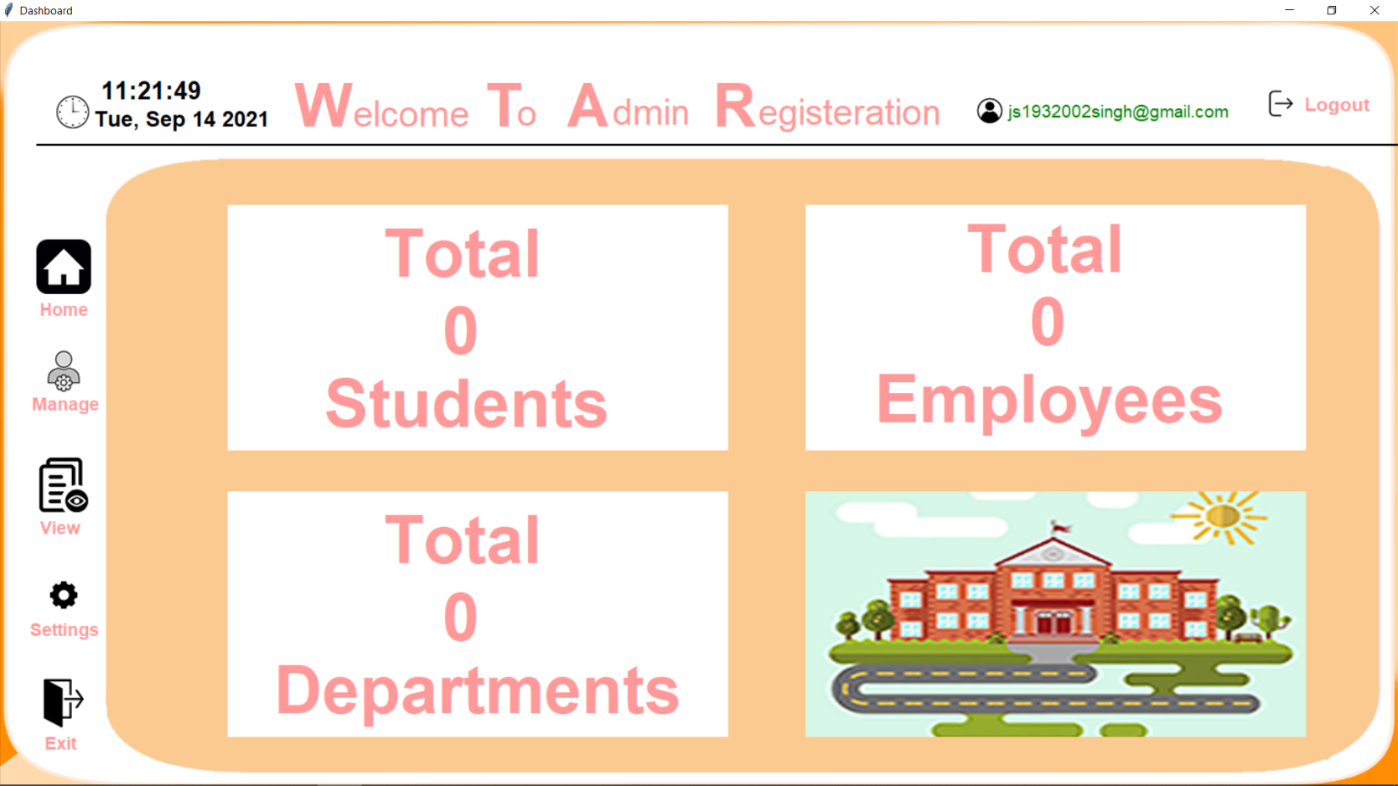

**Figure 5: Dashboard [Manage Screen]**

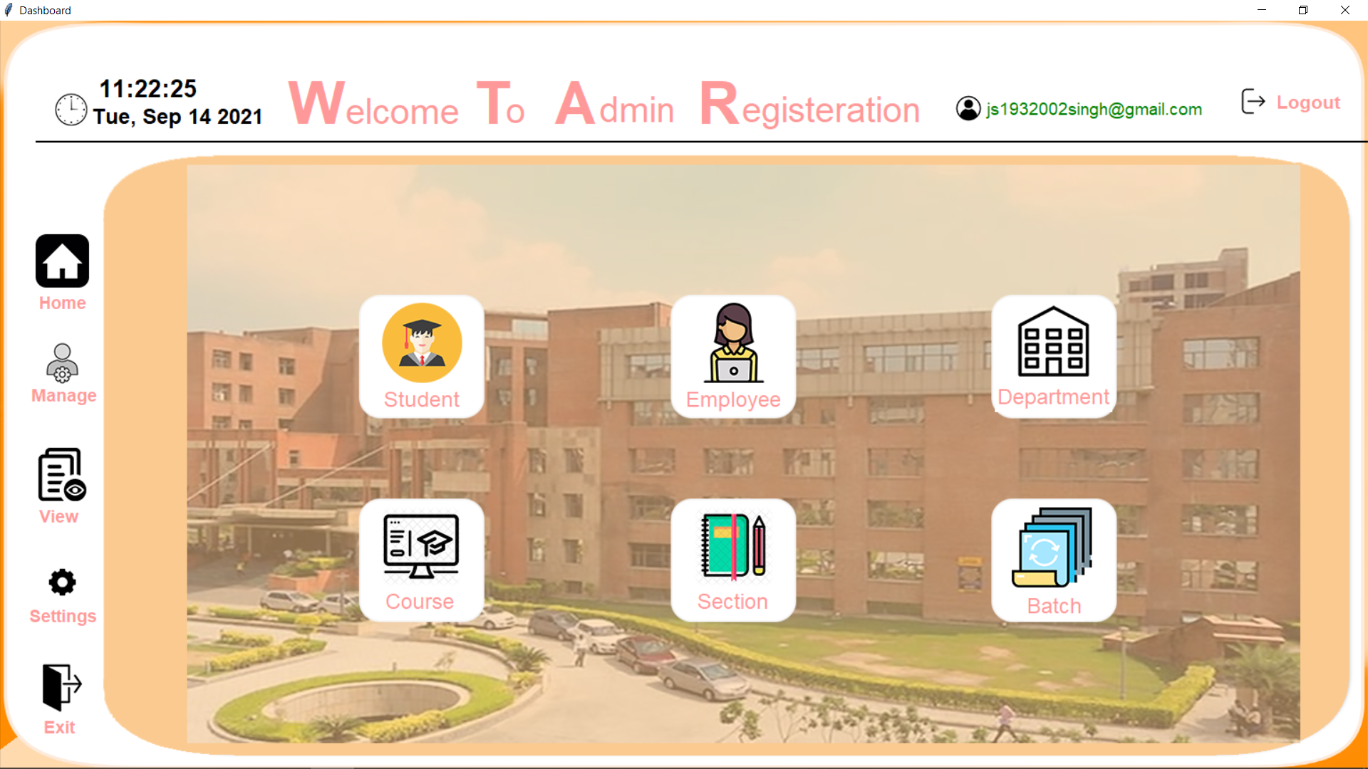

**Figure 6: Dashboard [View Page]**

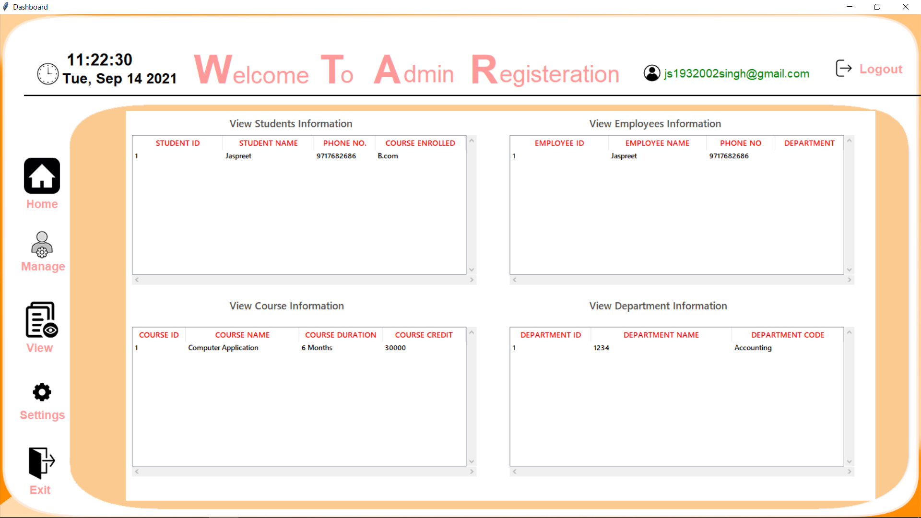

**Figure 7: Dashboard [Settings Page]**

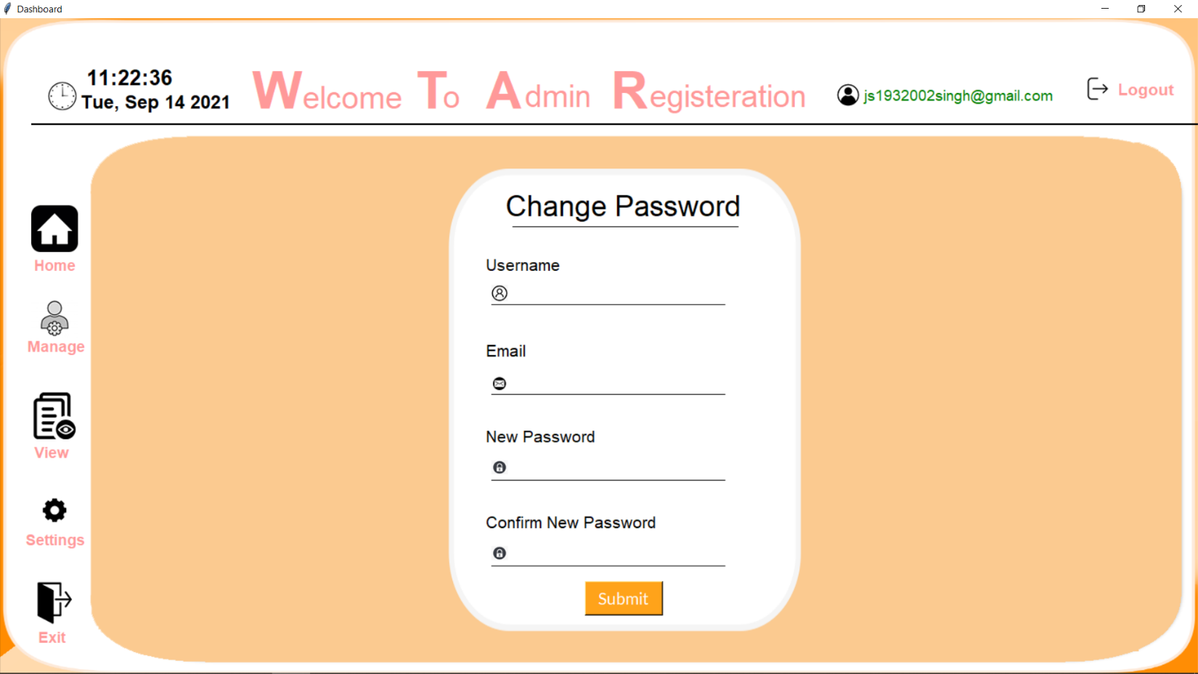

**Figure 8: Student [Manage]**

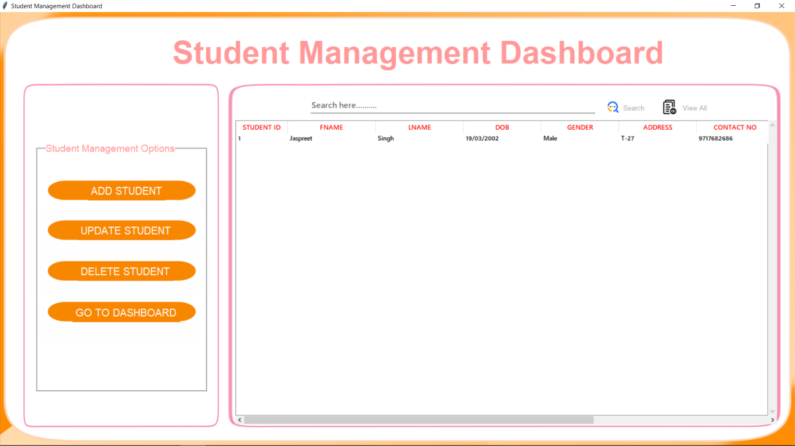

**Figure 9: Employee [Manage]**

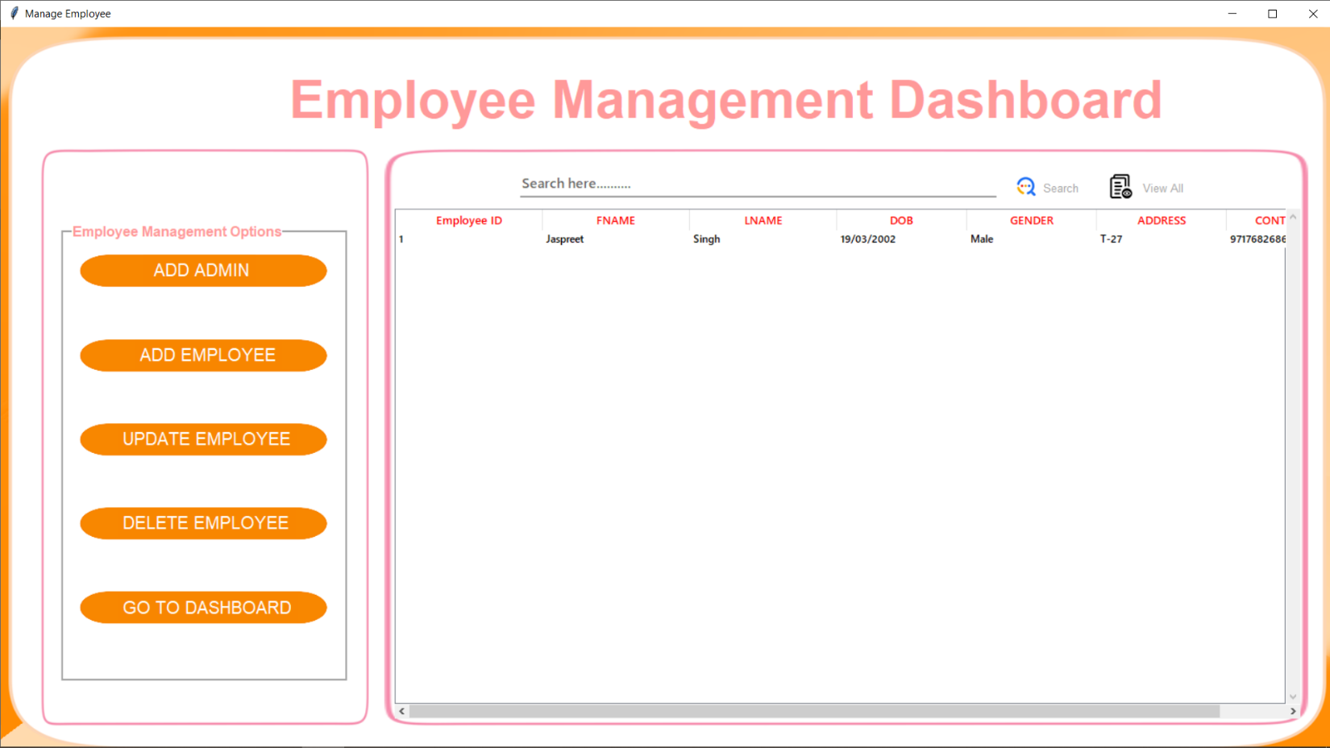

**Figure 10: Department [Manage]**

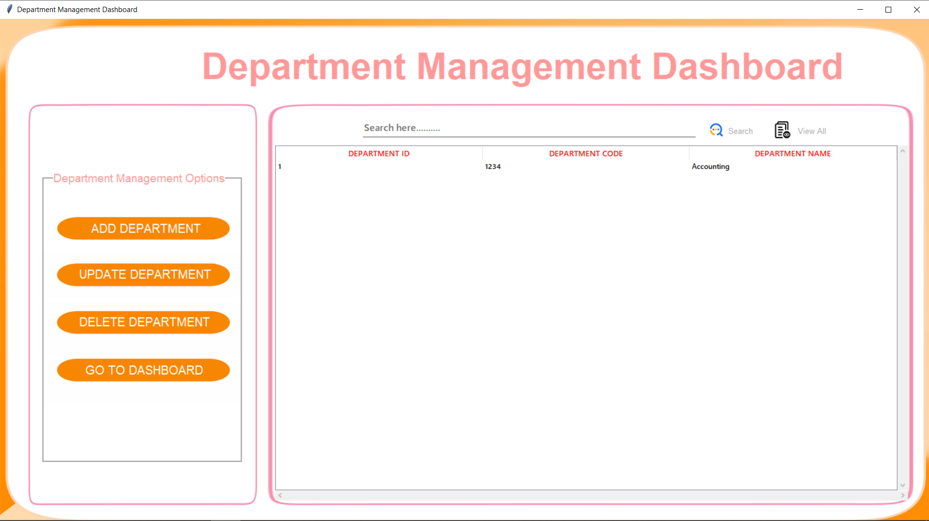

**Figure 11: Course [Manage]**

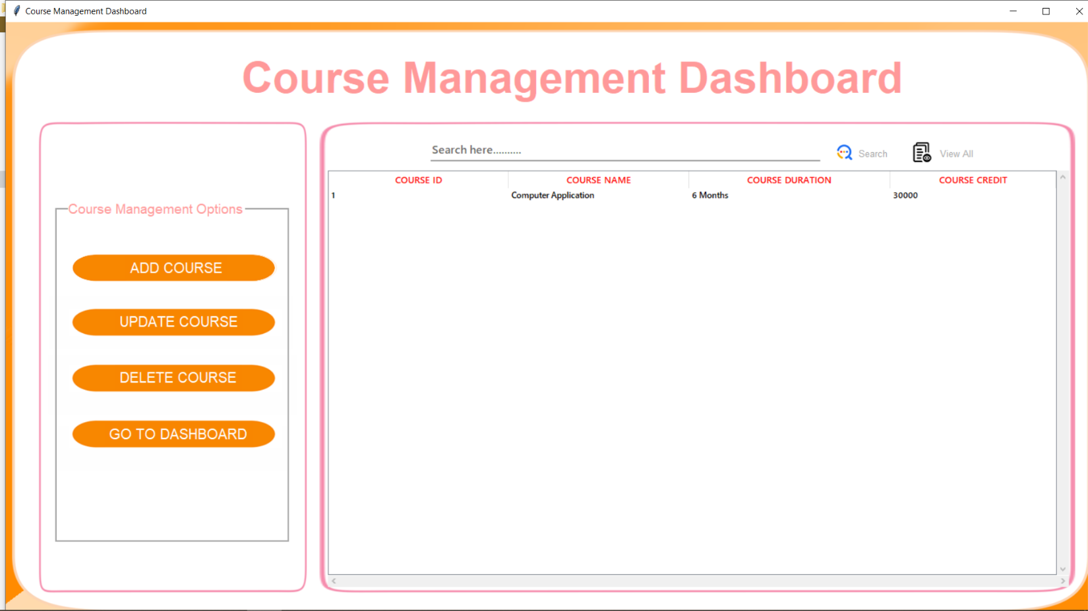

**Figure 12: Section [Manage]**

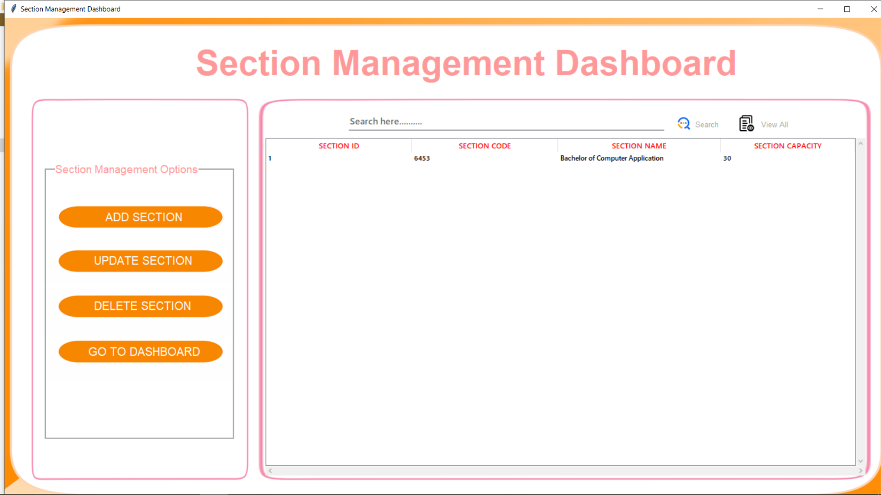

**Figure 13: Batch [Manage]**

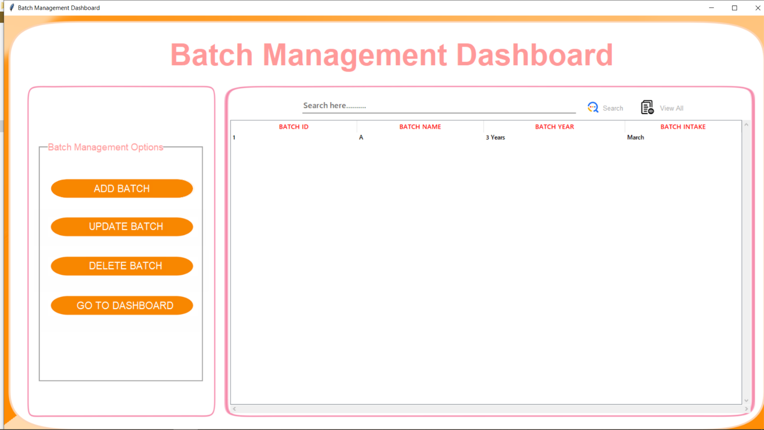

**Figure 14: Add Student**

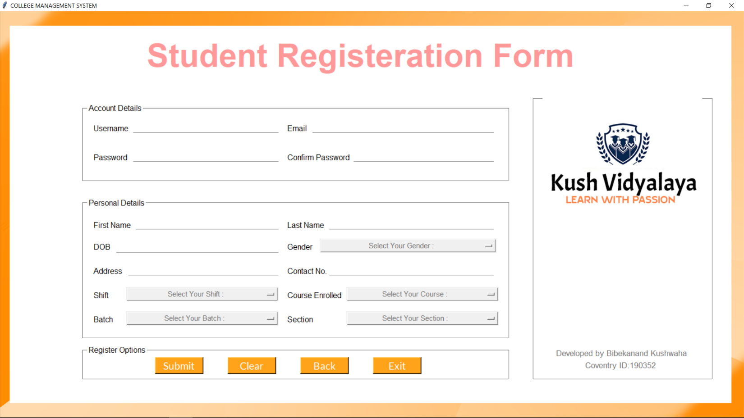

**Figure 15: Add Employee**

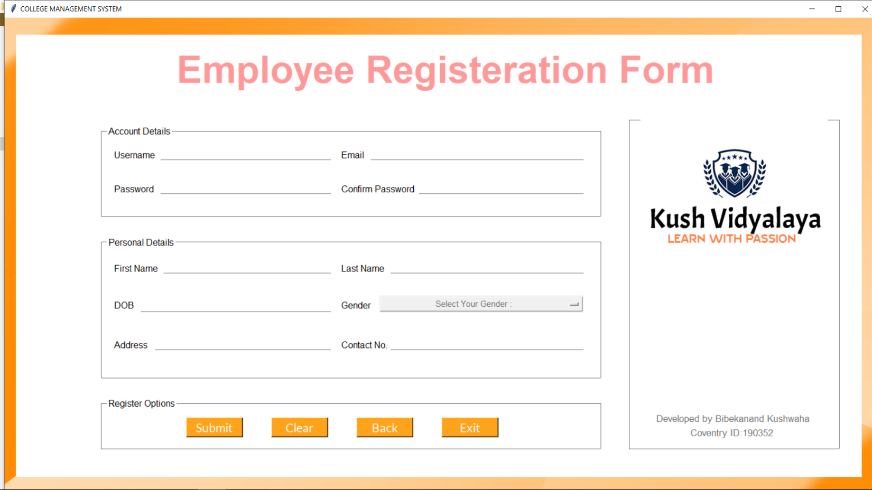

**Figure 16: Add Department**

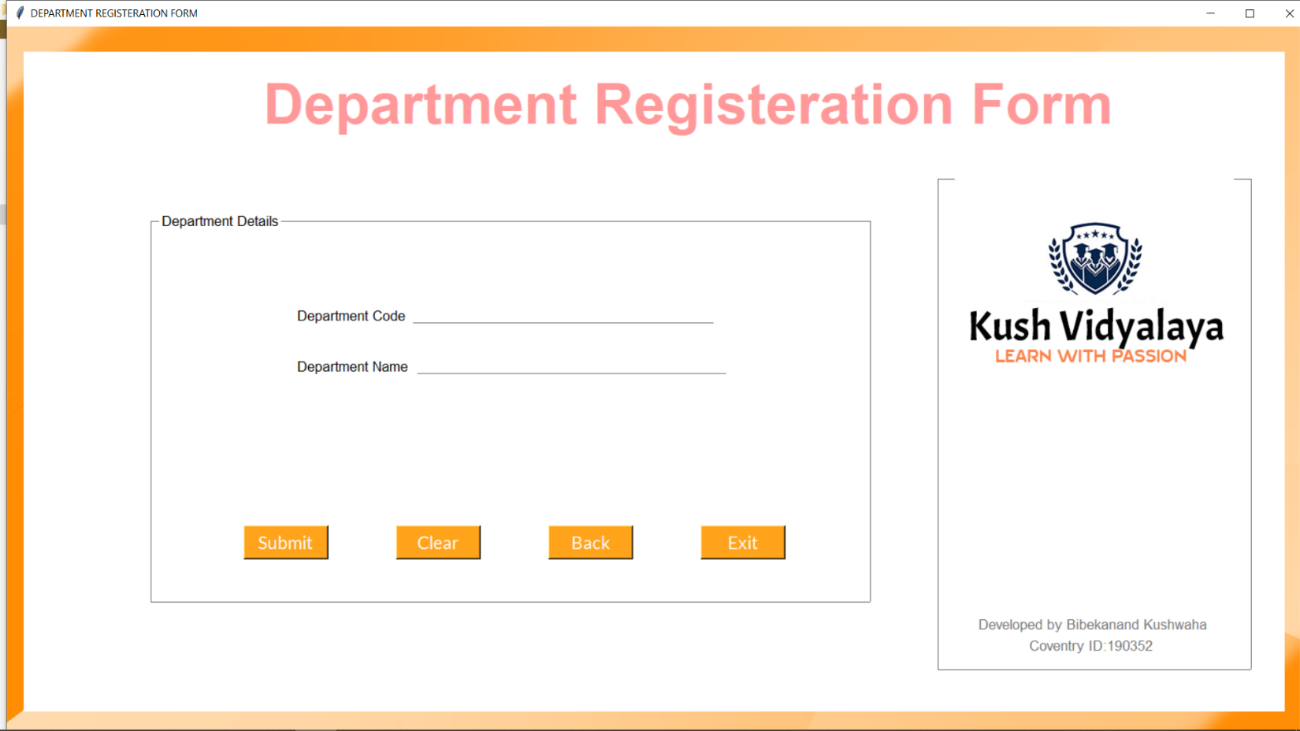

**Figure 17: Add Course**

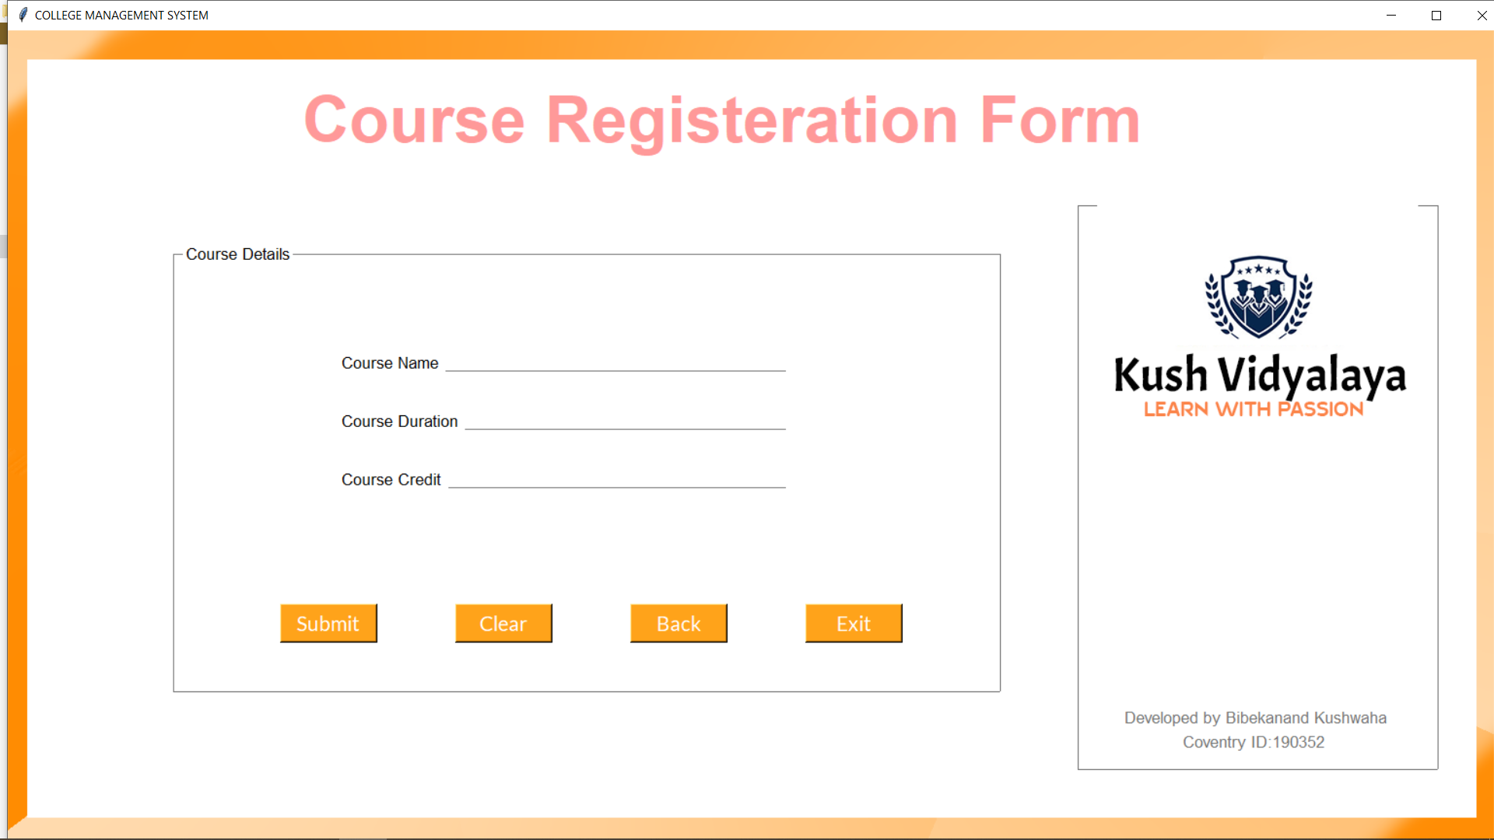

**Figure 18: Add Section**

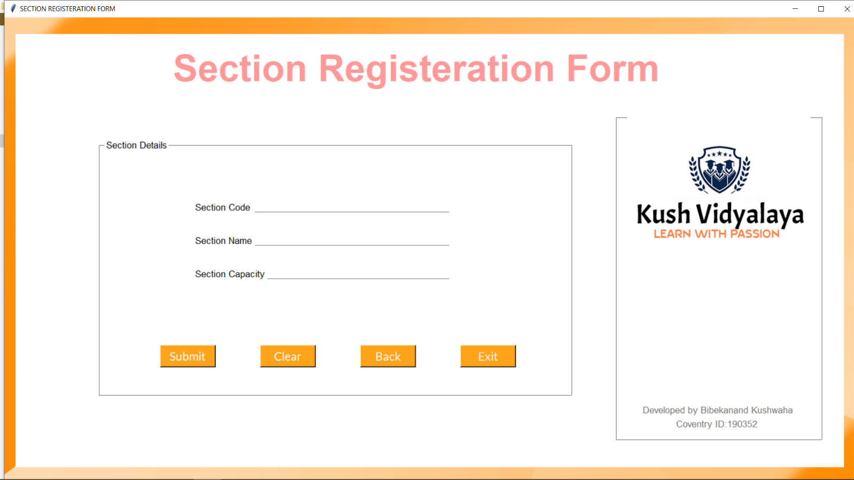

**Figure 19: Add Batch**

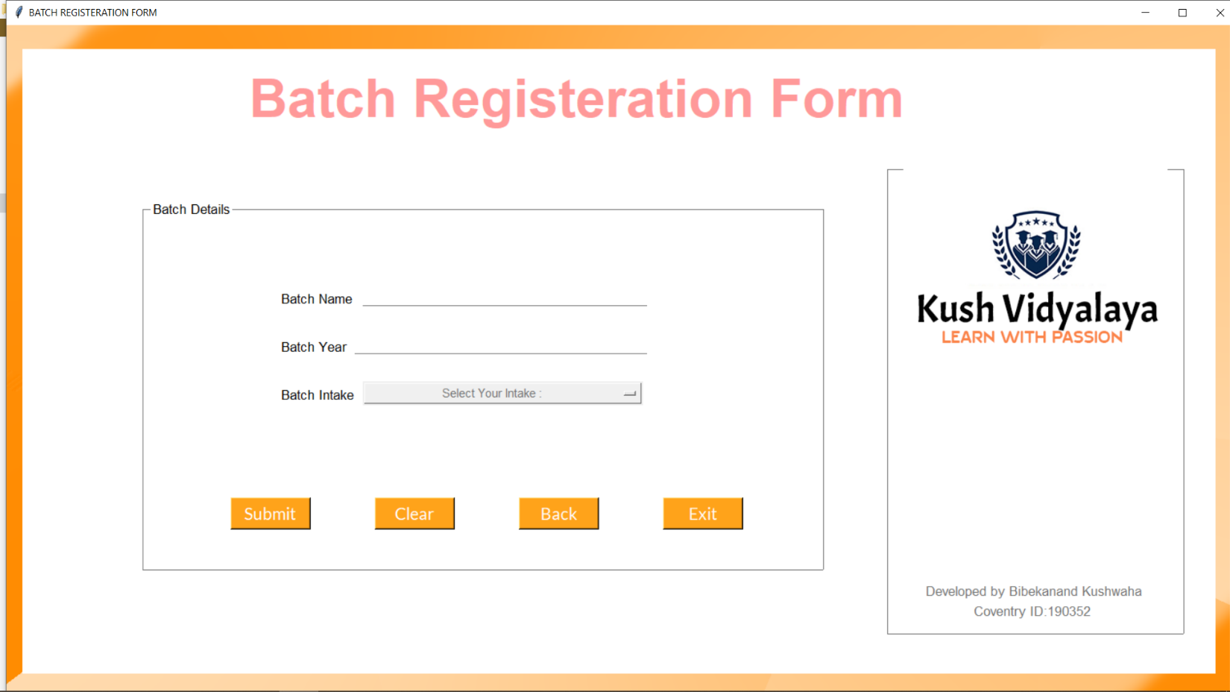

**Figure 20: Update Student**

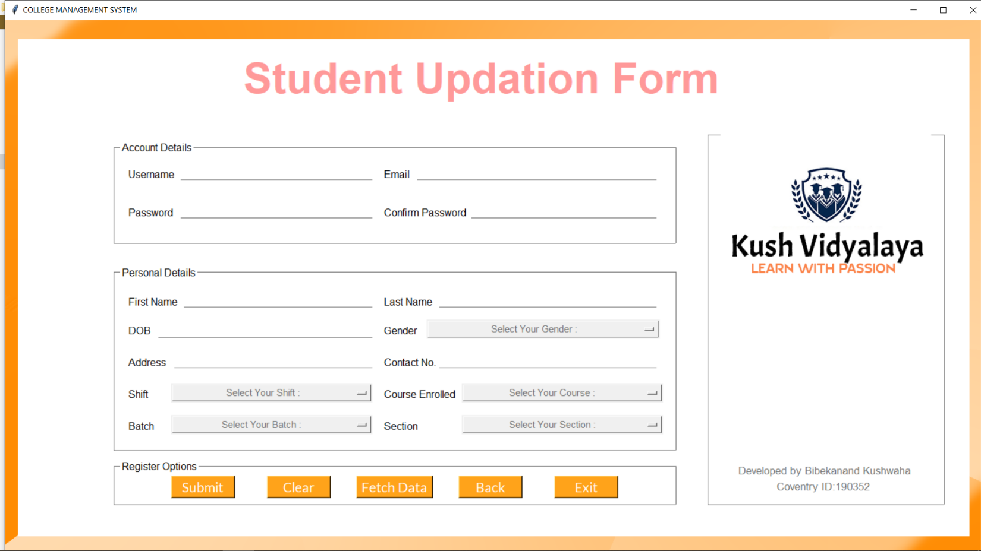

**Figure 21: Update Employee**

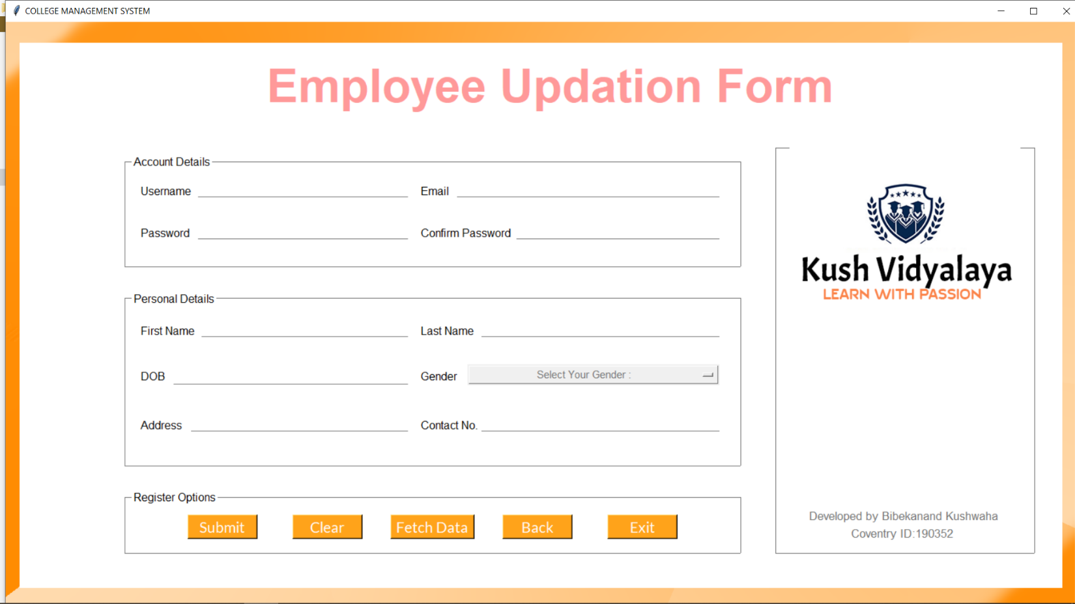

**Figure 22: Update Department**

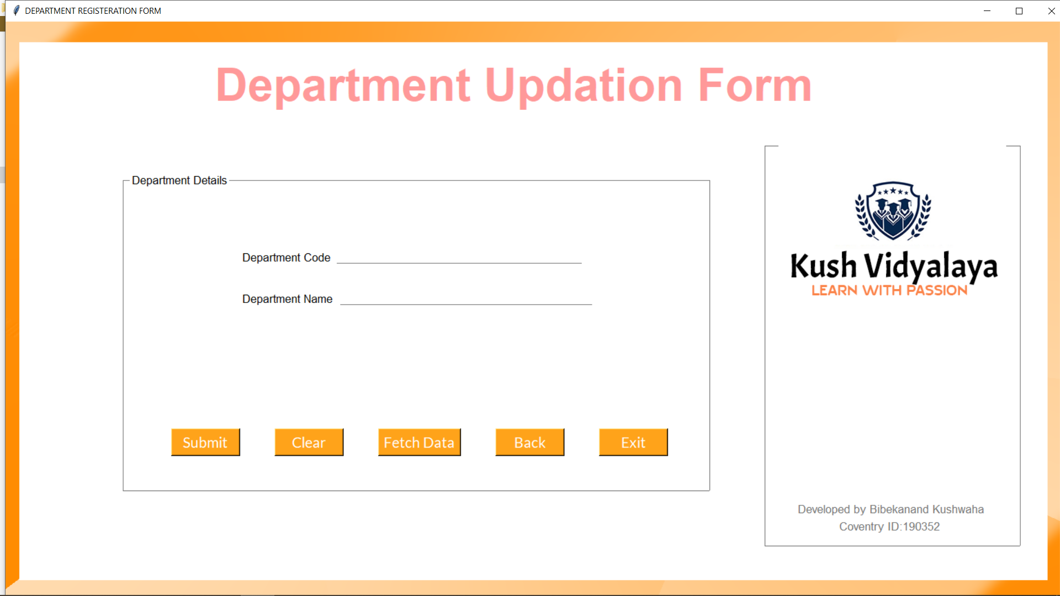

**Figure 23: Update Course**

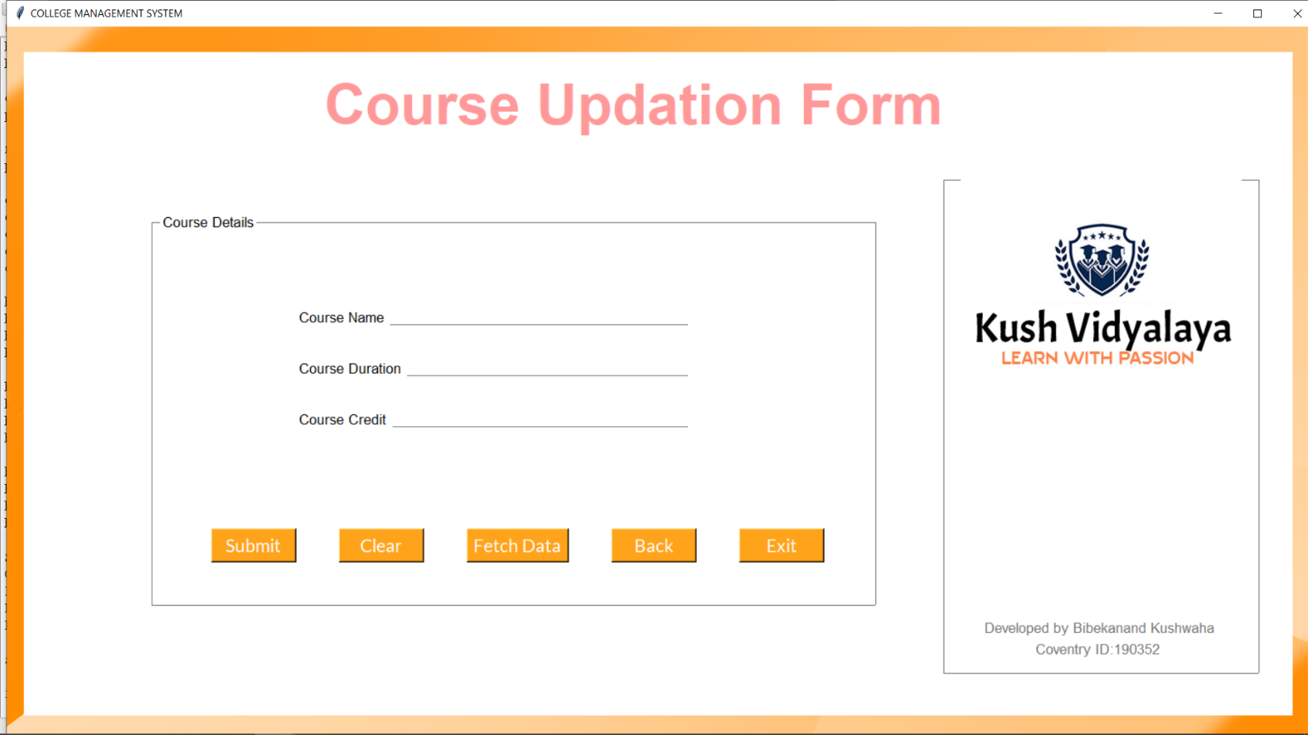

**Figure 24: Update Section**

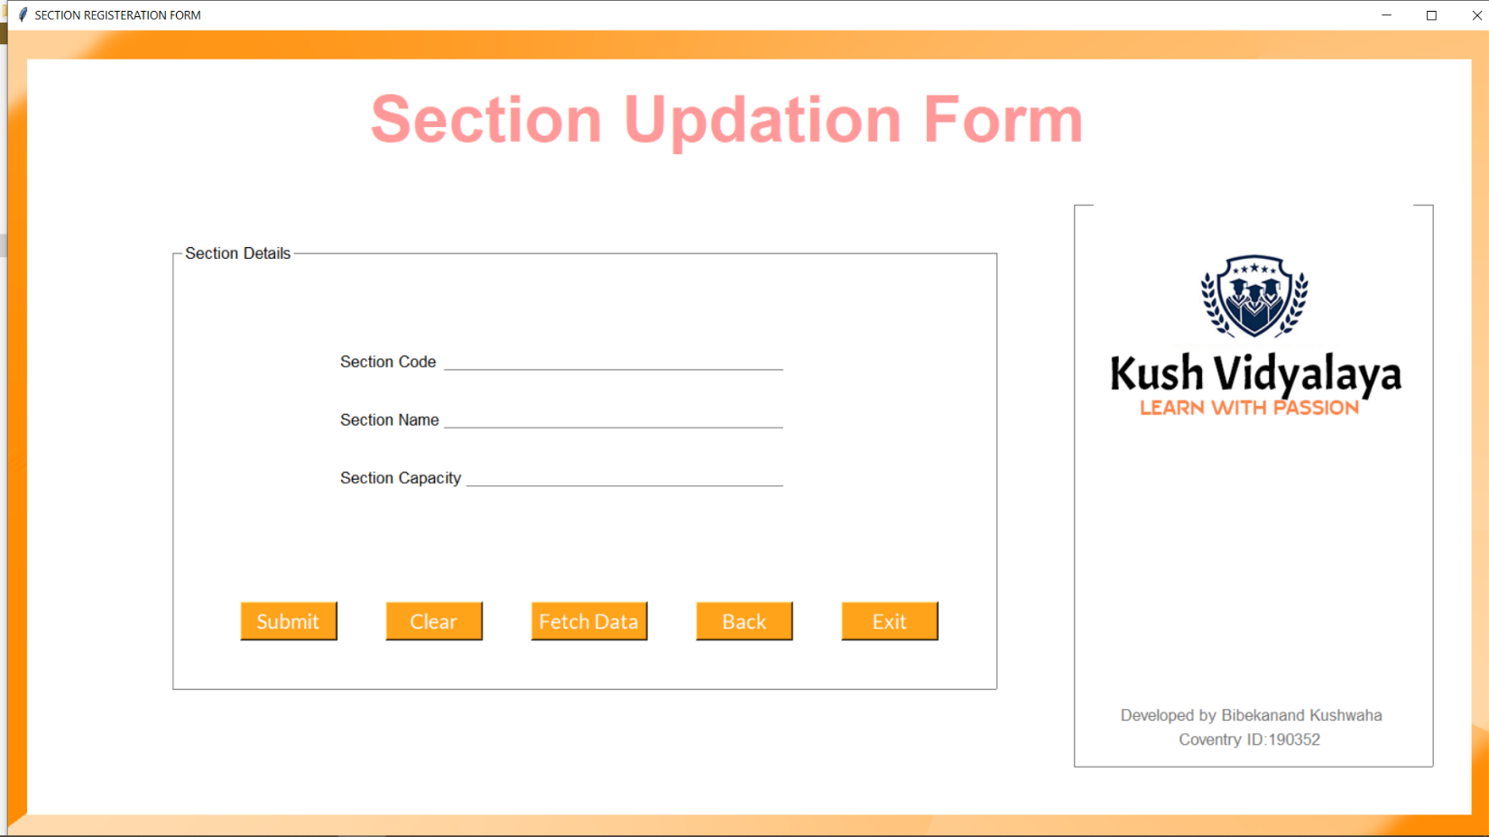

**Figure 25: Update Batch**

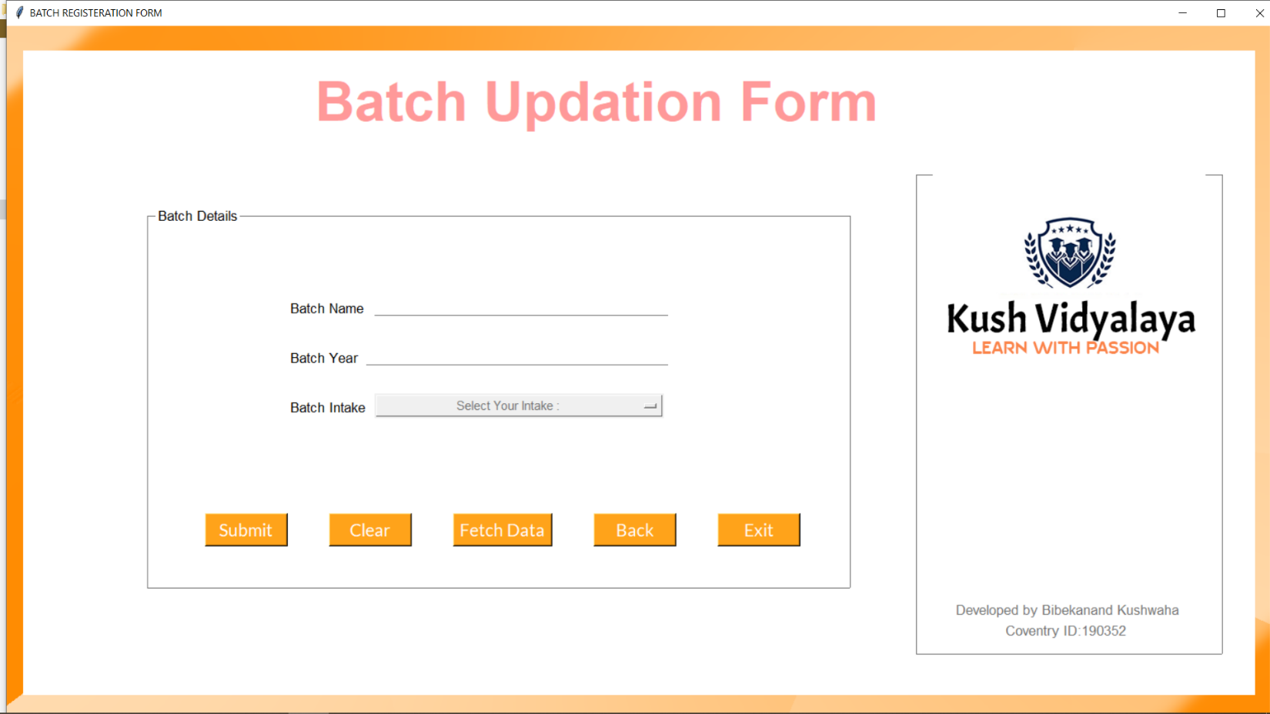

**Figure 26: Delete Student**

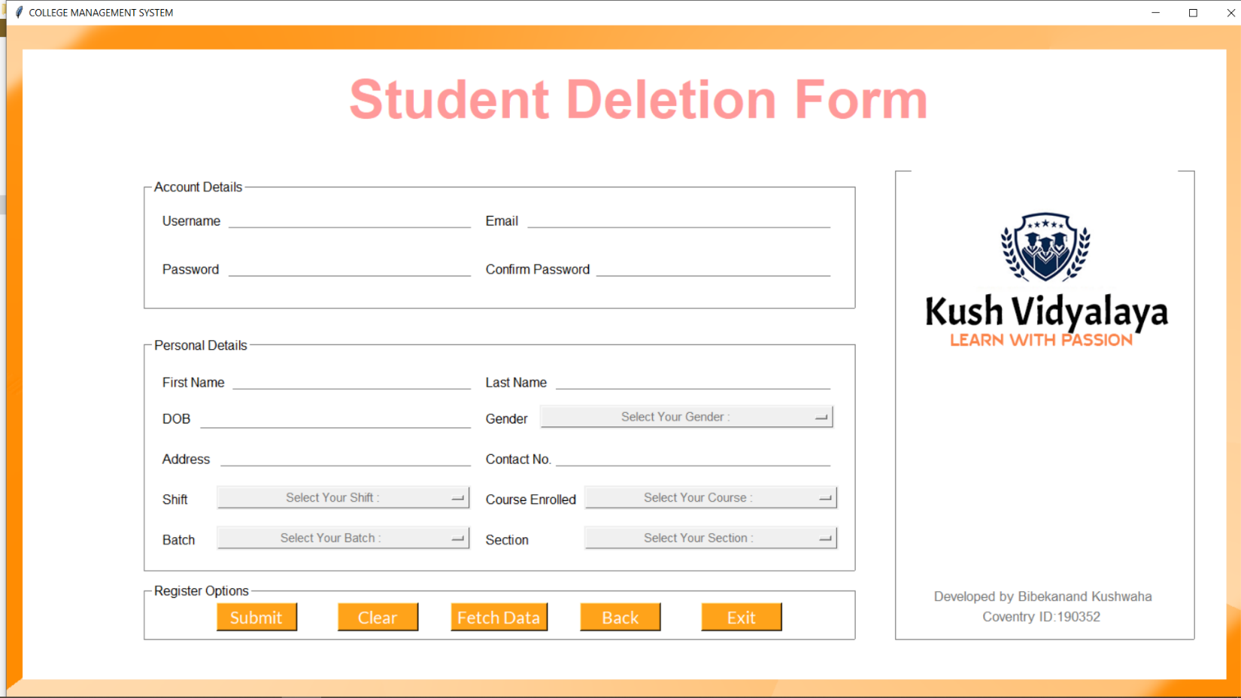

**Figure 27: Delete Employee**

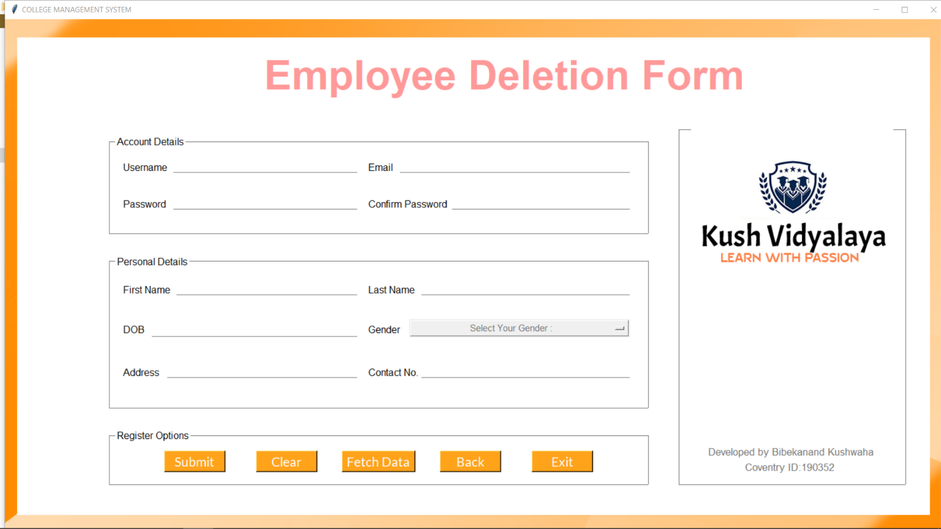

**Figure 28: Delete Department**

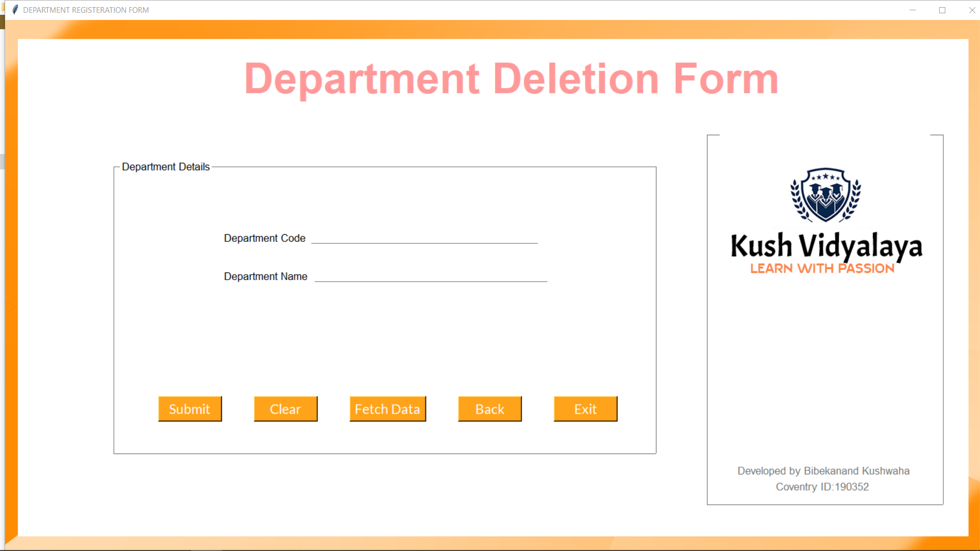

**Figure 29: Delete Course**

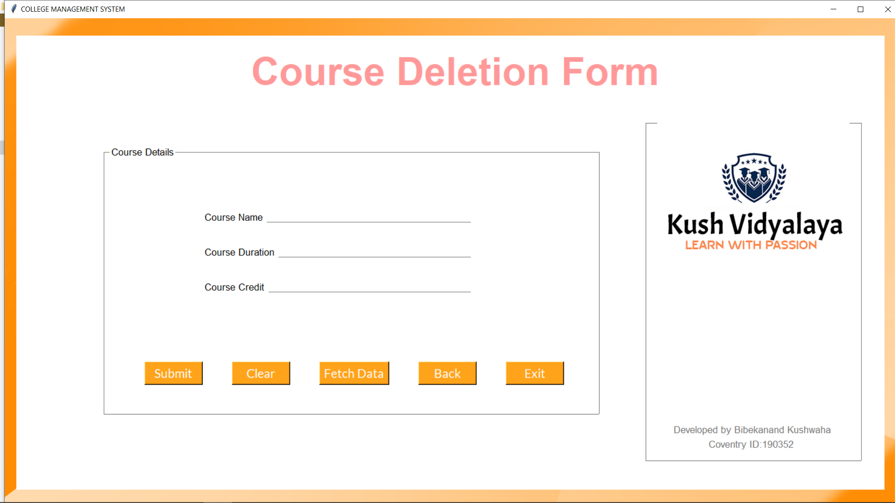

**Figure 30: Delete Section**

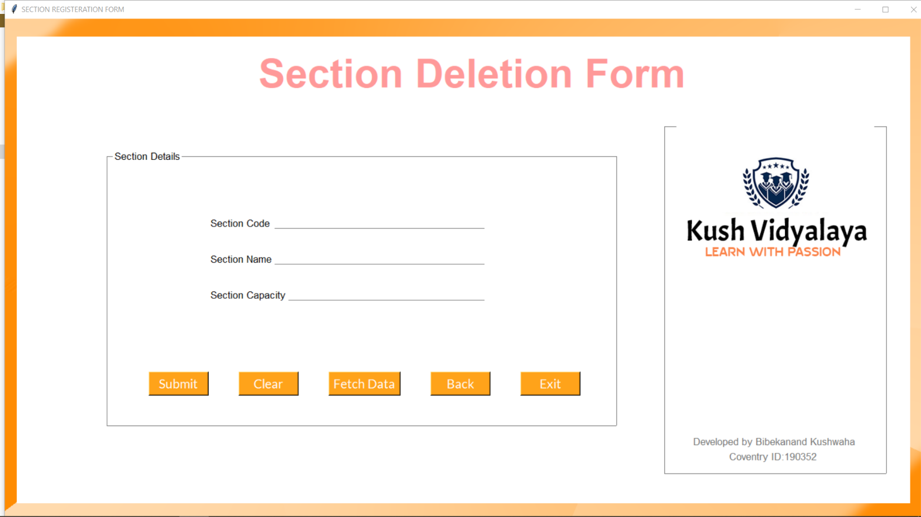

**Figure 31: Delete Batch**

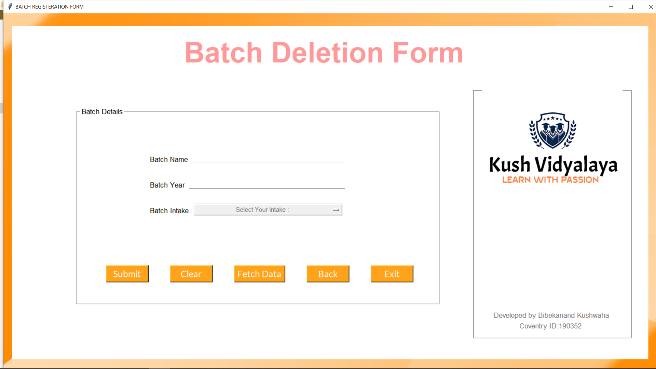

**Figure 32: Admin Login [Manage Employee]**

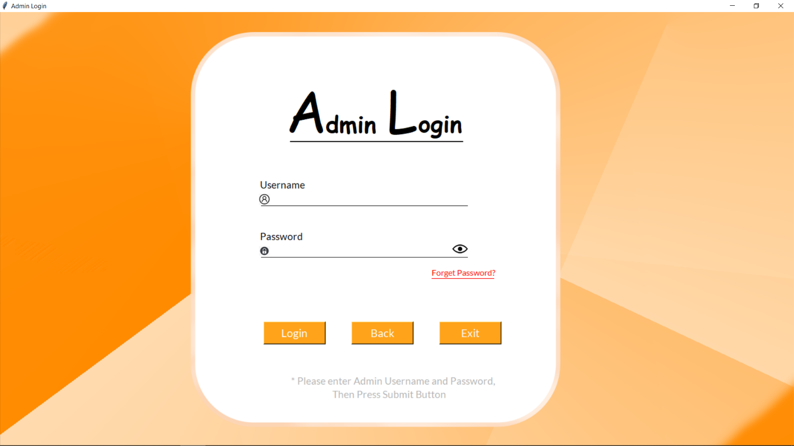

**Figure 33: Admin Signup [Manage Employee]**

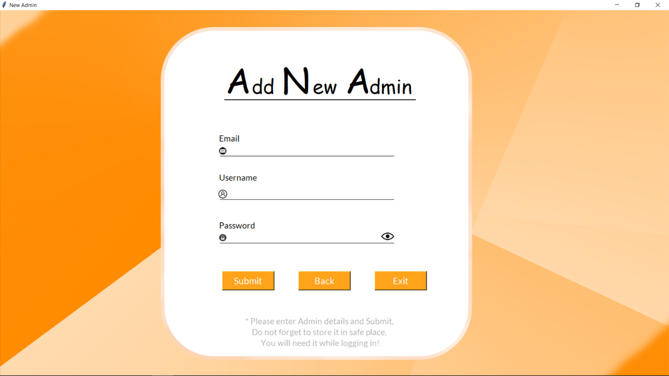

**Figure 34: Database Sheets**

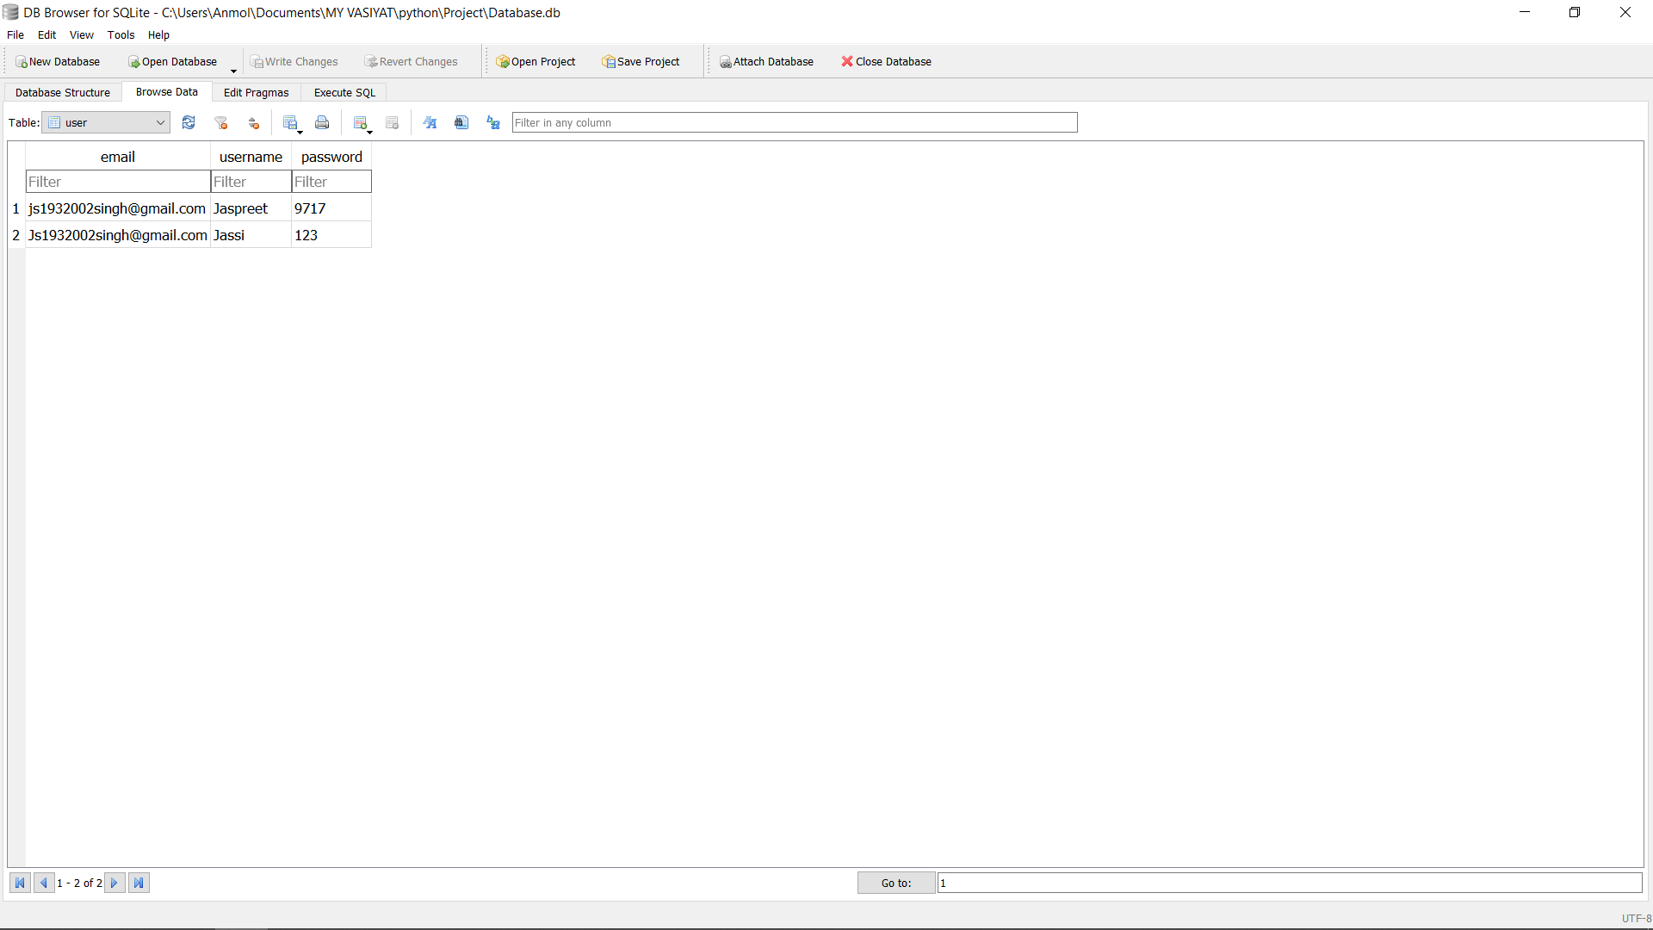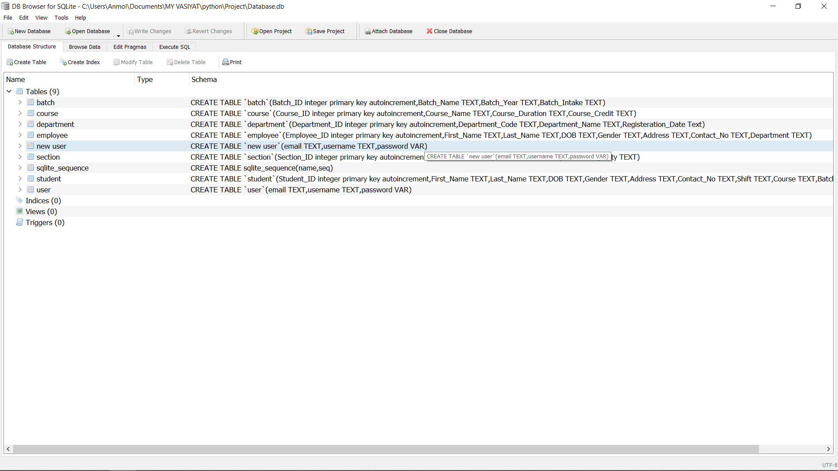

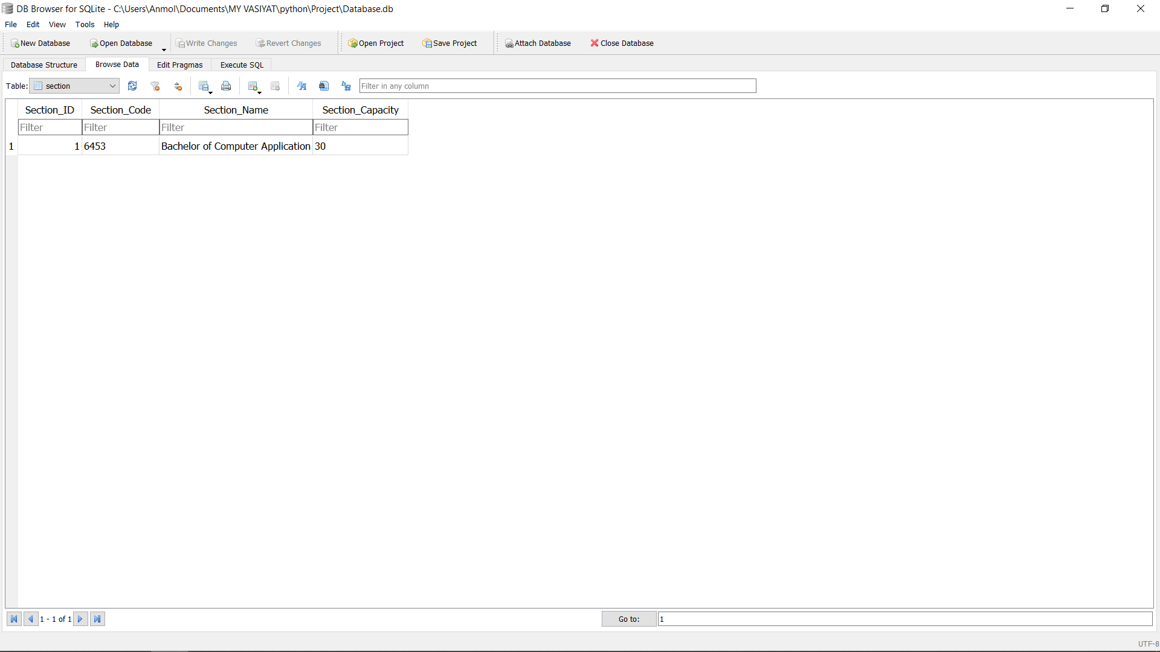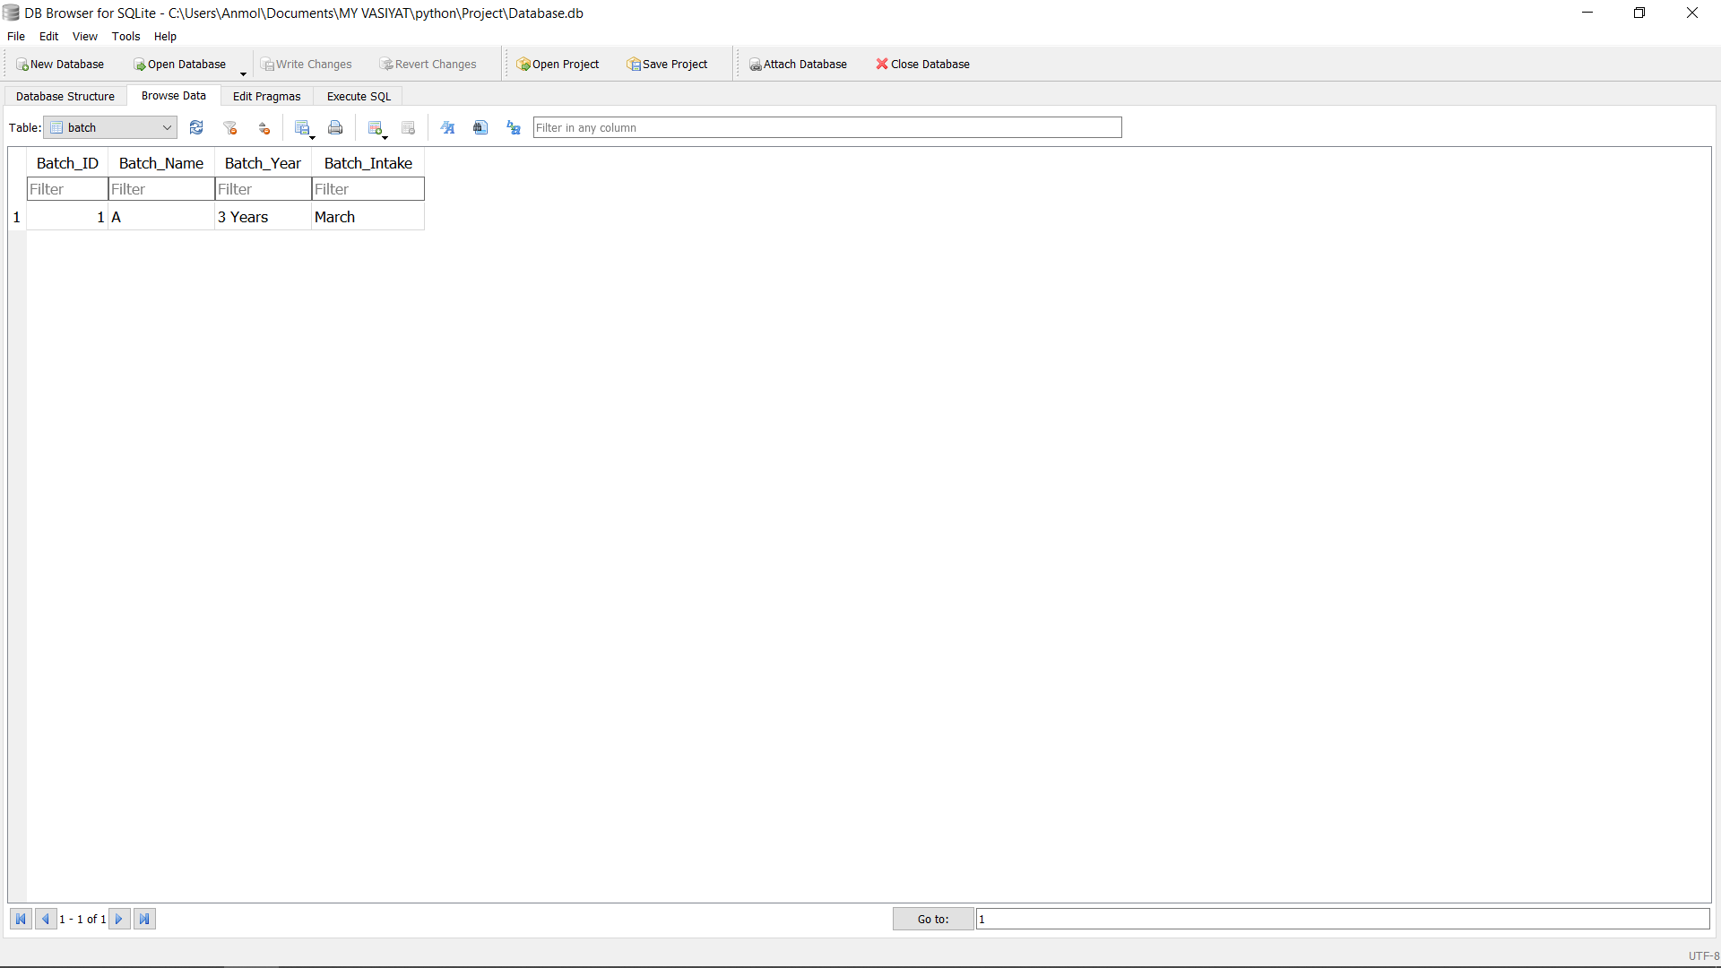

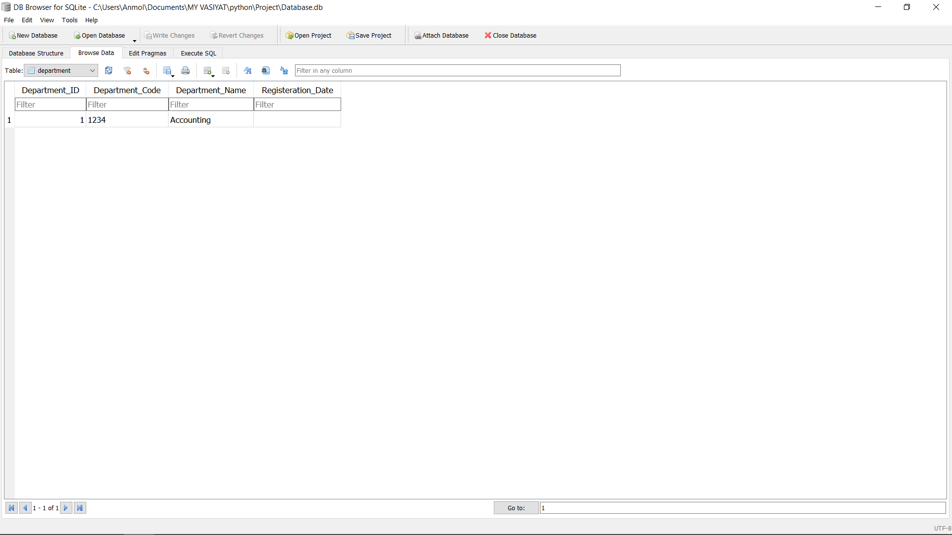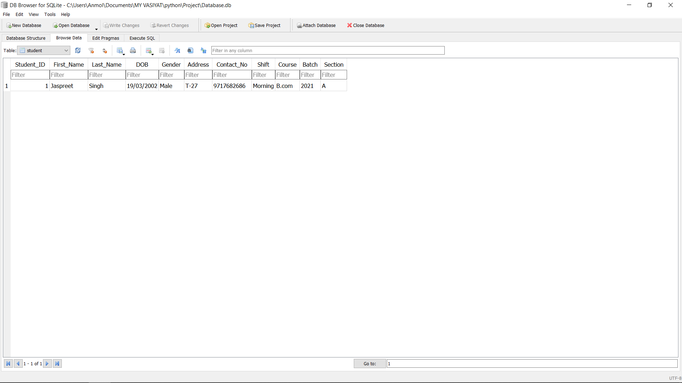

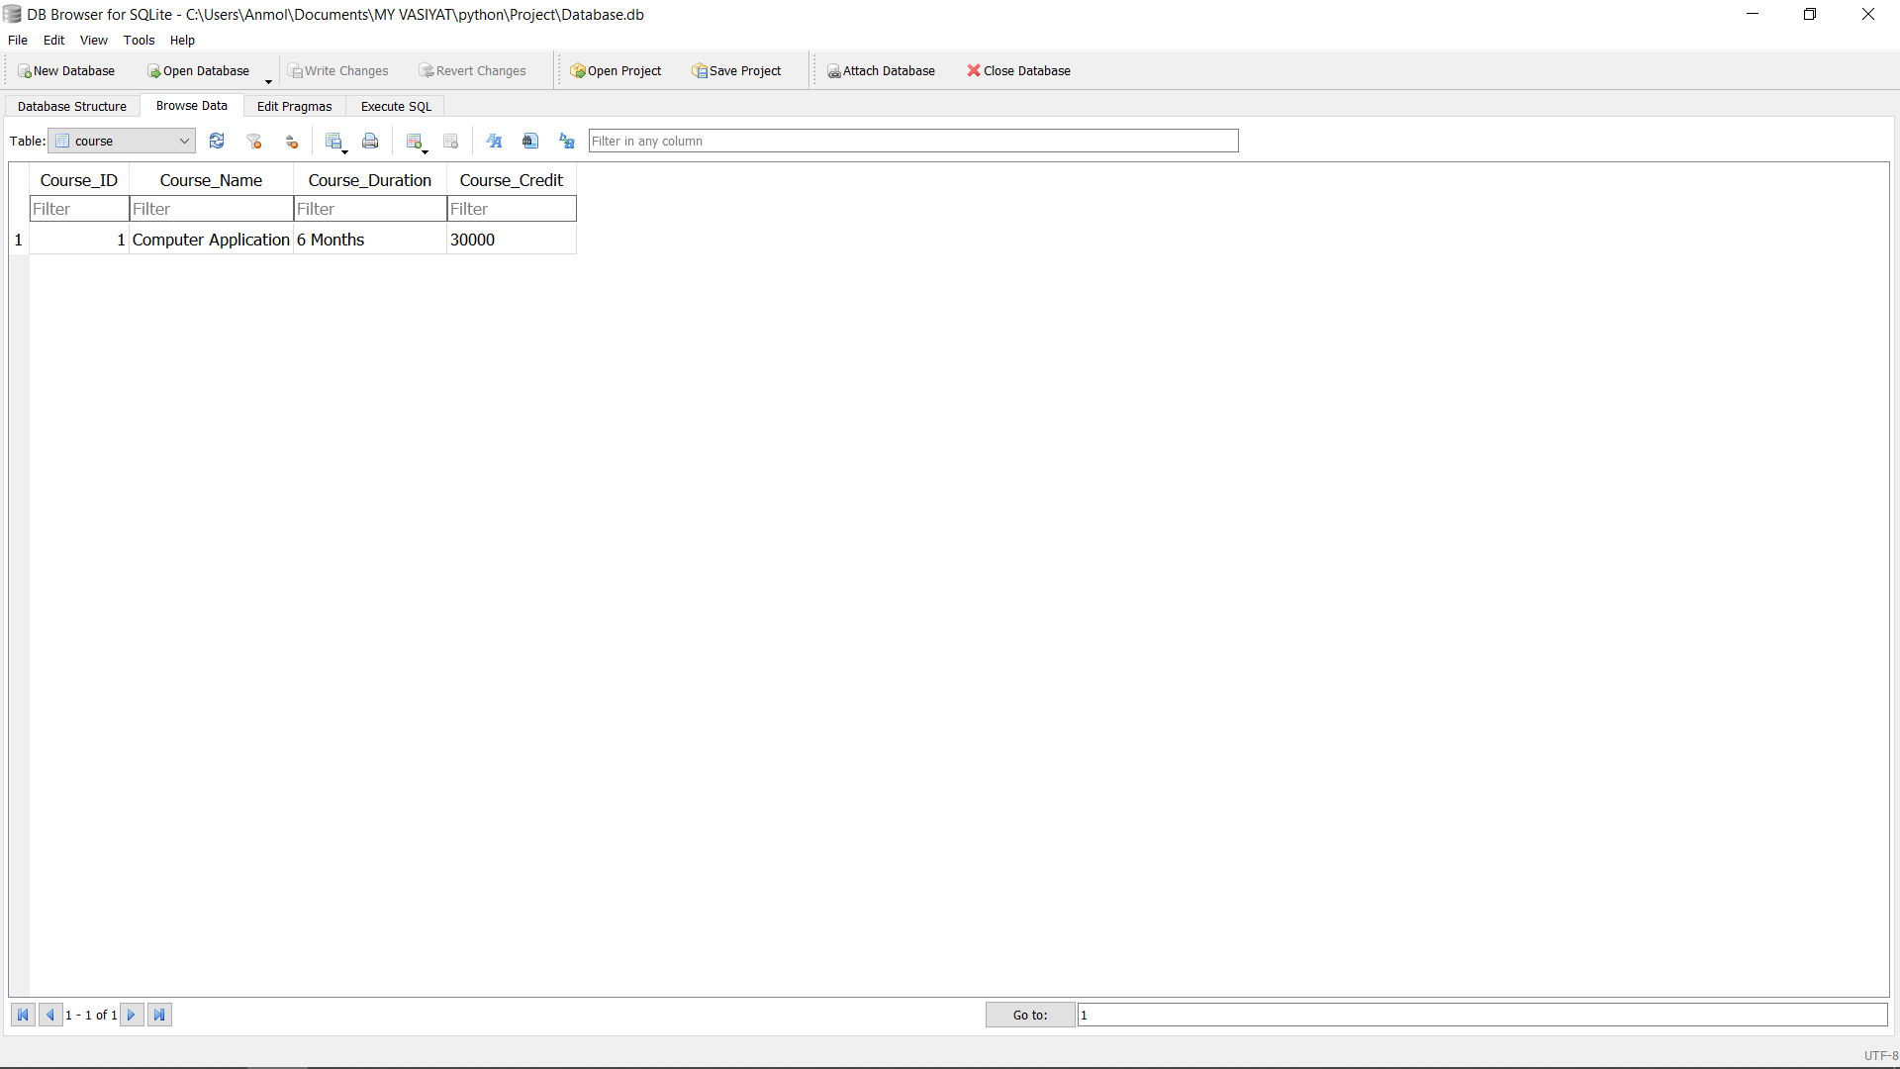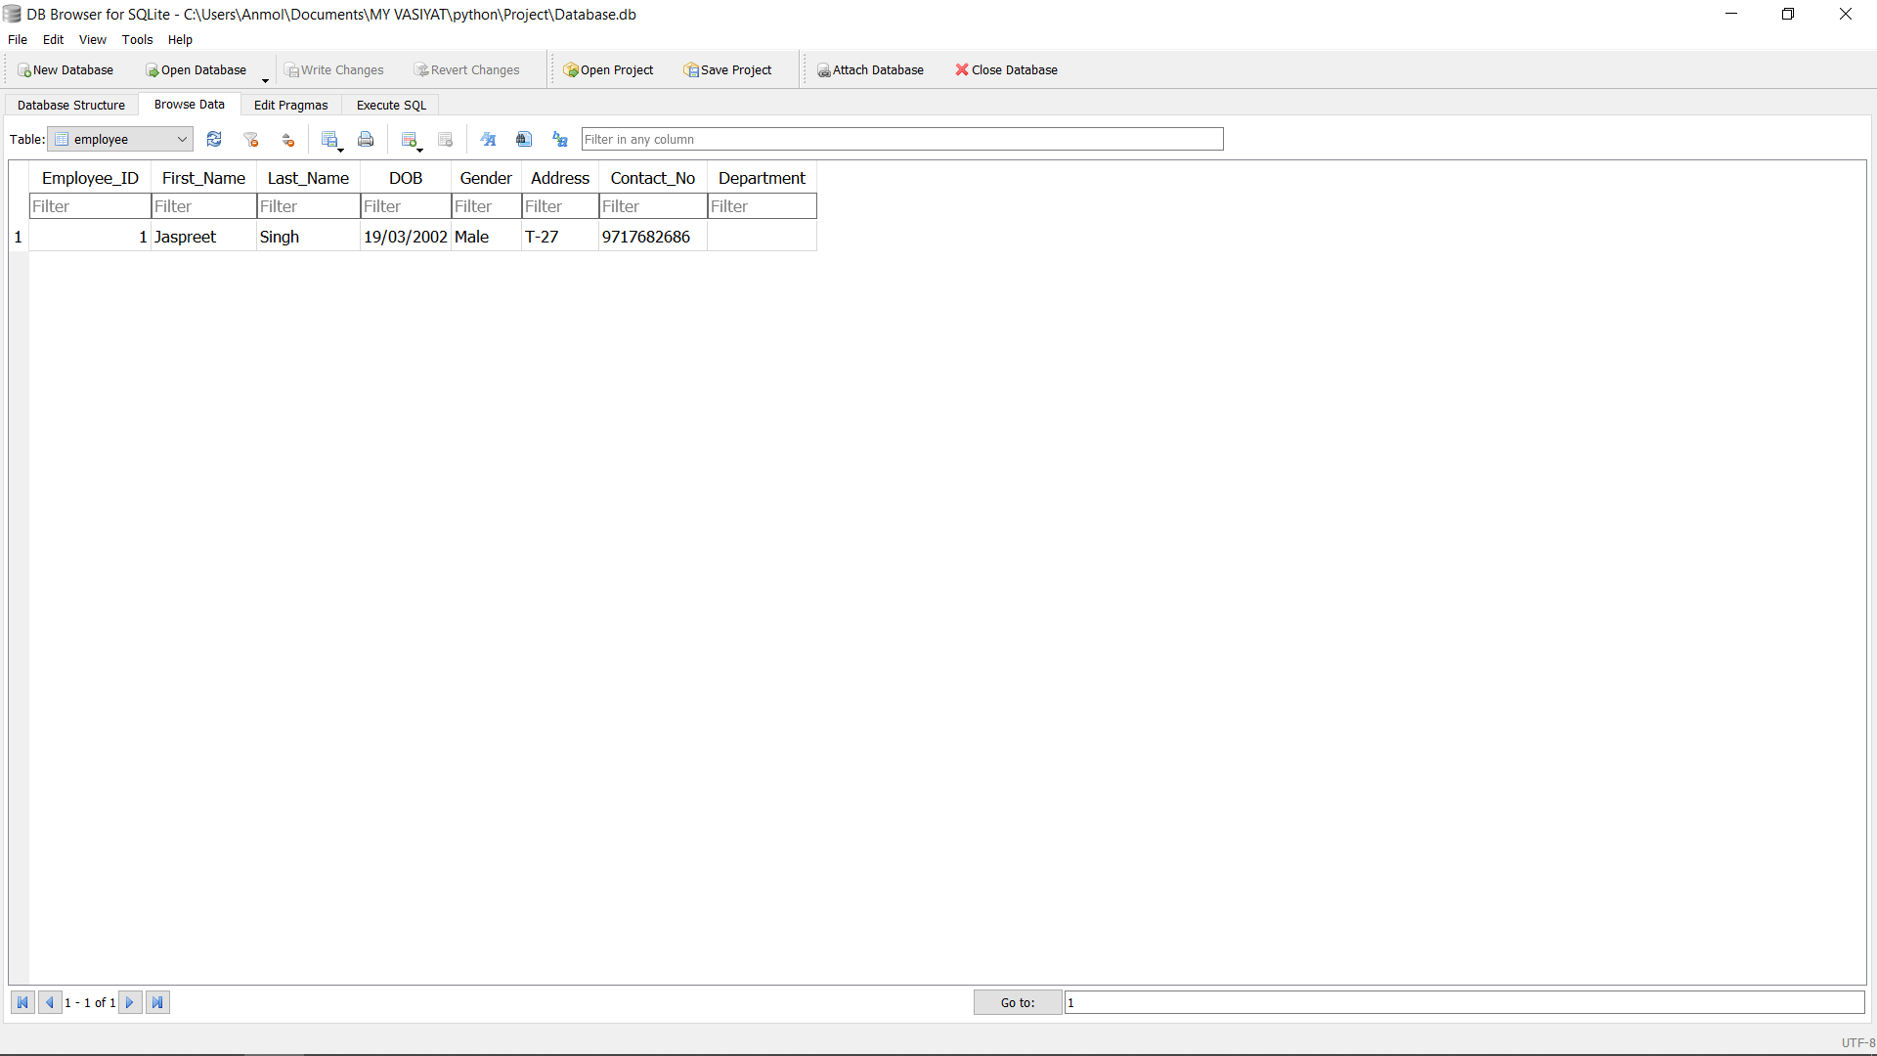

**Source Code**

1. Login Screen (Source Code)

from tkinter import *

import os

from tkinter import messagebox

import sqlite3

root=Tk()

root.geometry("1600x900")

root.title("Login")

Canvas(root,width=300,height=300)

img=PhotoImage(file=r"C:\Users\Anmol\Documents\MY VASIYAT\python\Project\assets\BG.png")

Label(root,image=img).pack()

username = StringVar()

password = StringVar()

def Database():

global conn, cursor

conn = sqlite3.connect("Database.db")

cursor = conn.cursor()

def Login(event=None):

Database()

if username.get() == "" or password.get() == "":

messagebox.showinfo("Error","Please complete the required field!")

else:

cursor.execute("SELECT * FROM `user` WHERE `username` = ? AND `password` = ?", (username.get(), password.get()))

if cursor.fetchone() is not None:

HomeWindow()

username.set("")

password.set("")

messagebox.showinfo(text="")

else:

messagebox.showinfo("Error","Invalid username or password")

username.set("")

password.set("")

cursor.close()

conn.close()

def HomeWindow():

filename='dashboard.py'

os.system(filename)

root.destroy()

exit()

def forget():

filename='Forget.py'

os.system(filename)

root.destroy()

exit()

def clicked():

Password_entry['show']=''

def Exit():

root.destroy()

exit(0)

Head=Label(root,text="A",font=("Comic Sans MS",82),bg="white").place(x=550,y=110)

Head=Label(root,text="dmin",font=("Comic Sans MS",34,"bold"),bg="white").place(x=627,y=181)

Head=Label(root,text="L",font=("Comic Sans MS",82),bg="white").place(x=745,y=110)

Head=Label(root,text="ogin",font=("Comic Sans MS",34,"bold"),bg="white").place(x=806,y=180)

Head_Line=Label(root,text="",bg="black").place(x=561,y=250,width=335,height=2)

label_1=Label(root,text="Username",font=("Lato",14),bg="white").place(x=500,y=320)

Username_Line=Label(root,text="",bg="black").place(x=505,y=375,width=400,height=1)

Username_entry=Entry(root,bg="white",bd="0",font=("Lato",12),textvariable=username).place(x=525,y=353,width=380)

label_2=Label(root,text="Password",font=("Lato",14),bg="white").place(x=500,y=420)

Password_Line=Label(root,text="",bg="black").place(x=505,y=475,width=400,height=1)

Password_entry=Entry(root,show='*',bg="white",bd="0",font=("Lato",12),textvariable=password)

Password_entry['show']='*'

Password_entry.place(x=525,y=453,width=380)

forget=Button(root,text="Forget Password?",bd="0",font=("Lato",12),fg="red",bg="white",activebackground="white",command=forget).place(x=830,y=490)

forget_Line=Label(root,text="",bg="red").place(x=835,y=516,width=121,height=1)

Submit_button=Button(root,text="Submit",font=("Lato",16),bg="#ffa31a",fg="white",command=Login).place(x=550,y=600,width=100)

Exit_button=Button(root,text="Exit",font=("Lato",16),bg="#ffa31a",fg="white",command=Exit).place(x=750,y=600,width=100)

User=PhotoImage(file=r"C:\Users\Anmol\Documents\MY VASIYAT\python\Project\assets\user.png")

Lock=PhotoImage(file=r"C:\Users\Anmol\Documents\MY VASIYAT\python\Project\assets\lock.png")

Eye=PhotoImage(file=r"C:\Users\Anmol\Documents\MY VASIYAT\python\Project\assets\eye.png")

Button(root,image=User,bd="0",bg="white").place(x=501,y=352,width=21,height=22)

Button(root,image=Lock,bd="0",bg="white").place(x=501,y=454,width=21,height=18)

Button(root,image=Eye,bd="0",bg="white",activebackground="white",command=clicked).place(x=875,y=444,width=30,height=30)

Description=Label(root,text="* Please enter Admin Username and Password,",fg="#b3b3b3",bg="white",font=("Lato",14)).place(x=560,y=700)

Description1=Label(root,text="Then Press Submit Button",fg="#b3b3b3",bg="white",font=("Lato",14)).place(x=640,y=726)

root.mainloop()

1. Signup Screen (Source Code)

from tkinter import *

from tkinter import messagebox

import sqlite3

import smtplib

import random

import os

root=Tk()

root.geometry("1600x900")

root.title("Sign up")

Canvas(root,width=300,height=300)

img=PhotoImage(file=r"C:\Users\Anmol\Documents\MY VASIYAT\python\Project\assets\BG.png")

Label(root,image=img).pack()

email=StringVar()

username=StringVar()

password=StringVar()

def Database():

global conn, cursor

conn=sqlite3.connect('Database.db')

cursor=conn.cursor()

def Exit():

result = messagebox.askquestion('System', 'Are you sure you want to exit?', icon="warning")

if result == 'yes':

root.destroy()

exit()

def Register():

Database()

email1=email.get()

username1=username.get()

password1=password.get()

if email.get == "" or username.get() == "" or password.get() == "" :

messagebox.showinfo("Error","Please complete the required field!")

else:

cursor.execute('CREATE TABLE IF NOT EXISTS `user`(email TEXT,username TEXT,password VAR)')

cursor.execute("SELECT * FROM `user` WHERE `username` = ?", [username.get()])

if cursor.fetchone() is not None:

messagebox.showinfo("Error","Username is already taken")

else:

cursor.execute("INSERT INTO `user` (email, username, password) VALUES(?,?,?)",(email1,username1,password1))

conn.commit()

email.set("")

username.set("")

password.set("")

messagebox.showinfo("","Successfully Created!")

cursor.close()

conn.close()

def callback():

filename='Login.py'

os.system(filename)

root.destroy()

exit()

def clicked():

Pas_entry['show']=''

Head=Label(root,text="A",font=("Comic Sans MS",82),bg="white").place(x=485,y=92)

Head=Label(root,text="dmin",font=("Comic Sans MS",34,"bold"),bg="white").place(x=560,y=161)

Head=Label(root,text="R",font=("Comic Sans MS",82),bg="white").place(x=685,y=94)

Head=Label(root,text="egisteration",font=("Comic Sans MS",34,"bold"),bg="white").place(x=755,y=161)

Head_Line=Label(root,text="",bg="black").place(x=500,y=230,width=514,height=2)

label_1=Label(root,text="Email",font=("Lato",14),bg="white").place(x=500,y=300)

Em_Line=Label(root,text="",bg="black").place(x=505,y=352,width=400,height=1)

Em_entry=Entry(root,bg="white",bd="0",font=("Lato",12),textvariable=email).place(x=525,y=330,width=380)

label_2=Label(root,text="Username",font=("Lato",14),bg="white").place(x=500,y=400)

User_Line=Label(root,text="",bg="black").place(x=505,y=455,width=400,height=1)

User_entry=Entry(root,bg="white",bd="0",font=("Lato",12),textvariable=username).place(x=525,y=433,width=380)

label_3=Label(root,text="Password",font=("Lato",14),bg="white").place(x=500,y=500)

Pas_Line=Label(root,text="",bg="black").place(x=505,y=555,width=400,height=1)

Pas_entry=Entry(root,bg="white",bd="0",font=("Lato",12),textvariable=password)

Pas_entry['show']='*'

Pas_entry.place(x=525,y=533,width=380)

lbl_result = Label(root, text="", font=("Lato",14)).place(x=510,y=615)

Submit_button=Button(root,text="Submit",font=("Lato",16),bg="#ffa31a",fg="white",command=Register).place(x=510,y=615,width=100)

Login_button=Button(root,text="Login",font=("Lato",16),bg="#ffa31a",fg="white",command=callback).place(x=690,y=615,width=100)

Exit_button=Button(root,text="Exit",font=("Lato",16),bg="#ffa31a",fg="white",command=Exit).place(x=870,y=615,width=100)

Mail=PhotoImage(file=r"C:\Users\Anmol\Documents\MY VASIYAT\python\Project\assets\mail.png")

User=PhotoImage(file=r"C:\Users\Anmol\Documents\MY VASIYAT\python\Project\assets\user.png")

Lock=PhotoImage(file=r"C:\Users\Anmol\Documents\MY VASIYAT\python\Project\assets\lock.png")

Eye=PhotoImage(file=r"C:\Users\Anmol\Documents\MY VASIYAT\python\Project\assets\eye.png")

Button(root,image=Mail,bd="0",bg="white").place(x=500,y=330,width=21,height=22)

Button(root,image=User,bd="0",bg="white").place(x=500,y=432,width=21,height=22)

Button(root,image=Lock,bd="0",bg="white").place(x=500,y=536,width=21,height=18)

Button(root,image=Eye,bd="0",bg="white",activebackground="white",command=clicked).place(x=875,y=525,width=30,height=30)

Description=Label(root,text="* Please enter Admin details and Submit,",fg="#b3b3b3",bg="white",font=("Lato",14)).place(x=570,y=700)

Description1=Label(root,text="Do not forget to store it in safe place,",fg="#b3b3b3",bg="white",font=("Lato",14)).place(x=590,y=725)

Description2=Label(root,text="You will need it while logging in!",fg="#b3b3b3",bg="white",font=("Lato",14)).place(x=600,y=750)

root.mainloop()

1. Forget Password (Source Code)

from tkinter import *

import sqlite3

from tkinter import messagebox

root=Tk()

root.geometry("1600x900")

root.title("Forget Password")

Canvas(root,width=300,height=300)

img=PhotoImage(file=r"C:\Users\Anmol\Documents\MY VASIYAT\python\Project\assets\BG.png")

Label(root,image=img).pack()

def Update():

email=e1.get()

password=e2.get()

conn=sqlite3.connect('Admin Registered.db')

with conn:

cursor=conn.cursor()

up="Update `user` set password='%s' WHERE email='%s'"%(password,email)

cursor.execute(up)

conn.commit()

messagebox.showinfo("Information","Record Updated")

def clicked():

e2['show']=''

Head=Label(root,text="N",font=("Comic Sans MS",82),bg="white").place(x=540,y=110)

Head=Label(root,text="ew",font=("Comic Sans MS",34,"bold"),bg="white").place(x=631,y=181)

Head=Label(root,text="P",font=("Comic Sans MS",82),bg="white").place(x=721,y=110)

Hea1=Label(root,text="assword",font=("Comic Sans MS",34,"bold"),bg="white").place(x=765,y=195,height=40)

Head_Line=Label(root,text="",bg="black").place(x=553,y=248,width=400,height=2)

label_1=Label(root,text="Email",font=("Lato",14),bg="white").place(x=520,y=400)

New_Line=Label(root,text="",bg="black").place(x=525,y=455,width=400,height=1)

e1=Entry(root,bg="white",bd="0",font=("Lato",12))

e1.place(x=545,y=433,width=380)

label_2=Label(root,text="New Password",font=("Lato",14),bg="white").place(x=520,y=500)

Password_Line=Label(root,text="",bg="black").place(x=525,y=555,width=400,height=1)

e2=Entry(root,bg="white",bd="0",font=("Lato",12))

e2['show']='*'

e2.place(x=545,y=533,width=380)

Submit_button=Button(root,text="Submit",font=("Lato",16),bg="#ffa31a",fg="white",command=Update).place(x=700,y=615,width=100)

Mail=PhotoImage(file=r"C:\Users\Anmol\Documents\MY VASIYAT\python\Project\assets\mail.png")

Lock=PhotoImage(file=r"C:\Users\Anmol\Documents\MY VASIYAT\python\Project\assets\lock.png")

New_Lock=PhotoImage(file=r"C:\Users\Anmol\Documents\MY VASIYAT\python\Project\assets\New Lock.png")

Eye=PhotoImage(file=r"C:\Users\Anmol\Documents\MY VASIYAT\python\Project\assets\eye.png")

Button(root,image=Mail,bd="0",bg="white").place(x=521,y=432,width=21,height=22)

Button(root,image=Lock,bd="0",bg="white").place(x=521,y=535,width=21,height=18)

Button(root,image=Eye,bd="0",bg="white",activebackground="white",command=clicked).place(x=895,y=525,width=30,height=30)

New_Lock_Button=Button(root,image=New_Lock,bd="0",bg="white").place(x=713,y=285)

Description=Label(root,text="* Please enter your Old Password,",fg="#b3b3b3",bg="white",font=("Lato",14)).place(x=610,y=700)

Description1=Label(root,text="then enter New Password,",fg="#b3b3b3",bg="white",font=("Lato",14)).place(x=643,y=725)

Description2=Label(root,text="and submit it!",fg="#b3b3b3",bg="white",font=("Lato",14)).place(x=695,y=750)

root.mainloop()

1. Dashboard (Source Code)

from tkinter import *

from tkinter import messagebox

import os

import time

import datetime as dt

import sqlite3

from tkinter import ttk

def show_frame(frame):

frame.tkraise()

def logout():

result = messagebox.askquestion('System', 'Are you sure you want to Log Out?', icon="warning")

if result == 'yes':

filename='Login.py'

os.system(filename)

def digitalclock():

text_input = time.strftime("%H:%M:%S")

Time.config(text=text_input)

Time.after(200, digitalclock)

def call():

result = messagebox.askquestion('System', 'Are you sure you want to exit?', icon="warning")

if result == 'yes':

root.destroy()

exit()

def Update():

email=e1.get()

password=e2.get()

User=u_entry.get()

conn=sqlite3.connect('Admin Registered.db')

if e1.get == "" or e2.get() == "" or e3.get() == "" :

messagebox.showinfo("Error","Please complete the required field!")

else:

cursor=conn.cursor()

up="Update `user` set password='%s' WHERE email='%s'"%(password,email)

cursor.execute(up)

conn.commit()

messagebox.showinfo("Information","Record Updated")

return()

def s_update(rows):

view_student_tree.delete(*view_student_tree.get_children())

for i in rows:

view_student_tree.insert('','end',values=i)

def e_update(rows):

view_employee_tree.delete(*view_employee_tree.get_children())

for i in rows:

view_employee_tree.insert('','end',values=i)

def c_update(rows):

view_course_tree.delete(*view_course_tree.get_children())

for i in rows:

view_course_tree.insert('','end',values=i)

def d_update(rows):

view_department_tree.delete(*view_department_tree.get_children())

for i in rows:

view_department_tree.insert('','end',values=i)

def stud():

filename='Student.py'

os.system(filename)

root.destroy()

exit()

def emp():

filename='Employee.py'

os.system(filename)

root.destroy()

exit()

def dep():

filename='Department.py'

os.system(filename)

root.destroy()

exit()

def cou():

filename='Course.py'

os.system(filename)

root.destroy()

exit()

def sec():

filename='Section.py'

os.system(filename)

root.destroy()

exit()

def bat():

filename='Batch.py'

os.system(filename)

root.destroy()

exit()

root=Tk()

root.geometry("1600x900")

root.title("Dashboard")

root.rowconfigure(0, weight=1)

root.columnconfigure(0, weight=1)

Canvas(root,width=300,height=300)

img=PhotoImage(file=r"C:\Users\Anmol\Documents\MY VASIYAT\python\Project\assets\BG1.png")

Label(root,image=img).pack()

global conn, cursor

conn=sqlite3.connect('Database.db')

cursor=conn.cursor()

frame1 = Frame(root)

frame2 = Frame(root)

frame3 = Frame(root)

frame4 = Frame(root)

password=StringVar()

email=StringVar()

for frame in (frame1, frame2, frame3, frame4,):

frame.place(x=210,y=162,width=1250,height=650)

#==================Home Frame

frame1_title=Label(frame1,bg="#fbca90")

frame1_title.pack(fill='both', expand=True)

c1=PhotoImage(file=r"C:\Users\Anmol\Documents\MY VASIYAT\python\Project\assets\4.png")

frame1_title_button4=Button(frame1,text="",bd="0",bg="#fbca90",activebackground="white",image=c1).place(x=675,y=355,width=550,height=270)

frame1_title_button3=Button(frame1,text="",bd="0",bg="white",activebackground="white").place(x=40,y=355,width=550,height=270)

frame1_title_button2=Button(frame1,text="",bd="0",bg="white",activebackground="white").place(x=675,y=40,width=550,height=270)

frame1_title_button1=Button(frame1,text="",bd="0",bg="white",activebackground="white").place(x=40,y=40,width=550,height=270)

frame1_title_button3_label=Label(frame1,text="Total",bd="0",bg="white",fg="#ff9999",font=("Helvetica",55,"bold")).place(x=210,y=365)

frame1_title_button3_label=Label(frame1,text="0",bd="0",bg="white",fg="#ff9999",font=("Helvetica",55,"bold")).place(x=275,y=450)

frame1_title_button3_label=Label(frame1,text="Departments",bd="0",bg="white",fg="#ff9999",font=("Helvetica",55,"bold")).place(x=90,y=530)

frame1_title_button2_label=Label(frame1,text="Total",bd="0",bg="white",fg="#ff9999",font=("Helvetica",55,"bold")).place(x=850,y=45)

frame1_title_button2_label=Label(frame1,text="0",bd="0",bg="white",fg="#ff9999",font=("Helvetica",55,"bold")).place(x=920,y=125)

frame1_title_button2_label=Label(frame1,text="Employees",bd="0",bg="white",fg="#ff9999",font=("Helvetica",55,"bold")).place(x=750,y=210)

frame1_title_button1_label=Label(frame1,text="Total",bd="0",bg="white",fg="#ff9999",font=("Helvetica",55,"bold")).place(x=210,y=50)

frame1_title_button1_label=Label(frame1,text="0",bd="0",bg="white",fg="#ff9999",font=("Helvetica",55,"bold")).place(x=275,y=135)

frame1_title_button1_label=Label(frame1,text="Students",bd="0",bg="white",fg="#ff9999",font=("Helvetica",55,"bold")).place(x=145,y=215)

#==================Manage Frame

c2=PhotoImage(file=r"C:\Users\Anmol\Documents\MY VASIYAT\python\Project\assets\Manage_Pic.png")

frame2_title=Label(frame2, image=c2)

frame2_title.pack(fill='both', expand=True)

Student=PhotoImage(file=r"C:\Users\Anmol\Documents\MY VASIYAT\python\Project\assets\Student.png")

Employee=PhotoImage(file=r"C:\Users\Anmol\Documents\MY VASIYAT\python\Project\assets\Employee.png")

Department=PhotoImage(file=r"C:\Users\Anmol\Documents\MY VASIYAT\python\Project\assets\Department.png")

Course=PhotoImage(file=r"C:\Users\Anmol\Documents\MY VASIYAT\python\Project\assets\Course.png")

Section=PhotoImage(file=r"C:\Users\Anmol\Documents\MY VASIYAT\python\Project\assets\Section.png")

Batch=PhotoImage(file=r"C:\Users\Anmol\Documents\MY VASIYAT\python\Project\assets\Batch.png")

Student_btn=Button(frame2,text="",bd="0",image=Student,bg="white",activebackground="white",command=stud).place(x=209,y=150,width=110,height=100)

Employee_btn=Button(frame2,text="",bd="0",image=Employee,bg="white",activebackground="white",command=emp).place(x=559,y=150,width=110,height=100)

Department_btn=Button(frame2,text="",bd="0",image=Department,bg="white",activebackground="white",command=dep).place(x=918,y=150,width=110,height=100)

Course_btn=Button(frame2,text="",bd="0",image=Course,bg="white",activebackground="white",command=cou).place(x=208,y=379,width=110,height=100)

Section_btn=Button(frame2,text="",bd="0",image=Section,bg="white",activebackground="white",command=sec).place(x=559,y=379,width=110,height=100)

Batch_btn=Button(frame2,text="",bd="0",image=Batch,bg="white",activebackground="white",command=bat).place(x=916,y=380,width=110,height=100)

Student_label=Label(frame2,text="Student",bg="white",fg="#ff9999",font=("Helvetica",18)).place(x=218,y=248)

Employee_label=Label(frame2,text="Employee",bg="white",fg="#ff9999",font=("Helvetica",18)).place(x=557,y=248)

Department_label=Label(frame2,text="Department",bg="white",fg="#ff9999",font=("Helvetica",18)).place(x=907,y=245)

Course_label=Label(frame2,text="Course",bg="white",fg="#ff9999",font=("Helvetica",18)).place(x=220,y=475)

Section_label=Label(frame2,text="Section",bg="white",fg="#ff9999",font=("Helvetica",18)).place(x=570,y=475)

Batch_label=Label(frame2,text="Batch",bg="white",fg="#ff9999",font=("Helvetica",18)).place(x=940,y=480)

#==================View Frame

frame3_title=Label(frame3,bg="white")

frame3_title.pack(fill='both', expand=True)

# ========================================================================

# ============================Displaying Student Information==============

# ========================================================================

student_view_label = Label(frame3, text="View Students Information ", bg="white", fg="#4f4e4d",

font=("yu gothic ui", 13, "bold"))

student_view_label.place(x=170, y=6)

view_student_frame = Frame(frame3, bg="white")

view_student_frame.place(x=10, y=40, height=250, width=575)

style = ttk.Style()

style.configure("Treeview.Heading", font=('yu gothic ui', 10, "bold"), foreground="red")

style.configure("Treeview", font=('yu gothic ui', 9, "bold"), foreground="#f29b0f")

scroll_y = Scrollbar(view_student_frame, orient=VERTICAL)

scroll_x = Scrollbar(view_student_frame, orient=HORIZONTAL)

view_student_tree = ttk.Treeview(view_student_frame,

columns=(

"STUDENT ID", "STUDENT NAME", "PHONE NO.", "COURSE ENROLLED"),

xscrollcommand=scroll_x.set, yscrollcommand=scroll_y.set)

scroll_x.pack(side=BOTTOM, fill=X)

scroll_y.pack(side=RIGHT, fill=Y)

scroll_x.config(command=view_student_tree.xview)

scroll_y.config(command=view_student_tree.yview)

# ==========================TreeView Heading====================

view_student_tree.heading("STUDENT ID", text="STUDENT ID")

view_student_tree.heading("STUDENT NAME", text="STUDENT NAME")

view_student_tree.heading("PHONE NO.", text="PHONE NO.")

view_student_tree.heading("COURSE ENROLLED", text="COURSE ENROLLED")

view_student_tree["show"] = "headings"

# ==========================TreeView Column====================

view_student_tree.column("STUDENT ID", width=150)

view_student_tree.column("STUDENT NAME", width=150)

view_student_tree.column("PHONE NO.", width=100)

view_student_tree.column("COURSE ENROLLED", width=150)

view_student_tree.pack(fill=BOTH, expand=1)

query="SELECT Student_ID,First_Name,Contact_No,Course FROM `student`"

cursor.execute(query)

rows=cursor.fetchall()

s_update(rows)

# ========================================================================

# =========================Displaying instructor Information==============

# ========================================================================

view_employee_frame = Frame(frame3, bg="white")

view_employee_frame.place(x=640, y=40, height=250, width=575)

employee_view_label = Label(frame3, text="View Employees Information ", bg="white", fg="#4f4e4d",

font=("yu gothic ui", 13, "bold"))

employee_view_label.place(x=770, y=6)

scroll_y_e = Scrollbar(view_employee_frame, orient=VERTICAL)

scroll_x_e = Scrollbar(view_employee_frame, orient=HORIZONTAL)

view_employee_tree = ttk.Treeview(view_employee_frame,

columns=(

"EMPLOYEE ID", "EMPLOYEE NAME", "PHONE NO", "DEPARTMENT"),

xscrollcommand=scroll_x_e.set, yscrollcommand=scroll_y_e.set)

scroll_x_e.pack(side=BOTTOM, fill=X)

scroll_y_e.pack(side=RIGHT, fill=Y)

scroll_x_e.config(command=view_employee_tree.xview)

scroll_y_e.config(command=view_employee_tree.yview)

# ==========================TreeView Heading====================

view_employee_tree.heading("EMPLOYEE ID", text="EMPLOYEE ID")

view_employee_tree.heading("EMPLOYEE NAME", text="EMPLOYEE NAME")

view_employee_tree.heading("PHONE NO", text="PHONE NO")

view_employee_tree.heading("DEPARTMENT", text="DEPARTMENT")

view_employee_tree["show"] = "headings"

# ==========================TreeView Column====================

view_employee_tree.column("EMPLOYEE ID", width=150)

view_employee_tree.column("EMPLOYEE NAME", width=150)

view_employee_tree.column("PHONE NO", width=100)

view_employee_tree.column("DEPARTMENT", width=100)

view_employee_tree.pack(fill=BOTH, expand=1)

query="SELECT Employee_ID,First_Name,Contact_No,Department FROM `employee`"

cursor.execute(query)

rows=cursor.fetchall()

e_update(rows)

# ========================================================================

# =========================Displaying Course Information==============

# ========================================================================

view_course_frame = Frame(frame3, bg="white")

view_course_frame.place(x=10, y=360, height=250, width=575)

course_view_label = Label(frame3, text="View Course Information ", bg="white", fg="#4f4e4d",

font=("yu gothic ui", 13, "bold"))

course_view_label.place(x=170, y=310)

scroll_y_e = Scrollbar(view_course_frame, orient=VERTICAL)

scroll_x_e = Scrollbar(view_course_frame, orient=HORIZONTAL)

view_course_tree = ttk.Treeview(view_course_frame,

columns=(

"COURSE ID", "COURSE NAME", "COURSE DURATION", "COURSE CREDIT"),

xscrollcommand=scroll_x_e.set, yscrollcommand=scroll_y_e.set)

scroll_x_e.pack(side=BOTTOM, fill=X)

scroll_y_e.pack(side=RIGHT, fill=Y)

scroll_x_e.config(command=view_course_tree.xview)

scroll_y_e.config(command=view_course_tree.yview)

# ==========================TreeView Heading====================

view_course_tree.heading("COURSE ID", text="COURSE ID")

view_course_tree.heading("COURSE NAME", text="COURSE NAME")

view_course_tree.heading("COURSE DURATION", text="COURSE DURATION")

view_course_tree.heading("COURSE CREDIT", text="COURSE CREDIT")

view_course_tree["show"] = "headings"

# ==========================TreeView Column====================

view_course_tree.column("COURSE ID", width=50)

view_course_tree.column("COURSE NAME", width=150)

view_course_tree.column("COURSE DURATION", width=100)

view_course_tree.column("COURSE CREDIT", width=100)

view_course_tree.pack(fill=BOTH, expand=1)

query="SELECT Course_ID,Course_Name,Course_Duration,Course_Credit FROM `course`"

cursor.execute(query)

rows=cursor.fetchall()

c_update(rows)

# ========================================================================

# =========================Displaying Department Information==============

# ========================================================================

view_department_frame = Frame(frame3, bg="white")

view_department_frame.place(x=640, y=360, height=250, width=575)

department_view_label = Label(frame3, text="View Department Information ", bg="white", fg="#4f4e4d",

font=("yu gothic ui", 13, "bold"))

department_view_label.place(x=770, y=310)

scroll_y_e = Scrollbar(view_department_frame, orient=VERTICAL)

scroll_x_e = Scrollbar(view_department_frame, orient=HORIZONTAL)

view_department_tree = ttk.Treeview(view_department_frame,

columns=(

"DEPARTMENT ID", "DEPARTMENT NAME", "DEPARTMENT CODE"),

xscrollcommand=scroll_x_e.set, yscrollcommand=scroll_y_e.set)

scroll_x_e.pack(side=BOTTOM, fill=X)

scroll_y_e.pack(side=RIGHT, fill=Y)

scroll_x_e.config(command=view_department_tree.xview)

scroll_y_e.config(command=view_department_tree.yview)

# ==========================TreeView Heading====================

view_department_tree.heading("DEPARTMENT ID", text="DEPARTMENT ID")

view_department_tree.heading("DEPARTMENT NAME", text="DEPARTMENT NAME")

view_department_tree.heading("DEPARTMENT CODE", text="DEPARTMENT CODE")

view_department_tree["show"] = "headings"

# ==========================TreeView Column====================

view_department_tree.column("DEPARTMENT ID", width=50)

view_department_tree.column("DEPARTMENT NAME", width=150)

view_department_tree.column("DEPARTMENT CODE", width=100)

view_department_tree.pack(fill=BOTH, expand=1)

query="SELECT Department_ID,Department_Code,Department_Name FROM `department`"

cursor.execute(query)

rows=cursor.fetchall()

d_update(rows)

#==================Setting Frame

frame4_title=Label(frame4,bg='#fbca90')

frame4_title.pack(fill='both', expand=True)

f4=PhotoImage(file=r"C:\Users\Anmol\Documents\MY VASIYAT\python\Project\assets\frame4.png")

frame4_img=Button(frame4,text="",bd="0",bg="#fbca90",activebackground="#fbca90",image=f4).place(x=0,y=0,width=1250,height=650)

label=Label(frame4,text="Change Password",bg="white",fg="black",font=("Helvetica",28)).place(x=435,y=55)

line=Label(frame4,text="",bg="black").place(x=447,y=105,width=290,height=1)

u=Label(frame4,text="Username",bg="white",fg="black",font=("Helvetica",16)).place(x=410,y=140)

u_line=Label(frame4,text="",bg="black").place(x=420,y=205,width=300,height=1)

u_entry=Entry(frame4,text="",bd="0")

u_entry.place(x=445,y=185,width=275)

User=PhotoImage(file=r"C:\Users\Anmol\Documents\MY VASIYAT\python\Project\assets\user.png")

Button(frame4,image=User,bd="0",bg="white").place(x=420,y=180,width=21,height=21)

e=Label(frame4,text="Email",bg="white",fg="black",font=("Helvetica",16)).place(x=410,y=250)

e_line=Label(frame4,text="",bg="black").place(x=420,y=320,width=300,height=1)

e1=Entry(frame4,text="",bd="0")

e1.place(x=445,y=300,width=275)

e_mail=PhotoImage(file=r"C:\Users\Anmol\Documents\MY VASIYAT\python\Project\assets\mail.png")

Button(frame4,image=e_mail,bd="0",bg="white").place(x=420,y=295,width=21,height=22)

np=Label(frame4,text="New Password",bg="white",fg="black",font=("Helvetica",16)).place(x=410,y=360)

np_line=Label(frame4,text="",bg="black").place(x=420,y=430,width=300,height=1)

e2=Entry(frame4,text="",bd="0")

e2.place(x=445,y=410,width=275)

np_Lock=PhotoImage(file=r"C:\Users\Anmol\Documents\MY VASIYAT\python\Project\assets\lock.png")

Button(frame4,image=np_Lock,bd="0",bg="white").place(x=420,y=405,width=21,height=18)

cnp=Label(frame4,text="Confirm New Password",bg="white",fg="black",font=("Helvetica",16)).place(x=410,y=470)

cnp_line=Label(frame4,text="",bg="black").place(x=420,y=540,width=300,height=1)

cnp_entry=Entry(frame4,text="",bd="0").place(x=445,y=520,width=275)

cnp_Lock=PhotoImage(file=r"C:\Users\Anmol\Documents\MY VASIYAT\python\Project\assets\lock.png")

Button(frame4,image=cnp_Lock,bd="0",bg="white").place(x=420,y=515,width=21,height=18)

Submit_button=Button(frame4,text="Submit",font=("Lato",16),bg="#ffa31a",fg="white",command=Update).place(x=540,y=560,width=100)

line=Label(root,text="",bg="black").place(x=40,y=135,width=1520,height=2)

Head=Label(root,text="W",font=("Helvetica",50,"bold"),bg="white",fg="#ff9999").place(x=320,y=51)

Head=Label(root,text="elcome",font=("Helvetica",30),bg="white",fg="#ff9999").place(x=385,y=77)

Head=Label(root,text="T",font=("Helvetica",50,"bold"),bg="white",fg="#ff9999").place(x=530,y=51)

Head=Label(root,text="o",font=("Helvetica",30),bg="white",fg="#ff9999").place(x=565,y=76)

Head=Label(root,text="A",font=("Helvetica",50,"bold"),bg="white",fg="#ff9999").place(x=620,y=51)

Head=Label(root,text="dmin",font=("Helvetica",30),bg="white",fg="#ff9999").place(x=670,y=75)

Head=Label(root,text="R",font=("Helvetica",50,"bold"),bg="white",fg="#ff9999").place(x=780,y=51)

Head=Label(root,text="egisteration",font=("Helvetica",30),bg="white",fg="#ff9999").place(x=830,y=75)

Logout_lbl=Label(root,text="Logout",font=("Helvetica",16,"bold"),bg="white",fg="#ff9999").place(x=1430,y=77)

Home_lbl=Label(root,text="Home",font=("Helvetica",14,"bold"),bg="white",fg="#ff9999").place(x=41,y=303)

Manage_lbl=Label(root,text="Manage",font=("Helvetica",14,"bold"),bg="white",fg="#ff9999").place(x=32,y=407)

View_lbl=Label(root,text="View",font=("Helvetica",14,"bold"),bg="white",fg="#ff9999").place(x=41,y=543)

Setting_lbl=Label(root,text="Settings",font=("Helvetica",14,"bold"),bg="white",fg="#ff9999").place(x=30,y=655)

Exit_lbl=Label(root,text="Exit",font=("Helvetica",14,"bold"),bg="white",fg="#ff9999").place(x=46,y=780)

Profile=PhotoImage(file=r"C:\Users\Anmol\Documents\MY VASIYAT\python\Project\assets\Profile.png")

Logout=PhotoImage(file=r"C:\Users\Anmol\Documents\MY VASIYAT\python\Project\assets\logout.png")

Home=PhotoImage(file=r"C:\Users\Anmol\Documents\MY VASIYAT\python\Project\assets\home.png")

Manage=PhotoImage(file=r"C:\Users\Anmol\Documents\MY VASIYAT\python\Project\assets\manage.png")

View=PhotoImage(file=r"C:\Users\Anmol\Documents\MY VASIYAT\python\Project\assets\view.png")

Setting=PhotoImage(file=r"C:\Users\Anmol\Documents\MY VASIYAT\python\Project\assets\setting.png")

Exit=PhotoImage(file=r"C:\Users\Anmol\Documents\MY VASIYAT\python\Project\assets\exit.png")

Clock=PhotoImage(file=r"C:\Users\Anmol\Documents\MY VASIYAT\python\Project\assets\clock.png")

Profile_btn=Button(root,text="",bd="0",image=Profile,bg="white",activebackground="white").place(x=1060,y=70,width=55,height=58)

Logout_btn=Button(root,text="",bd="0",image=Logout,bg="white",activebackground="white",command=logout).place(x=1380,y=75,width=55,height=30)

Home_btn=Button(root,text="",bd="0",image=Home,bg="white",activebackground="white",command=lambda:show_frame(frame1)).place(x=40,y=240,width=60,height=60)

Manage_btn=Button(root,text="",bd="0",image=Manage,bg="white",activebackground="white",command=lambda:show_frame(frame2)).place(x=40,y=360,width=60,height=50)

View_btn=Button(root,text="",bd="0",image=View,bg="white",activebackground="white",command=lambda:show_frame(frame3)).place(x=40,y=480,width=60,height=60)

Setting_btn=Button(root,text="",bd="0",image=Setting,bg="white",activebackground="white",command=lambda:show_frame(frame4)).place(x=40,y=600,width=60,height=60)

Exit_btn=Button(root,text="",bd="0",image=Exit,bg="white",activebackground="white",command=call).place(x=40,y=720,width=60,height=60)

Clock_btn=Button(root,text="",bd="0",image=Clock,bg="white",activebackground="white").place(x=50,y=70,width=60,height=60)

Time=Label(root,font=("Helvetica",20,'bold'), bg="white", fg="black", bd =10)

Time.place(x=100,y=50)

digitalclock()

date=dt.datetime.now()

format_date = f"{date:%a, %b %d %Y}"

Date=Label(root,text=format_date,fg="black",bg="white",font=("helvetica",18,'bold'))

Date.place(x=100,y=90)

profile_label=Label(root,text="js1932002singh@gmail.com",font=("Helvetica",14),fg="green",bg="white").place(x=1105,y=85)

show_frame(frame1)

root.mainloop()

1. Manage Student (Source Code)

from tkinter import *

from tkinter import messagebox

import os

import sqlite3

from tkinter import ttk

def show_frame(frame):

frame.tkraise()

def dashboard():

filename='dashboard.py'

os.system(filename)

root.destroy()

exit()

def Add():

filename='Addstudent.py'

os.system(filename)

root.destroy()

exit()

def Update():

filename='Updatestudent.py'

os.system(filename)

root.destroy()

exit()

def Delete():

filename='Deletestudent.py'

os.system(filename)

root.destroy()

exit()

def update(rows):

student_tree.delete(*student_tree.get_children())

for i in rows:

student_tree.insert('','end',values=i)

def search():

q2=q.get()

query="SELECT * FROM `student` WHERE First_Name LIKE '%"+q2+"%' OR Last_Name LIKE '%"+q2+"%'"

cursor.execute(query)

rows=cursor.fetchall()

update(rows)

def clear_search(events):

search_entry.delete(0, "end")

def view():

query="SELECT * FROM `student`"

cursor.execute(query)

rows=cursor.fetchall()

def do_popup(event):

popup = Menu(frame1, tearoff=0)

popup.add_command(label="UPDATE", command=Update)

popup.add_separator()

popup.add_command(label="DELETE", command=Delete)

popup.add_separator()

popup.add_command(label="FETCH")

try:

popup.tk_popup(event.x_root, event.y_root, 0)

finally:

popup.grab_release()

global conn, cursor

conn=sqlite3.connect('Database.db')

cursor=conn.cursor()

root=Tk()

root.geometry("1600x900")

root.title("Student Management Dashboard")

root.rowconfigure(0, weight=1)

root.columnconfigure(0, weight=1)

Canvas(root,width=300,height=300)

img=PhotoImage(file=r"C:\Users\Anmol\Documents\MY VASIYAT\python\Project\assets\BG2.png")

Label(root,image=img).pack()

q=StringVar()

lbl=Label(root,text="Student Management Dashboard",fg="#ff9999",font=("Helvetica",46,"bold"),bg="white").place(x=330,y=40)

lbl=Label(root,text="Student Management Options",fg="#ff9999",font=("Helvetica",14),bg="white").place(x=85,y=250)

Box=Label(root,text="",bg="#a6a6a6").place(x=70,y=263,width=2,height=470)

Box=Label(root,text="",bg="#a6a6a6").place(x=70,y=263,width=18,height=2)

Box=Label(root,text="",bg="#a6a6a6").place(x=338,y=263,width=60,height=2)

Box=Label(root,text="",bg="#a6a6a6").place(x=398,y=263,width=2,height=470)

Box=Label(root,text="",bg="#a6a6a6").place(x=70,y=733,width=330,height=2)

search_entry=Entry(root,highlightthickness=0,relief=FLAT,bg="white",fg="#6b6a69",font=("yu gothic ui semibold",12))

search_entry.place(x=600,y=167,width=550)

search_txt="Search here.........."

search_entry.insert(0,search_txt)

search_entry.bind("<1>",clear_search)

search_line=Label(root,text="",bg="#a6a6a6").place(x=600,y=195,width=550,height=2)

Search=PhotoImage(file=r"C:\Users\Anmol\Documents\MY VASIYAT\python\Project\assets\Search.png")

View=PhotoImage(file=r"C:\Users\Anmol\Documents\MY VASIYAT\python\Project\assets\view1.png")

Btn=Button(root,text="",image=Search,bd="0",bg="white",activebackground="white",command=search).place(x=1170,y=170,width=30,height=30)

search_btn=Button(root,text="Search",bd="0",bg="white",activebackground="white",font=("Helvetica",10),fg="#a6a6a6",command=search).place(x=1200,y=174)

Btn=Button(root,text="",image=View,bd="0",bg="white",activebackground="white",command=view).place(x=1280,y=170,width=28,height=28)

view_btn=Button(root,text="View All",bd="0",bg="white",activebackground="white",font=("Helvetica",10),fg="#a6a6a6",command=view).place(x=1315,y=174)

btn=Button(root,text="ADD STUDENT",fg="white",font=("Helvetica",15),bg="#f88600",bd="0",activebackground="#f88600",command=Add).place(x=170,y=329)

btn=Button(root,text="UPDATE STUDENT",fg="white",font=("Helvetica",15),bg="#f88600",bd="0",activebackground="#f88600",command=Update).place(x=150,y=406)

btn=Button(root,text="DELETE STUDENT",fg="white",font=("Helvetica",15),bg="#f88600",bd="0",activebackground="#f88600",command=Delete).place(x=150,y=485)

btn=Button(root,text="GO TO DASHBOARD",fg="white",font=("Helvetica",15),bg="#f88600",bd="0",activebackground="#f88600",command=dashboard).place(x=140,y=565)

'''s1=StringVar()

s2=StringVar()

Select1=['Search','Sort'];

Select2=['Ascending','Descending'];

droplist=OptionMenu(root,s1, *Select1)

droplist.config(width=3,bd="1",font=("Helvetica",11),fg="#737373")

s1.set('Search :')

droplist.place(x=500,y=165,width=95,height=35)

droplist=OptionMenu(root,s2, *Select2)

droplist.config(width=3,bd="1",font=("Helvetica",11),fg="#737373")

s2.set('Sort By :')

droplist.place(x=620,y=165,width=100,height=35)'''

frame1=Frame(root)

for frame in (frame1,):

frame.place(x=455,y=210,width=1046,height=589)

#================== Frame

tree_view_frame = Frame(frame1, bg="white")

tree_view_frame.place(x=0,y=0,height=589,width=1046)

style = ttk.Style()

style.configure("Treeview.Heading", font=('yu gothic ui', 10, "bold"), foreground="red")

style.configure("Treeview", font=('yu gothic ui', 9, "bold"), foreground="#f29844")

scroll_x = Scrollbar(tree_view_frame, orient=HORIZONTAL)

scroll_y = Scrollbar(tree_view_frame, orient=VERTICAL)

student_tree = ttk.Treeview(tree_view_frame,

columns=(

"STUDENT ID","FNAME", "LNAME", "DOB", "GENDER", "ADDRESS",

"CONTACT NO", "SHIFT", "COURSE ENROLLED", "BATCH", "SECTION"),

xscrollcommand=scroll_x.set, yscrollcommand=scroll_y.set)

scroll_x.pack(side=BOTTOM, fill=X)

scroll_y.pack(side=RIGHT, fill=Y)

scroll_x.config(command=student_tree.xview)

scroll_y.config(command=student_tree.yview)

# ==========================TreeView Heading====================

student_tree.heading("STUDENT ID", text="STUDENT ID")

student_tree.heading("FNAME", text="FNAME")

student_tree.heading("LNAME", text="LNAME")

student_tree.heading("DOB", text="DOB")

student_tree.heading("GENDER", text="GENDER")

student_tree.heading("ADDRESS", text="ADDRESS")

student_tree.heading("CONTACT NO", text="CONTACT NO")

student_tree.heading("SHIFT", text="SHIFT")

student_tree.heading("COURSE ENROLLED", text="COURSE ENROLLED")

student_tree.heading("BATCH", text="BATCH")

student_tree.heading("SECTION", text="SECTION")

student_tree["show"] = "headings"

query="SELECT * FROM `student`"

cursor.execute(query)

rows=cursor.fetchall()

update(rows)

# ==========================TreeView Column====================

student_tree.column("STUDENT ID", width=100)

student_tree.column("FNAME", width=170)

student_tree.column("LNAME", width=170)

student_tree.column("ADDRESS", width=150)

student_tree.column("GENDER", width=150)

student_tree.column("CONTACT NO", width=150)

student_tree.column("DOB", width=150)

student_tree.column("SHIFT", width=150)

student_tree.column("COURSE ENROLLED", width=150)

student_tree.column("BATCH", width=100)

student_tree.column("SECTION", width=100)

student_tree.pack(fill=BOTH, expand=1)

student_tree.bind("<Button-3>",do_popup)

show_frame(frame1)

root.mainloop()

1. Manage Employee (Source Code)

from tkinter import *

from tkinter import messagebox

from tkinter import ttk

import os

import sqlite3

def show_frame(frame):

frame.tkraise()

def dashboard():

filename='dashboard.py'

os.system(filename)

root.destroy()

exit()

def AddA():

filename='Admin.py'

os.system(filename)

root.destroy()

exit()

def Add():

filename='AddEmployee.py'

os.system(filename)

root.destroy()

exit()

def Update():

filename='UpdateEmployee.py'

os.system(filename)

root.destroy()

exit()

def Delete():

filename='DeleteEmployee.py'

os.system(filename)

root.destroy()

exit()

def update(rows):

student_tree.delete(*student_tree.get_children())

for i in rows:

student_tree.insert('','end',values=i)

def search():

q2=q.get()

query="SELECT * FROM `employee` WHERE First_Name LIKE '%"+q2+"%' OR Last_Name LIKE '%"+q2+"%'"

cursor.execute(query)

rows=cursor.fetchall()

update(rows)

def clear_search(events):

search_entry.delete(0, "end")

def view():

query="SELECT * FROM `employee`"

cursor.execute(query)

rows=cursor.fetchall()

def do_popup(event):

popup = Menu(frame1, tearoff=0)

popup.add_command(label="UPDATE", command=Update)

popup.add_separator()

popup.add_command(label="DELETE", command=Delete)

popup.add_separator()

popup.add_command(label="FETCH")

try:

popup.tk_popup(event.x_root, event.y_root, 0)

finally:

popup.grab_release()

global conn, cursor

conn=sqlite3.connect('Database.db')

cursor=conn.cursor()

root=Tk()

root.geometry("1600x900")

root.title("Manage Employee")

root.rowconfigure(0, weight=1)

root.columnconfigure(0, weight=1)

Canvas(root,width=300,height=300)

img=PhotoImage(file=r"C:\Users\Anmol\Documents\MY VASIYAT\python\Project\assets\E1.png")

Label(root,image=img).pack()

q=StringVar()

lbl=Label(root,text="Employee Management Dashboard",fg="#ff9999",font=("Helvetica",46,"bold"),bg="white").place(x=330,y=45)

lbl=Label(root,text="Employee Management Options",bg="white",fg="#ff9999",font=("Helvetica",12,"bold")).place(x=80,y=224)

Box=Label(root,text="",bg="#a6a6a6").place(x=70,y=235,width=2,height=520)

Box=Label(root,text="",bg="#a6a6a6").place(x=70,y=235,width=12,height=2)

Box=Label(root,text="",bg="#a6a6a6").place(x=325,y=235,width=75,height=2)

Box=Label(root,text="",bg="#a6a6a6").place(x=398,y=235,width=2,height=520)

Box=Label(root,text="",bg="#a6a6a6").place(x=70,y=753,width=330,height=2)

search_entry=Entry(root,highlightthickness=0,relief=FLAT,bg="white",fg="#6b6a69",font=("yu gothic ui semibold",12))

search_entry.place(x=600,y=167,width=550)

search_txt="Search here.........."

search_entry.insert(0,search_txt)

search_entry.bind("<1>",clear_search)

search_line=Label(root,text="",bg="#a6a6a6").place(x=600,y=195,width=550,height=2)

Search=PhotoImage(file=r"C:\Users\Anmol\Documents\MY VASIYAT\python\Project\assets\Search.png")

View=PhotoImage(file=r"C:\Users\Anmol\Documents\MY VASIYAT\python\Project\assets\view1.png")

Btn=Button(root,text="",image=Search,bd="0",bg="white",activebackground="white",command=search).place(x=1170,y=170,width=30,height=30)

search_btn=Button(root,text="Search",bd="0",bg="white",activebackground="white",font=("Helvetica",10),fg="#a6a6a6",command=search).place(x=1200,y=174)

Btn=Button(root,text="",image=View,bd="0",bg="white",activebackground="white",command=view).place(x=1280,y=170,width=28,height=28)

view_btn=Button(root,text="View All",bd="0",bg="white",activebackground="white",font=("Helvetica",10),fg="#a6a6a6",command=view).place(x=1315,y=174)

btn=Button(root,text=" ADD ADMIN",fg="white",font=("Helvetica",15),bg="#f88600",bd="0",activebackground="#f88600",command=AddA).place(x=165,y=263)

btn=Button(root,text="ADD EMPLOYEE",fg="white",font=("Helvetica",15),bg="#f88600",bd="0",activebackground="#f88600",command=Add).place(x=155,y=361)

btn=Button(root,text="UPDATE EMPLOYEE",fg="white",font=("Helvetica",15),bg="#f88600",bd="0",activebackground="#f88600",command=Update).place(x=135,y=458)

btn=Button(root,text="DELETE EMPLOYEE",fg="white",font=("Helvetica",15),bg="#f88600",bd="0",activebackground="#f88600",command=Delete).place(x=135,y=555)

btn=Button(root,text="GO TO DASHBOARD",fg="white",font=("Helvetica",15),bg="#f88600",bd="0",activebackground="#f88600",command=dashboard).place(x=135,y=653)

'''s1=StringVar()

s2=StringVar()

Select1=['Search','Sort'];

Select2=['Ascending','Descending'];

droplist=OptionMenu(root,s1, *Select1)

droplist.config(width=3,bd="1",font=("Helvetica",11),fg="#737373")

s1.set('Search :')

droplist.place(x=500,y=165,width=95,height=35)

droplist=OptionMenu(root,s2, *Select2)

droplist.config(width=3,bd="1",font=("Helvetica",11),fg="#737373")

s2.set('Sort By :')

droplist.place(x=620,y=165,width=100,height=35)'''

frame1=Frame(root)

for frame in (frame1,):

frame.place(x=455,y=210,width=1046,height=589)

#================== Frame

tree_view_frame = Frame(frame1, bg="white")

tree_view_frame.place(x=0,y=0,height=589,width=1046)

style = ttk.Style()

style.configure("Treeview.Heading", font=('yu gothic ui', 10, "bold"), foreground="red")

style.configure("Treeview", font=('yu gothic ui', 9, "bold"), foreground="#f29844")

scroll_x = Scrollbar(tree_view_frame, orient=HORIZONTAL)

scroll_y = Scrollbar(tree_view_frame, orient=VERTICAL)

student_tree = ttk.Treeview(tree_view_frame,

columns=(

"Employee ID","FNAME", "LNAME", "DOB", "GENDER", "ADDRESS",

"CONTACT NO"),

xscrollcommand=scroll_x.set, yscrollcommand=scroll_y.set)

scroll_x.pack(side=BOTTOM, fill=X)

scroll_y.pack(side=RIGHT, fill=Y)

scroll_x.config(command=student_tree.xview)

scroll_y.config(command=student_tree.yview)

# ==========================TreeView Heading====================

student_tree.heading("Employee ID", text="Employee ID")

student_tree.heading("FNAME", text="FNAME")

student_tree.heading("LNAME", text="LNAME")

student_tree.heading("DOB", text="DOB")

student_tree.heading("GENDER", text="GENDER")

student_tree.heading("ADDRESS", text="ADDRESS")

student_tree.heading("CONTACT NO", text="CONTACT NO")

student_tree["show"] = "headings"

query="SELECT * FROM `employee`"

cursor.execute(query)

rows=cursor.fetchall()

update(rows)

# ==========================TreeView Column====================

student_tree.column("Employee ID", width=170)

student_tree.column("FNAME", width=170)

student_tree.column("LNAME", width=170)

student_tree.column("DOB", width=150)

student_tree.column("GENDER", width=150)

student_tree.column("ADDRESS", width=150)

student_tree.column("CONTACT NO", width=150)

student_tree.pack(fill=BOTH, expand=1)

student_tree.bind("<Button-3>",do_popup)

show_frame(frame1)

root.mainloop()

1. Manage Department (Source Code)

from tkinter import *

from tkinter import messagebox

import os

import sqlite3

from tkinter import ttk

def show_frame(frame):

frame.tkraise()

def dashboard():

filename='dashboard.py'

os.system(filename)

root.destroy()

exit()

def Add():

filename='Adddepartment.py'

os.system(filename)

root.destroy()

exit()

def Update():

filename='Updatedepartment.py'

os.system(filename)

root.destroy()

exit()

def Delete():

filename='Deletedepartment.py'

os.system(filename)

root.destroy()

exit()

def update(rows):

student_tree.delete(*student_tree.get_children())

for i in rows:

student_tree.insert('','end',values=i)

def search():

q2=q.get()

query="SELECT * FROM `department` WHERE Department_Name LIKE '%"+q2+"%'"

cursor.execute(query)

rows=cursor.fetchall()

update(rows)

def clear_search(events):

search_entry.delete(0, "end")

def view():

query="SELECT * FROM `department`"

cursor.execute(query)

rows=cursor.fetchall()

def do_popup(event):

popup = Menu(frame1, tearoff=0)

popup.add_command(label="UPDATE", command=Update)

popup.add_separator()

popup.add_command(label="DELETE", command=Delete)

popup.add_separator()

popup.add_command(label="FETCH")

try:

popup.tk_popup(event.x_root, event.y_root, 0)

finally:

popup.grab_release()

global conn, cursor

conn=sqlite3.connect('Database.db')

cursor=conn.cursor()

root=Tk()

root.geometry("1600x900")

root.title("Department Management Dashboard")

root.rowconfigure(0, weight=1)

root.columnconfigure(0, weight=1)

Canvas(root,width=300,height=300)

img=PhotoImage(file=r"C:\Users\Anmol\Documents\MY VASIYAT\python\Project\assets\BG2.png")

Label(root,image=img).pack()

q=StringVar()

lbl=Label(root,text="Department Management Dashboard",fg="#ff9999",font=("Helvetica",46,"bold"),bg="white").place(x=330,y=40)

lbl=Label(root,text="Department Management Options",fg="#ff9999",font=("Helvetica",14),bg="white").place(x=85,y=250)

Box=Label(root,text="",bg="#a6a6a6").place(x=70,y=263,width=2,height=470)

Box=Label(root,text="",bg="#a6a6a6").place(x=70,y=263,width=18,height=2)

Box=Label(root,text="",bg="#a6a6a6").place(x=372,y=263,width=28,height=2)

Box=Label(root,text="",bg="#a6a6a6").place(x=398,y=263,width=2,height=470)

Box=Label(root,text="",bg="#a6a6a6").place(x=70,y=733,width=330,height=2)

search_entry=Entry(root,highlightthickness=0,relief=FLAT,bg="white",fg="#6b6a69",font=("yu gothic ui semibold",12))

search_entry.place(x=600,y=167,width=550)

search_txt="Search here.........."

search_entry.insert(0,search_txt)

search_entry.bind("<1>",clear_search)

search_line=Label(root,text="",bg="#a6a6a6").place(x=600,y=195,width=550,height=2)

Search=PhotoImage(file=r"C:\Users\Anmol\Documents\MY VASIYAT\python\Project\assets\Search.png")

View=PhotoImage(file=r"C:\Users\Anmol\Documents\MY VASIYAT\python\Project\assets\view1.png")

Btn=Button(root,text="",image=Search,bd="0",bg="white",activebackground="white",command=search).place(x=1170,y=170,width=30,height=30)

search_btn=Button(root,text="Search",bd="0",bg="white",activebackground="white",font=("Helvetica",10),fg="#a6a6a6",command=search).place(x=1200,y=174)

Btn=Button(root,text="",image=View,bd="0",bg="white",activebackground="white",command=view).place(x=1280,y=170,width=28,height=28)

view_btn=Button(root,text="View All",bd="0",bg="white",activebackground="white",font=("Helvetica",10),fg="#a6a6a6",command=view).place(x=1315,y=174)

btn=Button(root,text="ADD DEPARTMENT",fg="white",font=("Helvetica",15),bg="#f88600",bd="0",activebackground="#f88600",command=Add).place(x=145,y=330)

btn=Button(root,text="UPDATE DEPARTMENT",fg="white",font=("Helvetica",15),bg="#f88600",bd="0",activebackground="#f88600",command=Update).place(x=125,y=406)

btn=Button(root,text="DELETE DEPARTMENT",fg="white",font=("Helvetica",15),bg="#f88600",bd="0",activebackground="#f88600",command=Delete).place(x=125,y=485)

btn=Button(root,text="GO TO DASHBOARD",fg="white",font=("Helvetica",15),bg="#f88600",bd="0",activebackground="#f88600",command=dashboard).place(x=135,y=565)

'''s1=StringVar()

s2=StringVar()

Select1=['Search','Sort'];

Select2=['Ascending','Descending'];

droplist=OptionMenu(root,s1, *Select1)

droplist.config(width=3,bd="1",font=("Helvetica",11),fg="#737373")

s1.set('Search :')

droplist.place(x=500,y=165,width=95,height=35)

droplist=OptionMenu(root,s2, *Select2)

droplist.config(width=3,bd="1",font=("Helvetica",11),fg="#737373")

s2.set('Sort By :')

droplist.place(x=620,y=165,width=100,height=35)'''

frame1=Frame(root)

for frame in (frame1,):

frame.place(x=455,y=210,width=1046,height=589)

#================== Frame

tree_view_frame = Frame(frame1, bg="white")

tree_view_frame.place(x=0,y=0,height=589,width=1046)

style = ttk.Style()

style.configure("Treeview.Heading", font=('yu gothic ui', 10, "bold"), foreground="red")

style.configure("Treeview", font=('yu gothic ui', 9, "bold"), foreground="#f29844")

scroll_x = Scrollbar(tree_view_frame, orient=HORIZONTAL)

scroll_y = Scrollbar(tree_view_frame, orient=VERTICAL)

student_tree = ttk.Treeview(tree_view_frame,

columns=(

"DEPARTMENT ID","DEPARTMENT CODE", "DEPARTMENT NAME"),

xscrollcommand=scroll_x.set, yscrollcommand=scroll_y.set)

scroll_x.pack(side=BOTTOM, fill=X)

scroll_y.pack(side=RIGHT, fill=Y)

scroll_x.config(command=student_tree.xview)

scroll_y.config(command=student_tree.yview)

# ==========================TreeView Heading====================

student_tree.heading("DEPARTMENT ID", text="DEPARTMENT ID")

student_tree.heading("DEPARTMENT CODE", text="DEPARTMENT CODE")

student_tree.heading("DEPARTMENT NAME", text="DEPARTMENT NAME")

student_tree["show"] = "headings"

# ==========================TreeView Column====================

student_tree.column("DEPARTMENT ID", width=170)

student_tree.column("DEPARTMENT CODE", width=170)

student_tree.column("DEPARTMENT NAME", width=170)

student_tree.pack(fill=BOTH, expand=1)

student_tree.bind("<Button-3>",do_popup)

query="SELECT * FROM `department`"

cursor.execute(query)

rows=cursor.fetchall()

update(rows)

show_frame(frame1)

root.mainloop()

1. Manage Course (Source Code)

from tkinter import *

from tkinter import messagebox

import os

import sqlite3

from tkinter import ttk

def show_frame(frame):

frame.tkraise()

def dashboard():

filename='dashboard.py'

os.system(filename)

root.destroy()

exit()

def Add():

filename='Addcourse.py'

os.system(filename)

root.destroy()

exit()

def Update():

filename='Upadetcourse.py'

os.system(filename)

root.destroy()

exit()

def Delete():

filename='Deletecourse.py'

os.system(filename)

root.destroy()

exit()

def update(rows):

student_tree.delete(*student_tree.get_children())

for i in rows:

student_tree.insert('','end',values=i)

def search():

q2=q.get()

query="SELECT * FROM `course` WHERE Course_Name LIKE '%"+q2+"%'"

cursor.execute(query)

rows=cursor.fetchall()

update(rows)

def clear_search(events):

search_entry.delete(0, "end")

def view():

query="SELECT * FROM `course`"

cursor.execute(query)

rows=cursor.fetchall()

def do_popup(event):

popup = Menu(frame1, tearoff=0)

popup.add_command(label="UPDATE", command=Update)

popup.add_separator()

popup.add_command(label="DELETE", command=Delete)

popup.add_separator()

popup.add_command(label="FETCH")

try:

popup.tk_popup(event.x_root, event.y_root, 0)

finally:

popup.grab_release()

global conn, cursor

conn=sqlite3.connect('Database.db')

cursor=conn.cursor()

root=Tk()

root.geometry("1600x900")

root.title("Course Management Dashboard")

root.rowconfigure(0, weight=1)

root.columnconfigure(0, weight=1)

Canvas(root,width=300,height=300)

img=PhotoImage(file=r"C:\Users\Anmol\Documents\MY VASIYAT\python\Project\assets\BG2.png")

Label(root,image=img).pack()

q=StringVar()

lbl=Label(root,text="Course Management Dashboard",fg="#ff9999",font=("Helvetica",46,"bold"),bg="white").place(x=330,y=40)

lbl=Label(root,text="Course Management Options",fg="#ff9999",font=("Helvetica",14),bg="white").place(x=85,y=250)

Box=Label(root,text="",bg="#a6a6a6").place(x=70,y=263,width=2,height=470)

Box=Label(root,text="",bg="#a6a6a6").place(x=70,y=263,width=18,height=2)

Box=Label(root,text="",bg="#a6a6a6").place(x=338,y=263,width=60,height=2)

Box=Label(root,text="",bg="#a6a6a6").place(x=398,y=263,width=2,height=470)

Box=Label(root,text="",bg="#a6a6a6").place(x=70,y=733,width=330,height=2)

search_entry=Entry(root,highlightthickness=0,relief=FLAT,bg="white",fg="#6b6a69",font=("yu gothic ui semibold",12))

search_entry.place(x=600,y=167,width=550)

search_txt="Search here.........."

search_entry.insert(0,search_txt)

search_entry.bind("<1>",clear_search)

search_line=Label(root,text="",bg="#a6a6a6").place(x=600,y=195,width=550,height=2)

Search=PhotoImage(file=r"C:\Users\Anmol\Documents\MY VASIYAT\python\Project\assets\Search.png")

View=PhotoImage(file=r"C:\Users\Anmol\Documents\MY VASIYAT\python\Project\assets\view1.png")

Btn=Button(root,text="",image=Search,bd="0",bg="white",activebackground="white",command=search).place(x=1170,y=170,width=30,height=30)

search_btn=Button(root,text="Search",bd="0",bg="white",activebackground="white",font=("Helvetica",10),fg="#a6a6a6",command=search).place(x=1200,y=174)

Btn=Button(root,text="",image=View,bd="0",bg="white",activebackground="white",command=view).place(x=1280,y=170,width=28,height=28)

view_btn=Button(root,text="View All",bd="0",bg="white",activebackground="white",font=("Helvetica",10),fg="#a6a6a6",command=view).place(x=1315,y=174)

btn=Button(root,text="ADD COURSE",fg="white",font=("Helvetica",15),bg="#f88600",bd="0",activebackground="#f88600",command=Add).place(x=170,y=330)

btn=Button(root,text="UPDATE COURSE",fg="white",font=("Helvetica",15),bg="#f88600",bd="0",activebackground="#f88600",command=Update).place(x=155,y=406)

btn=Button(root,text="DELETE COURSE",fg="white",font=("Helvetica",15),bg="#f88600",bd="0",activebackground="#f88600",command=Delete).place(x=155,y=485)

btn=Button(root,text="GO TO DASHBOARD",fg="white",font=("Helvetica",15),bg="#f88600",bd="0",activebackground="#f88600",command=dashboard).place(x=140,y=565)

'''s1=StringVar()

s2=StringVar()

Select1=['Search','Sort'];

Select2=['Ascending','Descending'];

droplist=OptionMenu(root,s1, *Select1)

droplist.config(width=3,bd="1",font=("Helvetica",11),fg="#737373")

s1.set('Search :')

droplist.place(x=500,y=165,width=95,height=35)

droplist=OptionMenu(root,s2, *Select2)

droplist.config(width=3,bd="1",font=("Helvetica",11),fg="#737373")

s2.set('Sort By :')

droplist.place(x=620,y=165,width=100,height=35)'''

frame1=Frame(root)

for frame in (frame1,):

frame.place(x=455,y=210,width=1046,height=589)

#================== Frame

tree_view_frame = Frame(frame1, bg="white")

tree_view_frame.place(x=0,y=0,height=589,width=1046)

style = ttk.Style()

style.configure("Treeview.Heading", font=('yu gothic ui', 10, "bold"), foreground="red")

style.configure("Treeview", font=('yu gothic ui', 9, "bold"), foreground="#f29844")

scroll_x = Scrollbar(tree_view_frame, orient=HORIZONTAL)

scroll_y = Scrollbar(tree_view_frame, orient=VERTICAL)

student_tree = ttk.Treeview(tree_view_frame,

columns=(

"COURSE ID", "COURSE NAME", "COURSE DURATION", "COURSE CREDIT"),

xscrollcommand=scroll_x.set, yscrollcommand=scroll_y.set)

scroll_x.pack(side=BOTTOM, fill=X)

scroll_y.pack(side=RIGHT, fill=Y)

scroll_x.config(command=student_tree.xview)

scroll_y.config(command=student_tree.yview)

# ==========================TreeView Heading====================

student_tree.heading("COURSE ID", text="COURSE ID")

student_tree.heading("COURSE NAME", text="COURSE NAME")

student_tree.heading("COURSE DURATION", text="COURSE DURATION")

student_tree.heading("COURSE CREDIT", text="COURSE CREDIT")

student_tree["show"] = "headings"

# ==========================TreeView Column====================

student_tree.column("COURSE ID", width=170)

student_tree.column("COURSE NAME", width=170)

student_tree.column("COURSE DURATION", width=200)

student_tree.column("COURSE CREDIT", width=150)

student_tree.pack(fill=BOTH, expand=1)

student_tree.bind("<Button-3>",do_popup)

query="SELECT * FROM `course`"

cursor.execute(query)

rows=cursor.fetchall()

update(rows)

show_frame(frame1)

root.mainloop()

1. Manage Section (Source Code)

from tkinter import *

from tkinter import messagebox

import os

import sqlite3

from tkinter import ttk

def show_frame(frame):

frame.tkraise()

def dashboard():

filename='dashboard.py'

os.system(filename)

root.destroy()

exit()

def Add():

filename='Addsection.py'

os.system(filename)

root.destroy()

exit()

def Update():

filename='Updatesection.py'

os.system(filename)

root.destroy()

exit()

def Delete():

filename='Deletesection.py'

os.system(filename)

root.destroy()

exit()

def update(rows):

student_tree.delete(*student_tree.get_children())

for i in rows:

student_tree.insert('','end',values=i)

def search():

q2=q.get()

query="SELECT * FROM `section` WHERE Section_Name LIKE '%"+q2+"%'"

cursor.execute(query)

rows=cursor.fetchall()

update(rows)

def clear_search(events):

search_entry.delete(0, "end")

def view():

query="SELECT * FROM `student`"

cursor.execute(query)

rows=cursor.fetchall()

def do_popup(event):

popup = Menu(frame1, tearoff=0)

popup.add_command(label="UPDATE", command=Update)

popup.add_separator()

popup.add_command(label="DELETE", command=Delete)

popup.add_separator()

popup.add_command(label="FETCH")

try:

popup.tk_popup(event.x_root, event.y_root, 0)

finally:

popup.grab_release()

global conn, cursor

conn=sqlite3.connect('Database.db')

cursor=conn.cursor()

root=Tk()

root.geometry("1600x900")

root.title("Section Management Dashboard")

root.rowconfigure(0, weight=1)

root.columnconfigure(0, weight=1)

Canvas(root,width=300,height=300)

img=PhotoImage(file=r"C:\Users\Anmol\Documents\MY VASIYAT\python\Project\assets\BG2.png")

Label(root,image=img).pack()

q=StringVar()

lbl=Label(root,text="Section Management Dashboard",fg="#ff9999",font=("Helvetica",46,"bold"),bg="white").place(x=330,y=40)

lbl=Label(root,text="Section Management Options",fg="#ff9999",font=("Helvetica",14),bg="white").place(x=85,y=250)

Box=Label(root,text="",bg="#a6a6a6").place(x=70,y=263,width=2,height=470)

Box=Label(root,text="",bg="#a6a6a6").place(x=70,y=263,width=18,height=2)

Box=Label(root,text="",bg="#a6a6a6").place(x=338,y=263,width=60,height=2)

Box=Label(root,text="",bg="#a6a6a6").place(x=398,y=263,width=2,height=470)

Box=Label(root,text="",bg="#a6a6a6").place(x=70,y=733,width=330,height=2)

search_entry=Entry(root,highlightthickness=0,relief=FLAT,bg="white",fg="#6b6a69",font=("yu gothic ui semibold",12))

search_entry.place(x=600,y=167,width=550)

search_txt="Search here.........."

search_entry.insert(0,search_txt)

search_entry.bind("<1>",clear_search)

search_line=Label(root,text="",bg="#a6a6a6").place(x=600,y=195,width=550,height=2)

Search=PhotoImage(file=r"C:\Users\Anmol\Documents\MY VASIYAT\python\Project\assets\Search.png")

View=PhotoImage(file=r"C:\Users\Anmol\Documents\MY VASIYAT\python\Project\assets\view1.png")

Btn=Button(root,text="",image=Search,bd="0",bg="white",activebackground="white",command=search).place(x=1170,y=170,width=30,height=30)

search_btn=Button(root,text="Search",bd="0",bg="white",activebackground="white",font=("Helvetica",10),fg="#a6a6a6",command=search).place(x=1200,y=174)

Btn=Button(root,text="",image=View,bd="0",bg="white",activebackground="white",command=view).place(x=1280,y=170,width=28,height=28)

view_btn=Button(root,text="View All",bd="0",bg="white",activebackground="white",font=("Helvetica",10),fg="#a6a6a6",command=view).place(x=1315,y=174)

btn=Button(root,text="ADD SECTION",fg="white",font=("Helvetica",15),bg="#f88600",bd="0",activebackground="#f88600",command=Add).place(x=170,y=330)

btn=Button(root,text="UPDATE SECTION",fg="white",font=("Helvetica",15),bg="#f88600",bd="0",activebackground="#f88600",command=Update).place(x=150,y=406)

btn=Button(root,text="DELETE SECTION",fg="white",font=("Helvetica",15),bg="#f88600",bd="0",activebackground="#f88600",command=Delete).place(x=150,y=485)

btn=Button(root,text="GO TO DASHBOARD",fg="white",font=("Helvetica",15),bg="#f88600",bd="0",activebackground="#f88600",command=dashboard).place(x=140,y=565)

'''s1=StringVar()

s2=StringVar()

Select1=['Search','Sort'];

Select2=['Ascending','Descending'];

droplist=OptionMenu(root,s1, *Select1)

droplist.config(width=3,bd="1",font=("Helvetica",11),fg="#737373")

s1.set('Search :')

droplist.place(x=500,y=165,width=95,height=35)

droplist=OptionMenu(root,s2, *Select2)

droplist.config(width=3,bd="1",font=("Helvetica",11),fg="#737373")

s2.set('Sort By :')

droplist.place(x=620,y=165,width=100,height=35)'''

frame1=Frame(root)

for frame in (frame1,):

frame.place(x=455,y=210,width=1046,height=589)

#================== Frame

tree_view_frame = Frame(frame1, bg="white")

tree_view_frame.place(x=0,y=0,height=589,width=1046)

style = ttk.Style()

style.configure("Treeview.Heading", font=('yu gothic ui', 10, "bold"), foreground="red")

style.configure("Treeview", font=('yu gothic ui', 9, "bold"), foreground="#f29844")

scroll_x = Scrollbar(tree_view_frame, orient=HORIZONTAL)

scroll_y = Scrollbar(tree_view_frame, orient=VERTICAL)

student_tree = ttk.Treeview(tree_view_frame,

columns=(

"SECTION ID", "SECTION CODE", "SECTION NAME", "SECTION CAPACITY"),

xscrollcommand=scroll_x.set, yscrollcommand=scroll_y.set)

scroll_x.pack(side=BOTTOM, fill=X)

scroll_y.pack(side=RIGHT, fill=Y)

scroll_x.config(command=student_tree.xview)

scroll_y.config(command=student_tree.yview)

# ==========================TreeView Heading====================

student_tree.heading("SECTION ID", text="SECTION ID")

student_tree.heading("SECTION CODE", text="SECTION CODE")

student_tree.heading("SECTION NAME", text="SECTION NAME")

student_tree.heading("SECTION CAPACITY", text="SECTION CAPACITY")

student_tree["show"] = "headings"

# ==========================TreeView Column====================

student_tree.column("SECTION ID", width=170)

student_tree.column("SECTION CODE", width=170)

student_tree.column("SECTION NAME", width=200)

student_tree.column("SECTION CAPACITY", width=150)

student_tree.pack(fill=BOTH, expand=1)

student_tree.bind("<Button-3>",do_popup)

query="SELECT * FROM `section`"

cursor.execute(query)

rows=cursor.fetchall()

update(rows)

show_frame(frame1)

root.mainloop()

10.Manage Batch (Source Code)

from tkinter import *

from tkinter import messagebox

import os

import sqlite3

from tkinter import ttk

def show_frame(frame):

frame.tkraise()

def dashboard():

filename='dashboard.py'

os.system(filename)

root.destroy()

exit()

def Add():

filename='Addbatch.py'

os.system(filename)

root.destroy()

exit()

def Update():

filename='Updatebatch.py'

os.system(filename)

root.destroy()

exit()

def Delete():

filename='Deletebatch.py'

os.system(filename)

root.destroy()

exit()

def update(rows):

student_tree.delete(*student_tree.get_children())

for i in rows:

student_tree.insert('','end',values=i)

def search():

q2=q.get()

query="SELECT * FROM `batch` WHERE Batch_Name LIKE '%"+q2+"%'"

cursor.execute(query)

rows=cursor.fetchall()

update(rows)

def clear_search(events):

search_entry.delete(0, "end")

def view():

query="SELECT * FROM `batch`"

cursor.execute(query)

rows=cursor.fetchall()

def do_popup(event):

popup = Menu(frame1, tearoff=0)

popup.add_command(label="UPDATE", command=Update)

popup.add_separator()

popup.add_command(label="DELETE", command=Delete)

popup.add_separator()

popup.add_command(label="FETCH")

try:

popup.tk_popup(event.x_root, event.y_root, 0)

finally:

popup.grab_release()

global conn, cursor

conn=sqlite3.connect('Database.db')

cursor=conn.cursor()

root=Tk()

root.geometry("1600x900")

root.title("Batch Management Dashboard")

root.rowconfigure(0, weight=1)

root.columnconfigure(0, weight=1)

Canvas(root,width=300,height=300)

img=PhotoImage(file=r"C:\Users\Anmol\Documents\MY VASIYAT\python\Project\assets\BG2.png")

Label(root,image=img).pack()

q=StringVar()

lbl=Label(root,text="Batch Management Dashboard",fg="#ff9999",font=("Helvetica",46,"bold"),bg="white").place(x=330,y=40)

lbl=Label(root,text="Batch Management Options",fg="#ff9999",font=("Helvetica",14),bg="white").place(x=85,y=250)

Box=Label(root,text="",bg="#a6a6a6").place(x=70,y=263,width=2,height=470)

Box=Label(root,text="",bg="#a6a6a6").place(x=70,y=263,width=18,height=2)

Box=Label(root,text="",bg="#a6a6a6").place(x=320,y=263,width=78,height=2)

Box=Label(root,text="",bg="#a6a6a6").place(x=398,y=263,width=2,height=470)

Box=Label(root,text="",bg="#a6a6a6").place(x=70,y=733,width=330,height=2)

search_entry=Entry(root,highlightthickness=0,relief=FLAT,bg="white",fg="#6b6a69",font=("yu gothic ui semibold",12))

search_entry.place(x=600,y=167,width=550)

search_txt="Search here.........."

search_entry.insert(0,search_txt)

search_entry.bind("<1>",clear_search)

search_line=Label(root,text="",bg="#a6a6a6").place(x=600,y=195,width=550,height=2)

Search=PhotoImage(file=r"C:\Users\Anmol\Documents\MY VASIYAT\python\Project\assets\Search.png")

View=PhotoImage(file=r"C:\Users\Anmol\Documents\MY VASIYAT\python\Project\assets\view1.png")

Btn=Button(root,text="",image=Search,bd="0",bg="white",activebackground="white",command=search).place(x=1170,y=170,width=30,height=30)

search_btn=Button(root,text="Search",bd="0",bg="white",activebackground="white",font=("Helvetica",10),fg="#a6a6a6",command=search).place(x=1200,y=174)

Btn=Button(root,text="",image=View,bd="0",bg="white",activebackground="white",command=view).place(x=1280,y=170,width=28,height=28)

view_btn=Button(root,text="View All",bd="0",bg="white",activebackground="white",font=("Helvetica",10),fg="#a6a6a6",command=view).place(x=1315,y=174)

btn=Button(root,text="ADD BATCH",fg="white",font=("Helvetica",15),bg="#f88600",bd="0",activebackground="#f88600",command=Add).place(x=175,y=330)

btn=Button(root,text="UPDATE BATCH",fg="white",font=("Helvetica",15),bg="#f88600",bd="0",activebackground="#f88600",command=Update).place(x=165,y=406)

btn=Button(root,text="DELETE BATCH",fg="white",font=("Helvetica",15),bg="#f88600",bd="0",activebackground="#f88600",command=Delete).place(x=165,y=485)

btn=Button(root,text="GO TO DASHBOARD",fg="white",font=("Helvetica",15),bg="#f88600",bd="0",activebackground="#f88600",command=dashboard).place(x=140,y=565)

'''s1=StringVar()

s2=StringVar()

Select1=['Search','Sort'];

Select2=['Ascending','Descending'];

droplist=OptionMenu(root,s1, *Select1)

droplist.config(width=3,bd="1",font=("Helvetica",11),fg="#737373")

s1.set('Search :')

droplist.place(x=500,y=165,width=95,height=35)

droplist=OptionMenu(root,s2, *Select2)

droplist.config(width=3,bd="1",font=("Helvetica",11),fg="#737373")

s2.set('Sort By :')

droplist.place(x=620,y=165,width=100,height=35)'''

frame1=Frame(root)

for frame in (frame1,):

frame.place(x=455,y=210,width=1046,height=589)

#================== Frame

tree_view_frame = Frame(frame1, bg="white")

tree_view_frame.place(x=0,y=0,height=589,width=1046)

style = ttk.Style()

style.configure("Treeview.Heading", font=('yu gothic ui', 10, "bold"), foreground="red")

style.configure("Treeview", font=('yu gothic ui', 9, "bold"), foreground="#f29844")

scroll_x = Scrollbar(tree_view_frame, orient=HORIZONTAL)

scroll_y = Scrollbar(tree_view_frame, orient=VERTICAL)

student_tree = ttk.Treeview(tree_view_frame,

columns=(

"BATCH ID", "BATCH NAME", "BATCH YEAR", "BATCH INTAKE"),

xscrollcommand=scroll_x.set, yscrollcommand=scroll_y.set)

scroll_x.pack(side=BOTTOM, fill=X)

scroll_y.pack(side=RIGHT, fill=Y)

scroll_x.config(command=student_tree.xview)

scroll_y.config(command=student_tree.yview)

# ==========================TreeView Heading====================

student_tree.heading("BATCH ID", text="BATCH ID")

student_tree.heading("BATCH NAME", text="BATCH NAME")

student_tree.heading("BATCH YEAR", text="BATCH YEAR")

student_tree.heading("BATCH INTAKE", text="BATCH INTAKE")

student_tree["show"] = "headings"

# ==========================TreeView Column====================

student_tree.column("BATCH ID", width=170)

student_tree.column("BATCH NAME", width=170)

student_tree.column("BATCH YEAR", width=200)

student_tree.column("BATCH INTAKE", width=150)

student_tree.pack(fill=BOTH, expand=1)

student_tree.bind("<Button-3>",do_popup)

query="SELECT * FROM `batch`"

cursor.execute(query)

rows=cursor.fetchall()

update(rows)

show_frame(frame1)

root.mainloop()

11.Add Student

from tkinter import *

from tkinter import messagebox

import os

import turtle

import time

import sqlite3

root=Tk()

root.geometry("1600x900")

root.title("COLLEGE MANAGEMENT SYSTEM")

root.rowconfigure(0, weight=1)

root.columnconfigure(0, weight=1)

Canvas(root,width=300,height=300)

img=PhotoImage(file=r"C:\Users\Anmol\Documents\MY VASIYAT\python\Project\assets\BG.png")

Label(root,image=img).pack()

username=StringVar()

password=StringVar()

email=StringVar()

confirm=StringVar()

first=StringVar()

last=StringVar()

DOB=StringVar()

g=StringVar()

ad=StringVar()

no=StringVar()

s=StringVar()

c=StringVar()

b=StringVar()

se=StringVar()

def show_frame(frame):

frame.tkraise()

def Login(event=None):

global conn, cursor

conn = sqlite3.connect("Database.db")

cursor = conn.cursor()

if username.get() == "" or password.get == "" or email.get() == "" or confirm.get == "":

messagebox.showinfo("Error","Please complete the required field!")

else:

cursor.execute("SELECT * FROM `user` WHERE `email` = ? AND `username` = ? AND `password` = ?", (email.get(), username.get(), password.get()))

if cursor.fetchone() is not None:

email.set("")

username.set("")

password.set("")

confirm.set("")

fname=first.get()

lname=last.get()

date1=DOB.get()

gender1=g.get()

address=ad.get()

contact=no.get()

shift1=s.get()

course1=c.get()

bat=b.get()

section1=se.get()

if first.get == "" or last.get() == "" or DOB.get() == "" or g.get() == "" or ad.get() == "" or no.get() == "" or s.get() == "" or c.get() == "" or b.get() == "" or se.get() == "":

messagebox.showinfo("Error","Please complete the required field!")

else:

cursor.execute('CREATE TABLE IF NOT EXISTS `student`(Student_ID integer primary key autoincrement,First_Name TEXT,Last_Name TEXT,DOB TEXT,Gender TEXT,Address TEXT,Contact_No TEXT,Shift TEXT,Course TEXT,Batch TEXT,Section TEXT)')

cursor.execute("INSERT INTO `student`(First_Name, Last_Name, DOB, Gender, Address, Contact_No, Shift, Course, Batch, Section) VALUES(?,?,?,?,?,?,?,?,?,?)",(fname,lname,date1,gender1,address,contact,shift1,course1,bat,section1))

conn.commit()

first.set("")

last.set("")

DOB.set("")

g.set("")

ad.set("")

no.set("")

s.set("")

c.set("")

b.set("")

se.set("")

messagebox.showinfo("","Successfully Created!")

else:

messagebox.showinfo("Error","Invalid username or password")

if password.get() != confirm.get():

messagebox.showinfo("Error", "Password and Confirm Password are not same", icon="warning")

email.set("")

username.set("")

password.set("")

confirm.set("")

cursor.close()

conn.close()

def back():

filename='Student.py'

os.system(filename)

root.destroy()

exit()

def clear():

e1.delete(0, END)

e2.delete(0, END)

e3.delete(0, END)

e4.delete(0, END)

e5.delete(0, END)

e6.delete(0, END)

e7.delete(0, END)

e8.delete(0, END)

DOB.set("")

g.set("")

s.set("")

c.set("")

se.set("")

b.set("")

def Exit():

result = messagebox.askquestion('System', 'Are you sure you want to exit?', icon="warning")

if result == 'yes':

root.destroy()

exit()

frame1=Frame(root)

for frame in (frame1,):

frame.place(x=20,y=30,width=1490,height=780)

#================== Frame

frame1_title=Label(frame1,bg="White")

frame1_title.pack(fill='both', expand=True)

Head=Label(frame1,text="Student Registeration Form",font=("Helvetica",50,"bold"),bg="white",fg="#ff9999").place(x=280,y=20)

pic_line1=Label(frame1,text="",bg="#737373").place(x=1080,y=150,width=1,height=580)

pic_line2=Label(frame1,text="",bg="#737373").place(x=1450,y=150,width=1,height=580)

pic_line3=Label(frame1,text="",bg="#737373").place(x=1080,y=730,width=370,height=1)

pic_line4=Label(frame1,text="",bg="#737373").place(x=1080,y=150,width=370,height=1)

box_label=Label(frame1,text="Developed by Bibekanand Kushwaha",font=("Helvetica",13),bg="white",fg="#737373").place(x=1125,y=665)

box_label=Label(frame1,text="Coventry ID:190352",font=("Helvetica",13),bg="white",fg="#737373").place(x=1185,y=690)

college=PhotoImage(file=r"C:\Users\Anmol\Documents\MY VASIYAT\python\Project\assets\College.png")

pic_button=Button(frame1,text="",bd="0",bg="white",image=college).place(x=1100,y=150,width=330,height=250)

name=PhotoImage(file=r"C:\Users\Anmol\Documents\MY VASIYAT\python\Project\assets\Name.png")

pic_button1=Button(frame1,text="",bd="0",bg="white",image=name).place(x=1100,y=300,width=330,height=150)

#================== Boxes

Box1_line1=Label(frame1,text="",bg="#737373").place(x=150,y=170,width=1,height=150)

Box1_line2=Label(frame1,text="",bg="#737373").place(x=1030,y=170,width=1,height=150)

Box1_line3=Label(frame1,text="",bg="#737373").place(x=150,y=170,width=880,height=1)

Box1_line4=Label(frame1,text="",bg="#737373").place(x=150,y=320,width=880,height=1)

Box1_label=Label(frame1,text="Account Details",font=("Helvetica",12),bg="white",fg="black").place(x=160,y=158)

Box2_line1=Label(frame1,text="",bg="#737373").place(x=150,y=365,width=1,height=280)

Box2_line2=Label(frame1,text="",bg="#737373").place(x=1030,y=365,width=1,height=280)

Box2_line3=Label(frame1,text="",bg="#737373").place(x=150,y=365,width=880,height=1)

Box2_line4=Label(frame1,text="",bg="#737373").place(x=150,y=645,width=880,height=1)

Box2_label=Label(frame1,text="Personal Details",font=("Helvetica",12),bg="white",fg="black").place(x=160,y=354)

Box3_line1=Label(frame1,text="",bg="#737373").place(x=150,y=670,width=1,height=60)

Box3_line2=Label(frame1,text="",bg="#737373").place(x=1030,y=670,width=1,height=60)

Box3_line3=Label(frame1,text="",bg="#737373").place(x=150,y=670,width=880,height=1)

Box3_line4=Label(frame1,text="",bg="#737373").place(x=150,y=730,width=880,height=1)

Box2_label=Label(frame1,text="Register Options",font=("Helvetica",12),bg="white",fg="black").place(x=160,y=658)

#================== Box1 Content

Box1_user=Label(frame1,text="Username",font=("Helvetica",12),bg="white",fg="black").place(x=170,y=200)

Box1_pas=Label(frame1,text="Password",font=("Helvetica",12),bg="white",fg="black").place(x=170,y=260)

Box1_user_line=Label(frame1,text="",bg="#737373").place(x=255,y=220,width=300,height=1)

Box1_pas_line=Label(frame1,text="",bg="#737373").place(x=255,y=280,width=300,height=1)

Box1_email=Label(frame1,text="Email",font=("Helvetica",12),bg="white",fg="black").place(x=570,y=200)

Box1_cpas=Label(frame1,text="Confirm Password",font=("Helvetica",12),bg="white",fg="black").place(x=570,y=260)

Box1_email_line=Label(frame1,text="",bg="#737373").place(x=625,y=220,width=375,height=1)

Box1_cpas_line=Label(frame1,text="",bg="#737373").place(x=710,y=280,width=290,height=1)

e1=Entry(frame1,text="",bd="0",textvariable=username)

e1.place(x=255,y=200,width=300)

e2=Entry(frame1,show='*',text="",bd="0",textvariable=password)

e2.place(x=255,y=260,width=300)

e3=Entry(frame1,text="",bd="0",textvariable=email)

e3.place(x=625,y=200,width=375)

e4=Entry(frame1,show='*',text="",bd="0",textvariable=confirm)

e4.place(x=710,y=260,width=290)

#================== Box2 Content

Box2_fname=Label(frame1,text="First Name",font=("Helvetica",12),bg="white",fg="black").place(x=170,y=400)

Box2_fname_line=Label(frame1,text="",bg="#737373").place(x=260,y=420,width=295,height=1)

e5=Entry(frame1,text="",bd="0",textvariable=first)

e5.place(x=260,y=400,width=300)

Box2_lname=Label(frame1,text="Last Name",font=("Helvetica",12),bg="white",fg="black").place(x=570,y=400)

Box2_lname_line=Label(frame1,text="",bg="#737373").place(x=660,y=420,width=340,height=1)

e6=Entry(frame1,text="",bd="0",textvariable=last)

e6.place(x=660,y=400,width=340)

Box2_DOB=Label(frame1,text="DOB",font=("Helvetica",12),bg="white",fg="black").place(x=170,y=445)

Box2_DOB_entry=Entry(frame1,text="DD/MM/YYYY",bd="0",textvariable=DOB).place(x=220,y=450,width=335)

Box2_DOB_line=Label(frame1,text="",bg="#737373").place(x=220,y=468,width=335,height=1)

Box2_gender=Label(frame1,text="Gender",font=("Helvetica",12),bg="white",fg="black").place(x=570,y=445)

genders=['Male','Female','Other'];

droplist=OptionMenu(frame1,g, *genders)

droplist.config(bd="1",font=("Helvetica",11),fg="#737373")

g.set('Select Your Gender :')

droplist.place(x=640,y=440,width=365,height=30)

Box2_ad=Label(frame1,text="Address",font=("Helvetica",12),bg="white",fg="black").place(x=170,y=495)

Box2_ad_line=Label(frame1,text="",bg="#737373").place(x=245,y=515,width=310,height=1)

e7=Entry(frame1,text="",bd="0",textvariable=ad)

e7.place(x=245,y=495,width=310)

Box2_no=Label(frame1,text="Contact No.",font=("Helvetica",12),bg="white",fg="black").place(x=570,y=495)

Box2_no_line=Label(frame1,text="",bg="#737373").place(x=660,y=515,width=340,height=1)

e8=Entry(frame1,text="",bd="0",textvariable=no)

e8.place(x=660,y=495,width=340)

Box2_shift=Label(frame1,text="Shift",font=("Helvetica",12),bg="white",fg="black").place(x=170,y=545)

shifts=['Morning','Afternoon','Evening'];

droplist=OptionMenu(frame1,s, *shifts)

droplist.config(width=3,bd="1",font=("Helvetica",11),fg="#737373")

s.set('Select Your Shift :')

droplist.place(x=240,y=540,width=315,height=30)

Box2_batch=Label(frame1,text="Batch",font=("Helvetica",12),bg="white",fg="black").place(x=170,y=595)

batch=[2021,2022,2023,2024,2025,2026];

droplist=OptionMenu(frame1,b, *batch)

droplist.config(bd="1",font=("Helvetica",11),fg="#737373")

b.set('Select Your Batch : ')

droplist.place(x=240,y=590,width=315,height=30)

Box2_ce=Label(frame1,text="Course Enrolled",font=("Helvetica",12),bg="white",fg="black").place(x=570,y=545)

courses=['B.com','B.A.','B.Tech','B.CA','M.com','M.A.','M.Tech','M.CA'];

droplist=OptionMenu(frame1,c, *courses)

droplist.config(bd="1",font=("Helvetica",11),fg="#737373")

c.set('Select Your Course : ')

droplist.place(x=695,y=540,width=315,height=30)

Box2_section=Label(frame1,text="Section",font=("Helvetica",12),bg="white",fg="black").place(x=570,y=595)

sections=['A','B','C','D','E','F'];

droplist=OptionMenu(frame1,se, *sections)

droplist.config(width=3,bd="1",font=("Helvetica",11),fg="#737373")

se.set('Select Your Section : ')

droplist.place(x=695,y=590,width=315,height=30)

#================== Box3 Content

Submit_button=Button(frame1,text="Submit",font=("Lato",16),bg="#ffa31a",fg="white",command=Login).place(x=300,y=685,width=100,height=35)

Clear_button=Button(frame1,text="Clear",font=("Lato",16),bg="#ffa31a",fg="white",command=clear).place(x=450,y=685,width=100,height=35)

Back_button=Button(frame1,text="Back",font=("Lato",16),bg="#ffa31a",fg="white",command=back).place(x=600,y=685,width=100,height=35)

Exit_button=Button(frame1,text="Exit",font=("Lato",16),bg="#ffa31a",fg="white",command=Exit).place(x=750,y=685,width=100,height=35)

show_frame(frame1)

root.mainloop()

from tkinter import *

from tkinter import messagebox

import os

import turtle

import time

import sqlite3

root=Tk()

root.geometry("1600x900")

root.title("COLLEGE MANAGEMENT SYSTEM")

root.rowconfigure(0, weight=1)

root.columnconfigure(0, weight=1)

Canvas(root,width=300,height=300)

img=PhotoImage(file=r"C:\Users\Anmol\Documents\MY VASIYAT\python\Project\assets\BG.png")

Label(root,image=img).pack()

username=StringVar()

password=StringVar()

email=StringVar()

confirm=StringVar()

first=StringVar()

last=StringVar()

DOB=StringVar()

g=StringVar()

ad=StringVar()

no=StringVar()

s=StringVar()

c=StringVar()

b=StringVar()

se=StringVar()

def show_frame(frame):

frame.tkraise()

def Login(event=None):

global conn, cursor

conn = sqlite3.connect("Database.db")

cursor = conn.cursor()

if username.get() == "" or password.get == "" or email.get() == "" or confirm.get == "":

messagebox.showinfo("Error","Please complete the required field!")

else:

cursor.execute("SELECT * FROM `user` WHERE `email` = ? AND `username` = ? AND `password` = ?", (email.get(), username.get(), password.get()))

if cursor.fetchone() is not None:

email.set("")

username.set("")

password.set("")

confirm.set("")

fname=first.get()

lname=last.get()

date1=DOB.get()

gender1=g.get()

address=ad.get()

contact=no.get()

shift1=s.get()

course1=c.get()

bat=b.get()

section1=se.get()

if first.get == "" or last.get() == "" or DOB.get() == "" or g.get() == "" or ad.get() == "" or no.get() == "" or s.get() == "" or c.get() == "" or b.get() == "" or se.get() == "":

messagebox.showinfo("Error","Please complete the required field!")

else:

cursor.execute('CREATE TABLE IF NOT EXISTS `student`(First_Name TEXT,Last_Name TEXT,DOB TEXT,Gender TEXT,Address TEXT,Contact_No TEXT,Shift TEXT,Course TEXT,Batch TEXT,Section TEXT)')

cursor.execute("INSERT INTO `student` (First_Name, Last_Name, DOB, Gender, Address, Contact_No, Shift, Course, Batch, Section) VALUES(?,?,?,?,?,?,?,?,?,?)",(fname,lname,date1,gender1,address,contact,shift1,course1,bat,section1))

conn.commit()

first.set("")

last.set("")

DOB.set("")

g.set("")

ad.set("")

no.set("")

s.set("")

c.set("")

b.set("")

se.set("")

messagebox.showinfo("","Successfully Created!")

else:

messagebox.showinfo("Error","Invalid username or password")

if password.get() != confirm.get():

messagebox.showinfo("Error", "Password and Confirm Password are not same", icon="warning")

email.set("")

username.set("")

password.set("")

confirm.set("")

cursor.close()

conn.close()

def back():

filename='Student.py'

os.system(filename)

root.destroy()

exit()

def clear():

e1.delete(0, END)

e2.delete(0, END)

e3.delete(0, END)

e4.delete(0, END)

e5.delete(0, END)

e6.delete(0, END)

e7.delete(0, END)

e8.delete(0, END)

DOB.set("")

g.set("")

s.set("")

c.set("")

se.set("")

b.set("")

def Exit():

result = messagebox.askquestion('System', 'Are you sure you want to exit?', icon="warning")

if result == 'yes':

root.destroy()

exit()

frame1=Frame(root)

for frame in (frame1,):

frame.place(x=20,y=30,width=1490,height=780)

#================== Frame

frame1_title=Label(frame1,bg="White")

frame1_title.pack(fill='both', expand=True)

Head=Label(frame1,text="Student Registeration Form",font=("Helvetica",50,"bold"),bg="white",fg="#ff9999").place(x=280,y=20)

pic_line1=Label(frame1,text="",bg="#737373").place(x=1080,y=150,width=1,height=580)

pic_line2=Label(frame1,text="",bg="#737373").place(x=1450,y=150,width=1,height=580)

pic_line3=Label(frame1,text="",bg="#737373").place(x=1080,y=730,width=370,height=1)

pic_line4=Label(frame1,text="",bg="#737373").place(x=1080,y=150,width=370,height=1)

box_label=Label(frame1,text="Developed by Bibekanand Kushwaha",font=("Helvetica",13),bg="white",fg="#737373").place(x=1125,y=665)

box_label=Label(frame1,text="Coventry ID:190352",font=("Helvetica",13),bg="white",fg="#737373").place(x=1185,y=690)

college=PhotoImage(file=r"C:\Users\Anmol\Documents\MY VASIYAT\python\Project\assets\College.png")

pic_button=Button(frame1,text="",bd="0",bg="white",image=college).place(x=1100,y=150,width=330,height=250)

name=PhotoImage(file=r"C:\Users\Anmol\Documents\MY VASIYAT\python\Project\assets\Name.png")

pic_button1=Button(frame1,text="",bd="0",bg="white",image=name).place(x=1100,y=300,width=330,height=150)

#================== Boxes

Box1_line1=Label(frame1,text="",bg="#737373").place(x=150,y=170,width=1,height=150)

Box1_line2=Label(frame1,text="",bg="#737373").place(x=1030,y=170,width=1,height=150)

Box1_line3=Label(frame1,text="",bg="#737373").place(x=150,y=170,width=880,height=1)

Box1_line4=Label(frame1,text="",bg="#737373").place(x=150,y=320,width=880,height=1)

Box1_label=Label(frame1,text="Account Details",font=("Helvetica",12),bg="white",fg="black").place(x=160,y=158)

Box2_line1=Label(frame1,text="",bg="#737373").place(x=150,y=365,width=1,height=280)

Box2_line2=Label(frame1,text="",bg="#737373").place(x=1030,y=365,width=1,height=280)

Box2_line3=Label(frame1,text="",bg="#737373").place(x=150,y=365,width=880,height=1)

Box2_line4=Label(frame1,text="",bg="#737373").place(x=150,y=645,width=880,height=1)

Box2_label=Label(frame1,text="Personal Details",font=("Helvetica",12),bg="white",fg="black").place(x=160,y=354)

Box3_line1=Label(frame1,text="",bg="#737373").place(x=150,y=670,width=1,height=60)

Box3_line2=Label(frame1,text="",bg="#737373").place(x=1030,y=670,width=1,height=60)

Box3_line3=Label(frame1,text="",bg="#737373").place(x=150,y=670,width=880,height=1)

Box3_line4=Label(frame1,text="",bg="#737373").place(x=150,y=730,width=880,height=1)

Box2_label=Label(frame1,text="Register Options",font=("Helvetica",12),bg="white",fg="black").place(x=160,y=658)

#================== Box1 Content

Box1_user=Label(frame1,text="Username",font=("Helvetica",12),bg="white",fg="black").place(x=170,y=200)

Box1_pas=Label(frame1,text="Password",font=("Helvetica",12),bg="white",fg="black").place(x=170,y=260)

Box1_user_line=Label(frame1,text="",bg="#737373").place(x=255,y=220,width=300,height=1)

Box1_pas_line=Label(frame1,text="",bg="#737373").place(x=255,y=280,width=300,height=1)

Box1_email=Label(frame1,text="Email",font=("Helvetica",12),bg="white",fg="black").place(x=570,y=200)

Box1_cpas=Label(frame1,text="Confirm Password",font=("Helvetica",12),bg="white",fg="black").place(x=570,y=260)

Box1_email_line=Label(frame1,text="",bg="#737373").place(x=625,y=220,width=375,height=1)

Box1_cpas_line=Label(frame1,text="",bg="#737373").place(x=710,y=280,width=290,height=1)

e1=Entry(frame1,text="",bd="0",textvariable=username)

e1.place(x=255,y=200,width=300)

e2=Entry(frame1,show='*',text="",bd="0",textvariable=password)

e2.place(x=255,y=260,width=300)

e3=Entry(frame1,text="",bd="0",textvariable=email)

e3.place(x=625,y=200,width=375)

e4=Entry(frame1,show='*',text="",bd="0",textvariable=confirm)

e4.place(x=710,y=260,width=290)

#================== Box2 Content

Box2_fname=Label(frame1,text="First Name",font=("Helvetica",12),bg="white",fg="black").place(x=170,y=400)

Box2_fname_line=Label(frame1,text="",bg="#737373").place(x=260,y=420,width=295,height=1)

e5=Entry(frame1,text="",bd="0",textvariable=first)

e5.place(x=260,y=400,width=300)

Box2_lname=Label(frame1,text="Last Name",font=("Helvetica",12),bg="white",fg="black").place(x=570,y=400)

Box2_lname_line=Label(frame1,text="",bg="#737373").place(x=660,y=420,width=340,height=1)

e6=Entry(frame1,text="",bd="0",textvariable=last)

e6.place(x=660,y=400,width=340)

Box2_DOB=Label(frame1,text="DOB",font=("Helvetica",12),bg="white",fg="black").place(x=170,y=445)

Box2_DOB_entry=Entry(frame1,text="DD/MM/YYYY",bd="0",textvariable=DOB).place(x=220,y=450,width=335)

Box2_DOB_line=Label(frame1,text="",bg="#737373").place(x=220,y=468,width=335,height=1)

Box2_gender=Label(frame1,text="Gender",font=("Helvetica",12),bg="white",fg="black").place(x=570,y=445)

genders=['Male','Female','Other'];

droplist=OptionMenu(frame1,g, *genders)

droplist.config(bd="1",font=("Helvetica",11),fg="#737373")

g.set('Select Your Gender :')

droplist.place(x=640,y=440,width=365,height=30)

Box2_ad=Label(frame1,text="Address",font=("Helvetica",12),bg="white",fg="black").place(x=170,y=495)

Box2_ad_line=Label(frame1,text="",bg="#737373").place(x=245,y=515,width=310,height=1)

e7=Entry(frame1,text="",bd="0",textvariable=ad)

e7.place(x=245,y=495,width=310)

Box2_no=Label(frame1,text="Contact No.",font=("Helvetica",12),bg="white",fg="black").place(x=570,y=495)

Box2_no_line=Label(frame1,text="",bg="#737373").place(x=660,y=515,width=340,height=1)

e8=Entry(frame1,text="",bd="0",textvariable=no)

e8.place(x=660,y=495,width=340)

Box2_shift=Label(frame1,text="Shift",font=("Helvetica",12),bg="white",fg="black").place(x=170,y=545)

shifts=['Morning','Afternoon','Evening'];

droplist=OptionMenu(frame1,s, *shifts)

droplist.config(width=3,bd="1",font=("Helvetica",11),fg="#737373")

s.set('Select Your Shift :')

droplist.place(x=240,y=540,width=315,height=30)

Box2_batch=Label(frame1,text="Batch",font=("Helvetica",12),bg="white",fg="black").place(x=170,y=595)

batch=[2021,2022,2023,2024,2025,2026];

droplist=OptionMenu(frame1,b, *batch)

droplist.config(bd="1",font=("Helvetica",11),fg="#737373")

b.set('Select Your Batch : ')

droplist.place(x=240,y=590,width=315,height=30)

Box2_ce=Label(frame1,text="Course Enrolled",font=("Helvetica",12),bg="white",fg="black").place(x=570,y=545)

courses=['B.com','B.A.','B.Tech','B.CA','M.com','M.A.','M.Tech','M.CA'];

droplist=OptionMenu(frame1,c, *courses)

droplist.config(bd="1",font=("Helvetica",11),fg="#737373")

c.set('Select Your Course : ')

droplist.place(x=695,y=540,width=315,height=30)

Box2_section=Label(frame1,text="Section",font=("Helvetica",12),bg="white",fg="black").place(x=570,y=595)

sections=['A','B','C','D','E','F'];

droplist=OptionMenu(frame1,se, *sections)

droplist.config(width=3,bd="1",font=("Helvetica",11),fg="#737373")

se.set('Select Your Section : ')

droplist.place(x=695,y=590,width=315,height=30)

#================== Box3 Content

Submit_button=Button(frame1,text="Submit",font=("Lato",16),bg="#ffa31a",fg="white",command=Login).place(x=300,y=685,width=100,height=35)

Clear_button=Button(frame1,text="Clear",font=("Lato",16),bg="#ffa31a",fg="white",command=clear).place(x=450,y=685,width=100,height=35)

Back_button=Button(frame1,text="Back",font=("Lato",16),bg="#ffa31a",fg="white",command=back).place(x=600,y=685,width=100,height=35)

Exit_button=Button(frame1,text="Exit",font=("Lato",16),bg="#ffa31a",fg="white",command=Exit).place(x=750,y=685,width=100,height=35)

show_frame(frame1)

root.mainloop()

12.Add Employee

from tkinter import *

from tkinter import messagebox

import os

import turtle

import time

import sqlite3

root=Tk()

root.geometry("1600x900")

root.title("COLLEGE MANAGEMENT SYSTEM")

root.rowconfigure(0, weight=1)

root.columnconfigure(0, weight=1)

Canvas(root,width=300,height=300)

img=PhotoImage(file=r"C:\Users\Anmol\Documents\MY VASIYAT\python\Project\assets\BG.png")

Label(root,image=img).pack()

username=StringVar()

password=StringVar()

email=StringVar()

confirm=StringVar()

first=StringVar()

last=StringVar()

DOB=StringVar()

gender=StringVar()

ad=StringVar()

no=StringVar()

department=StringVar()

def show_frame(frame):

frame.tkraise()

def Login(event=None):

global conn, cursor

conn = sqlite3.connect("Database.db")

cursor = conn.cursor()

if username.get() == "" or password.get == "" or email.get() == "" or confirm.get == "":

messagebox.showinfo("Error","Please complete the required field!")

else:

cursor.execute("SELECT * FROM `new user` WHERE `email` = ? AND `username` = ? AND `password` = ?", (email.get(), username.get(), password.get()))

if cursor.fetchone() is not None:

email.set("")

username.set("")

password.set("")

confirm.set("")

fname=first.get()

lname=last.get()

date1=DOB.get()

gender1=gender.get()

address=ad.get()

contact=no.get()

dep=department.get()

if first.get == "" or last.get() == "" or DOB.get() == "" or gender.get() == "" or ad.get() == "" or no.get() == "":

messagebox.showinfo("Error","Please complete the required field!")

else:

cursor.execute('CREATE TABLE IF NOT EXISTS `employee`(Employee_ID integer primary key autoincrement,First_Name TEXT,Last_Name TEXT,DOB TEXT,Gender TEXT,Address TEXT,Contact_No TEXT,Department TEXT)')

cursor.execute("INSERT INTO `employee` (First_Name, Last_Name, DOB, Gender, Address, Contact_No, Department) VALUES(?,?,?,?,?,?,?)",(fname,lname,date1,gender1,address,contact,dep))

conn.commit()

first.set("")

last.set("")

DOB.set("")

gender.set("")

ad.set("")

no.set("")

messagebox.showinfo("","Successfully Created!")

else:

messagebox.showinfo("Error","Invalid username or password")

if password.get() != confirm.get():

messagebox.showinfo("Error", "Password and Confirm Password are not same", icon="warning")

email.set("")

username.set("")

password.set("")

confirm.set("")

cursor.close()

conn.close()

def clear():

Box1_user_entry.delete(0, END)

Box1_pas_entry.delete(0, END)

Box1_email_entry.delete(0, END)

Box1_cpas_entry.delete(0, END)

Box2_fname_entry.delete(0, END)

Box2_lname_entry.delete(0, END)

DOB.set("")

gender.set("")

Box2_ad_entry.delete(0, END)

Box2_no_entry.delete(0, END)

def back():

filename='Employee.py'

os.system(filename)

root.destroy()

exit()

def Exit():

result = messagebox.askquestion('System', 'Are you sure you want to exit?', icon="warning")

if result == 'yes':

root.destroy()

exit()

frame1=Frame(root)

for frame in (frame1,):

frame.place(x=20,y=30,width=1490,height=780)

#================== Frame

frame1_title=Label(frame1,bg="White")

frame1_title.pack(fill='both', expand=True)

Head=Label(frame1,text="Employee Registeration Form",font=("Helvetica",50,"bold"),bg="white",fg="#ff9999").place(x=280,y=20)

pic_line1=Label(frame1,text="",bg="#737373").place(x=1080,y=150,width=1,height=580)

pic_line2=Label(frame1,text="",bg="#737373").place(x=1450,y=150,width=1,height=580)

pic_line3=Label(frame1,text="",bg="#737373").place(x=1080,y=730,width=370,height=1)

pic_line4=Label(frame1,text="",bg="#737373").place(x=1080,y=150,width=370,height=1)

box_label=Label(frame1,text="Developed by Bibekanand Kushwaha",font=("Helvetica",13),bg="white",fg="#737373").place(x=1125,y=665)

box_label=Label(frame1,text="Coventry ID:190352",font=("Helvetica",13),bg="white",fg="#737373").place(x=1185,y=690)

college=PhotoImage(file=r"C:\Users\Anmol\Documents\MY VASIYAT\python\Project\assets\College.png")

pic_button=Button(frame1,text="",bd="0",bg="white",image=college).place(x=1100,y=150,width=330,height=250)

name=PhotoImage(file=r"C:\Users\Anmol\Documents\MY VASIYAT\python\Project\assets\Name.png")

pic_button1=Button(frame1,text="",bd="0",bg="white",image=name).place(x=1100,y=300,width=330,height=150)

#================== Boxes

Box1_line1=Label(frame1,text="",bg="#737373").place(x=150,y=170,width=1,height=150)

Box1_line2=Label(frame1,text="",bg="#737373").place(x=1030,y=170,width=1,height=150)

Box1_line3=Label(frame1,text="",bg="#737373").place(x=150,y=170,width=880,height=1)

Box1_line4=Label(frame1,text="",bg="#737373").place(x=150,y=320,width=880,height=1)

Box1_label=Label(frame1,text="Account Details",font=("Helvetica",12),bg="white",fg="black").place(x=160,y=158)

Box2_line1=Label(frame1,text="",bg="#737373").place(x=150,y=365,width=1,height=240)

Box2_line2=Label(frame1,text="",bg="#737373").place(x=1030,y=365,width=1,height=240)

Box2_line3=Label(frame1,text="",bg="#737373").place(x=150,y=365,width=880,height=1)

Box2_line4=Label(frame1,text="",bg="#737373").place(x=150,y=605,width=880,height=1)

Box2_label=Label(frame1,text="Personal Details",font=("Helvetica",12),bg="white",fg="black").place(x=160,y=354)

Box3_line1=Label(frame1,text="",bg="#737373").place(x=150,y=650,width=1,height=80)

Box3_line2=Label(frame1,text="",bg="#737373").place(x=1030,y=650,width=1,height=80)

Box3_line3=Label(frame1,text="",bg="#737373").place(x=150,y=650,width=880,height=1)

Box3_line4=Label(frame1,text="",bg="#737373").place(x=150,y=730,width=880,height=1)

Box3_label=Label(frame1,text="Register Options",font=("Helvetica",12),bg="white",fg="black").place(x=160,y=638)

#================== Box1 Content

Box1_user=Label(frame1,text="Username",font=("Helvetica",12),bg="white",fg="black").place(x=170,y=200)

Box1_pas=Label(frame1,text="Password",font=("Helvetica",12),bg="white",fg="black").place(x=170,y=260)

Box1_user_line=Label(frame1,text="",bg="#737373").place(x=255,y=220,width=300,height=1)

Box1_pas_line=Label(frame1,text="",bg="#737373").place(x=255,y=280,width=300,height=1)

Box1_email=Label(frame1,text="Email",font=("Helvetica",12),bg="white",fg="black").place(x=570,y=200)

Box1_cpas=Label(frame1,text="Confirm Password",font=("Helvetica",12),bg="white",fg="black").place(x=570,y=260)

Box1_email_line=Label(frame1,text="",bg="#737373").place(x=625,y=220,width=375,height=1)

Box1_cpas_line=Label(frame1,text="",bg="#737373").place(x=710,y=280,width=290,height=1)

Box1_user_entry=Entry(frame1,text="",bd="0",textvariable=username)

Box1_user_entry.place(x=255,y=200,width=300)

Box1_pas_entry=Entry(frame1,text="",show="*",bd="0",textvariable=password)

Box1_pas_entry.place(x=255,y=260,width=300)

Box1_email_entry=Entry(frame1,text="",bd="0",textvariable=email)

Box1_email_entry.place(x=625,y=200,width=375)

Box1_cpas_entry=Entry(frame1,text="",show="*",bd="0",textvariable=confirm)

Box1_cpas_entry.place(x=710,y=260,width=290)

#================== Box2 Content

Box2_fname=Label(frame1,text="First Name",font=("Helvetica",12),bg="white",fg="black").place(x=170,y=400)

Box2_fname_line=Label(frame1,text="",bg="#737373").place(x=260,y=420,width=295,height=1)

Box2_fname_entry=Entry(frame1,text="",bd="0",textvariable=first)

Box2_fname_entry.place(x=260,y=400,width=300)

Box2_lname=Label(frame1,text="Last Name",font=("Helvetica",12),bg="white",fg="black").place(x=570,y=400)

Box2_lname_line=Label(frame1,text="",bg="#737373").place(x=660,y=420,width=340,height=1)

Box2_lname_entry=Entry(frame1,text="",bd="0",textvariable=last)

Box2_lname_entry.place(x=660,y=400,width=340)

Box2_DOB=Label(frame1,text="DOB",font=("Helvetica",12),bg="white",fg="black").place(x=170,y=465)

Box2_DOB_entry=Entry(frame1,text="DD/MM/YYYY",bd="0",textvariable=DOB).place(x=220,y=470,width=335)

Box2_DOB_line=Label(frame1,text="",bg="#737373").place(x=220,y=488,width=335,height=1)

Box2_gender=Label(frame1,text="Gender",font=("Helvetica",12),bg="white",fg="black").place(x=570,y=465)

genders=["Male","Female","Other"];

droplist=OptionMenu(frame1,gender, *genders)

droplist.config(bd="1",font=("Helvetica",11),fg="#737373")

gender.set('Select Your Gender :')

droplist.place(x=640,y=460,width=360,height=30)

Box2_ad=Label(frame1,text="Address",font=("Helvetica",12),bg="white",fg="black").place(x=170,y=535)

Box2_ad_line=Label(frame1,text="",bg="#737373").place(x=245,y=555,width=310,height=1)

Box2_ad_entry=Entry(frame1,text="",bd="0",textvariable=ad)

Box2_ad_entry.place(x=245,y=535,width=310)

Box2_no=Label(frame1,text="Contact No.",font=("Helvetica",12),bg="white",fg="black").place(x=570,y=535)

Box2_no_line=Label(frame1,text="",bg="#737373").place(x=660,y=555,width=340,height=1)

Box2_no_entry=Entry(frame1,text="",bd="0",textvariable=no)

Box2_no_entry.place(x=660,y=535,width=340)

#================== Box3 Content

Submit_button=Button(frame1,text="Submit",font=("Lato",16),bg="#ffa31a",fg="white",command=Login).place(x=300,y=675,width=100,height=35)

Clear_button=Button(frame1,text="Clear",font=("Lato",16),bg="#ffa31a",fg="white",command=clear).place(x=450,y=675,width=100,height=35)

Back_button=Button(frame1,text="Back",font=("Lato",16),bg="#ffa31a",fg="white",command=back).place(x=600,y=675,width=100,height=35)

Exit_button=Button(frame1,text="Exit",font=("Lato",16),bg="#ffa31a",fg="white",command=Exit).place(x=750,y=675,width=100,height=35)

show_frame(frame1)

root.mainloop()

13.Add Department

from tkinter import *

from tkinter import messagebox

import os

import sqlite3

root=Tk()

root.geometry("1600x900")

root.title("DEPARTMENT REGISTERATION FORM")

root.rowconfigure(0, weight=1)

root.columnconfigure(0, weight=1)

Canvas(root,width=300,height=300)

img=PhotoImage(file=r"C:\Users\Anmol\Documents\MY VASIYAT\python\Project\assets\BG.png")

Label(root,image=img).pack()

def show_frame(frame):

frame.tkraise()

dcode=StringVar()

dname=StringVar()

def Register():

global conn, cursor

conn = sqlite3.connect("Database.db")

cursor = conn.cursor()

code1=dcode.get()

name1=dname.get()

if dcode.get == "" or dname.get() == "":

messagebox.showinfo("Error","Please complete the required field!")

else:

cursor.execute("CREATE TABLE IF NOT EXISTS `department`(Department_ID integer primary key autoincrement,Department_Code TEXT,Department_Name TEXT)")

cursor.execute("INSERT INTO `department`(Department_Code, Department_Name) VALUES(?,?)",(code1,name1))

conn.commit()

dcode.set("")

dname.set("")

messagebox.showinfo("","Successfully Created!")

cursor.close()

conn.close()

def clear():

box_content1_entry.delete(0, END)

box_content2_entry.delete(0, END)

def back():

filename='Department.py'

os.system(filename)

root.destroy()

exit()

def Exit():

result = messagebox.askquestion('System', 'Are you sure you want to exit?', icon="warning")

if result == 'yes':

root.destroy()

exit()

frame1=Frame(root)

for frame in (frame1,):

frame.place(x=20,y=30,width=1490,height=780)

#================== Frame

frame1_title=Label(frame1,bg="White")

frame1_title.pack(fill='both', expand=True)

Head=Label(frame1,text="Department Registeration Form",font=("Helvetica",50,"bold"),bg="white",fg="#ff9999").place(x=280,y=20)

pic_line1=Label(frame1,text="",bg="#737373").place(x=1080,y=150,width=1,height=580)

pic_line2=Label(frame1,text="",bg="#737373").place(x=1450,y=150,width=1,height=580)

pic_line3=Label(frame1,text="",bg="#737373").place(x=1080,y=730,width=370,height=1)

pic_line4=Label(frame1,text="",bg="#737373").place(x=1080,y=150,width=370,height=1)

box_label=Label(frame1,text="Developed by Bibekanand Kushwaha",font=("Helvetica",13),bg="white",fg="#737373").place(x=1125,y=665)

box_label=Label(frame1,text="Coventry ID:190352",font=("Helvetica",13),bg="white",fg="#737373").place(x=1185,y=690)

college=PhotoImage(file=r"C:\Users\Anmol\Documents\MY VASIYAT\python\Project\assets\College.png")

pic_button=Button(frame1,text="",bd="0",bg="white",image=college).place(x=1100,y=150,width=330,height=250)

name=PhotoImage(file=r"C:\Users\Anmol\Documents\MY VASIYAT\python\Project\assets\Name.png")

pic_button1=Button(frame1,text="",bd="0",bg="white",image=name).place(x=1100,y=300,width=330,height=150)

content_box_line1=Label(frame1,text="",bg="#737373").place(x=150,y=200,width=850,height=1)

content_box_line2=Label(frame1,text="",bg="#737373").place(x=150,y=650,width=850,height=1)

content_box_line3=Label(frame1,text="",bg="#737373").place(x=150,y=200,width=1,height=450)

content_box_line4=Label(frame1,text="",bg="#737373").place(x=1000,y=200,width=1,height=450)

content_box_label=Label(frame1,text="Department Details",font=("Helvetica",13),bg="white",fg="black").place(x=160,y=188)

box_content1=Label(frame1,text="Department Code",font=("Helvetica",13),bg="white",fg="black").place(x=320,y=300)

box_content1_line=Label(frame1,text="",bg="#737373").place(x=460,y=320,width=355,height=1)

box_content1_entry=Entry(frame1,text="",bd="0",textvariable=dcode)

box_content1_entry.place(x=460,y=300,width=355)

box_content2=Label(frame1,text="Department Name",font=("Helvetica",13),bg="white",fg="black").place(x=320,y=360)

box_content2_line=Label(frame1,text="",bg="#737373").place(x=465,y=380,width=365,height=1)

box_content2_entry=Entry(frame1,text="",bd="0",textvariable=dname)

box_content2_entry.place(x=465,y=360,width=365)

Submit_button=Button(frame1,text="Submit",font=("Lato",16),bg="#ffa31a",fg="white",command=Register).place(x=260,y=560,width=100,height=40)

Clear_button=Button(frame1,text="Clear",font=("Lato",16),bg="#ffa31a",fg="white",command=clear).place(x=440,y=560,width=100,height=40)

Back_button=Button(frame1,text="Back",font=("Lato",16),bg="#ffa31a",fg="white",command=back).place(x=620,y=560,width=100,height=40)

Exit_button=Button(frame1,text="Exit",font=("Lato",16),bg="#ffa31a",fg="white",command=Exit).place(x=800,y=560,width=100,height=40)

show_frame(frame1)

root.mainloop()

14.Add Course

from tkinter import *

from tkinter import messagebox

import os

import turtle

import time

import sqlite3

root=Tk()

root.geometry("1600x900")

root.title("COLLEGE MANAGEMENT SYSTEM")

root.rowconfigure(0, weight=1)

root.columnconfigure(0, weight=1)

Canvas(root,width=300,height=300)

img=PhotoImage(file=r"C:\Users\Anmol\Documents\MY VASIYAT\python\Project\assets\BG.png")

Label(root,image=img).pack()

def show_frame(frame):

frame.tkraise()

cname=StringVar()

cduration=StringVar()

ccredit=StringVar()

def Register():

global conn, cursor

conn = sqlite3.connect("Database.db")

cursor = conn.cursor()

name1=cname.get()

duration1=cduration.get()

credit1=ccredit.get()

if cname.get == "" or cduration.get() == "" or ccredit.get == "":

messagebox.showinfo("Error","Please complete the required field!")

else:

cursor.execute('CREATE TABLE IF NOT EXISTS `course`(Course_ID integer primary key autoincrement,Course_Name TEXT,Course_Duration TEXT,Course_Credit TEXT)')

cursor.execute("INSERT INTO `course` (Course_Name, Course_Duration, Course_Credit) VALUES(?,?,?)",(name1,duration1,credit1))

conn.commit()

cname.set("")

cduration.set("")

ccredit.set("")

messagebox.showinfo("","Successfully Created!")

cursor.close()

conn.close()

def clear():

box_content1_entry.delete(0, END)

box_content2_entry.delete(0, END)

box_content3_entry.delete(0, END)

def back():

filename='Course.py'

os.system(filename)

root.destroy()

exit()

def Exit():

result = messagebox.askquestion('System', 'Are you sure you want to exit?', icon="warning")

if result == 'yes':

root.destroy()

exit()

frame1=Frame(root)

for frame in (frame1,):

frame.place(x=20,y=30,width=1490,height=780)

#================== Frame

frame1_title=Label(frame1,bg="White")

frame1_title.pack(fill='both', expand=True)

Head=Label(frame1,text="Course Registeration Form",font=("Helvetica",50,"bold"),bg="white",fg="#ff9999").place(x=280,y=20)

pic_line1=Label(frame1,text="",bg="#737373").place(x=1080,y=150,width=1,height=580)

pic_line2=Label(frame1,text="",bg="#737373").place(x=1450,y=150,width=1,height=580)

pic_line3=Label(frame1,text="",bg="#737373").place(x=1080,y=730,width=370,height=1)

pic_line4=Label(frame1,text="",bg="#737373").place(x=1080,y=150,width=370,height=1)

box_label=Label(frame1,text="Developed by Bibekanand Kushwaha",font=("Helvetica",13),bg="white",fg="#737373").place(x=1125,y=665)

box_label=Label(frame1,text="Coventry ID:190352",font=("Helvetica",13),bg="white",fg="#737373").place(x=1185,y=690)

college=PhotoImage(file=r"C:\Users\Anmol\Documents\MY VASIYAT\python\Project\assets\College.png")

pic_button=Button(frame1,text="",bd="0",bg="white",image=college).place(x=1100,y=150,width=330,height=250)

name=PhotoImage(file=r"C:\Users\Anmol\Documents\MY VASIYAT\python\Project\assets\Name.png")

pic_button1=Button(frame1,text="",bd="0",bg="white",image=name).place(x=1100,y=300,width=330,height=150)

content_box_line1=Label(frame1,text="",bg="#737373").place(x=150,y=200,width=850,height=1)

content_box_line2=Label(frame1,text="",bg="#737373").place(x=150,y=650,width=850,height=1)

content_box_line3=Label(frame1,text="",bg="#737373").place(x=150,y=200,width=1,height=450)

content_box_line4=Label(frame1,text="",bg="#737373").place(x=1000,y=200,width=1,height=450)

content_box_label=Label(frame1,text="Course Details",font=("Helvetica",13),bg="white",fg="black").place(x=160,y=188)

box_content1=Label(frame1,text="Course Name",font=("Helvetica",13),bg="white",fg="black").place(x=320,y=300)

box_content1_line=Label(frame1,text="",bg="#737373").place(x=430,y=320,width=350,height=1)

box_content1_entry=Entry(frame1,text="",bd="0",textvariable=cname)

box_content1_entry.place(x=430,y=300,width=350)

box_content2=Label(frame1,text="Course Duration",font=("Helvetica",13),bg="white",fg="black").place(x=320,y=360)

box_content2_line=Label(frame1,text="",bg="#737373").place(x=450,y=380,width=330,height=1)

box_content2_entry=Entry(frame1,text="",bd="0",textvariable=cduration)

box_content2_entry.place(x=450,y=360,width=330)

box_content3=Label(frame1,text="Course Credit",font=("Helvetica",13),bg="white",fg="black").place(x=320,y=420)

box_content3_line=Label(frame1,text="",bg="#737373").place(x=433,y=440,width=347,height=1)

box_content3_entry=Entry(frame1,text="",bd="0",textvariable=ccredit)

box_content3_entry.place(x=433,y=420,width=347)

Submit_button=Button(frame1,text="Submit",font=("Lato",16),bg="#ffa31a",fg="white",command=Register).place(x=260,y=560,width=100,height=40)

Clear_button=Button(frame1,text="Clear",font=("Lato",16),bg="#ffa31a",fg="white",command=clear).place(x=440,y=560,width=100,height=40)

Back_button=Button(frame1,text="Back",font=("Lato",16),bg="#ffa31a",fg="white",command=back).place(x=620,y=560,width=100,height=40)

Exit_button=Button(frame1,text="Exit",font=("Lato",16),bg="#ffa31a",fg="white",command=Exit).place(x=800,y=560,width=100,height=40)

show_frame(frame1)

root.mainloop()

15.Add Section

from tkinter import *

from tkinter import messagebox

import os

import sqlite3

root=Tk()

root.geometry("1600x900")

root.title("SECTION REGISTERATION FORM")

root.rowconfigure(0, weight=1)

root.columnconfigure(0, weight=1)

Canvas(root,width=300,height=300)

img=PhotoImage(file=r"C:\Users\Anmol\Documents\MY VASIYAT\python\Project\assets\BG.png")

Label(root,image=img).pack()

def show_frame(frame):

frame.tkraise()

scode=StringVar()

sname=StringVar()

scapacity=StringVar()

def Register():

global conn, cursor

conn = sqlite3.connect("Database.db")

cursor = conn.cursor()

code1=scode.get()

name1=sname.get()

capacity1=scapacity.get()

if scode.get == "" or sname.get() == "" or scapacity.get == "":

messagebox.showinfo("Error","Please complete the required field!")

else:

cursor.execute('CREATE TABLE IF NOT EXISTS `section`(Section_ID integer primary key autoincrement,Section_Code TEXT,Section_Name TEXT,Section_Capacity TEXT)')

cursor.execute("INSERT INTO `section` (Section_Code, Section_Name, Section_Capacity) VALUES(?,?,?)",(code1,name1,capacity1))

conn.commit()

scode.set("")

sname.set("")

scapacity.set("")

messagebox.showinfo("","Successfully Created!")

cursor.close()

conn.close()

def clear():

box_content1_entry.delete(0, END)

box_content2_entry.delete(0, END)

box_content3_entry.delete(0, END)

def back():

filename='Section.py'

os.system(filename)

root.destroy()

exit()

def Exit():

result = messagebox.askquestion('System', 'Are you sure you want to exit?', icon="warning")

if result == 'yes':

root.destroy()

exit()

frame1=Frame(root)

for frame in (frame1,):

frame.place(x=20,y=30,width=1490,height=780)

#================== Frame

frame1_title=Label(frame1,bg="White")

frame1_title.pack(fill='both', expand=True)

Head=Label(frame1,text="Section Registeration Form",font=("Helvetica",50,"bold"),bg="white",fg="#ff9999").place(x=280,y=20)

pic_line1=Label(frame1,text="",bg="#737373").place(x=1080,y=150,width=1,height=580)

pic_line2=Label(frame1,text="",bg="#737373").place(x=1450,y=150,width=1,height=580)

pic_line3=Label(frame1,text="",bg="#737373").place(x=1080,y=730,width=370,height=1)

pic_line4=Label(frame1,text="",bg="#737373").place(x=1080,y=150,width=370,height=1)

box_label=Label(frame1,text="Developed by Bibekanand Kushwaha",font=("Helvetica",13),bg="white",fg="#737373").place(x=1125,y=665)

box_label=Label(frame1,text="Coventry ID:190352",font=("Helvetica",13),bg="white",fg="#737373").place(x=1185,y=690)

college=PhotoImage(file=r"C:\Users\Anmol\Documents\MY VASIYAT\python\Project\assets\College.png")

pic_button=Button(frame1,text="",bd="0",bg="white",image=college).place(x=1100,y=150,width=330,height=250)

name=PhotoImage(file=r"C:\Users\Anmol\Documents\MY VASIYAT\python\Project\assets\Name.png")

pic_button1=Button(frame1,text="",bd="0",bg="white",image=name).place(x=1100,y=300,width=330,height=150)

content_box_line1=Label(frame1,text="",bg="#737373").place(x=150,y=200,width=850,height=1)

content_box_line2=Label(frame1,text="",bg="#737373").place(x=150,y=650,width=850,height=1)

content_box_line3=Label(frame1,text="",bg="#737373").place(x=150,y=200,width=1,height=450)

content_box_line4=Label(frame1,text="",bg="#737373").place(x=1000,y=200,width=1,height=450)

content_box_label=Label(frame1,text="Section Details",font=("Helvetica",13),bg="white",fg="black").place(x=160,y=188)

box_content1=Label(frame1,text="Section Code",font=("Helvetica",13),bg="white",fg="black").place(x=320,y=300)

box_content1_line=Label(frame1,text="",bg="#737373").place(x=430,y=320,width=350,height=1)

box_content1_entry=Entry(frame1,text="",bd="0",textvariable=scode)

box_content1_entry.place(x=430,y=300,width=350)

box_content2=Label(frame1,text="Section Name",font=("Helvetica",13),bg="white",fg="black").place(x=320,y=360)

box_content2_line=Label(frame1,text="",bg="#737373").place(x=430,y=380,width=350,height=1)

box_content2_entry=Entry(frame1,text="",bd="0",textvariable=sname)

box_content2_entry.place(x=430,y=360,width=350)

box_content3=Label(frame1,text="Section Capacity",font=("Helvetica",13),bg="white",fg="black").place(x=320,y=420)

box_content3_line=Label(frame1,text="",bg="#737373").place(x=453,y=440,width=327,height=1)

box_content3_entry=Entry(frame1,text="",bd="0",textvariable=scapacity)

box_content3_entry.place(x=453,y=420,width=327)

Submit_button=Button(frame1,text="Submit",font=("Lato",16),bg="#ffa31a",fg="white",command=Register).place(x=260,y=560,width=100,height=40)

Clear_button=Button(frame1,text="Clear",font=("Lato",16),bg="#ffa31a",fg="white",command=clear).place(x=440,y=560,width=100,height=40)

Back_button=Button(frame1,text="Back",font=("Lato",16),bg="#ffa31a",fg="white",command=back).place(x=620,y=560,width=100,height=40)

Exit_button=Button(frame1,text="Exit",font=("Lato",16),bg="#ffa31a",fg="white",command=Exit).place(x=800,y=560,width=100,height=40)

show_frame(frame1)

root.mainloop()

16.Add Batch

from tkinter import *

from tkinter import messagebox

import os

import sqlite3

root=Tk()

root.geometry("1600x900")

root.title("BATCH REGISTERATION FORM")

root.rowconfigure(0, weight=1)

root.columnconfigure(0, weight=1)

Canvas(root,width=300,height=300)

img=PhotoImage(file=r"C:\Users\Anmol\Documents\MY VASIYAT\python\Project\assets\BG.png")

Label(root,image=img).pack()

def show_frame(frame):

frame.tkraise()

bname=StringVar()

byear=StringVar()

intake=StringVar()

def Register():

global conn, cursor

conn = sqlite3.connect("Database.db")

cursor = conn.cursor()

name1=bname.get()

year1=byear.get()

intake1=intake.get()

if bname.get == "" or byear.get() == "" or intake.get == "":

messagebox.showinfo("Error","Please complete the required field!")

else:

cursor.execute('CREATE TABLE IF NOT EXISTS `batch`(Batch_ID integer primary key autoincrement,Batch_Name TEXT,Batch_Year TEXT,Batch_Intake TEXT)')

cursor.execute("INSERT INTO `batch` (Batch_Name, Batch_Year, Batch_Intake) VALUES(?,?,?)",(name1,year1,intake1))

conn.commit()

bname.set("")

byear.set("")

intake.set("")

messagebox.showinfo("","Successfully Created!")

cursor.close()

conn.close()

def clear():

box_content1_entry.delete(0, END)

box_content2_entry.delete(0, END)

intake.set("")

def back():

filename='Batch.py'

os.system(filename)

root.destroy()

exit()

def Exit():

result = messagebox.askquestion('System', 'Are you sure you want to exit?', icon="warning")

if result == 'yes':

root.destroy()

exit()

frame1=Frame(root)

for frame in (frame1,):

frame.place(x=20,y=30,width=1490,height=780)

#================== Frame

frame1_title=Label(frame1,bg="White")

frame1_title.pack(fill='both', expand=True)

Head=Label(frame1,text="Batch Registeration Form",font=("Helvetica",50,"bold"),bg="white",fg="#ff9999").place(x=280,y=20)

pic_line1=Label(frame1,text="",bg="#737373").place(x=1080,y=150,width=1,height=580)

pic_line2=Label(frame1,text="",bg="#737373").place(x=1450,y=150,width=1,height=580)

pic_line3=Label(frame1,text="",bg="#737373").place(x=1080,y=730,width=370,height=1)

pic_line4=Label(frame1,text="",bg="#737373").place(x=1080,y=150,width=370,height=1)

box_label=Label(frame1,text="Developed by Bibekanand Kushwaha",font=("Helvetica",13),bg="white",fg="#737373").place(x=1125,y=665)

box_label=Label(frame1,text="Coventry ID:190352",font=("Helvetica",13),bg="white",fg="#737373").place(x=1185,y=690)

college=PhotoImage(file=r"C:\Users\Anmol\Documents\MY VASIYAT\python\Project\assets\College.png")

pic_button=Button(frame1,text="",bd="0",bg="white",image=college).place(x=1100,y=150,width=330,height=250)

name=PhotoImage(file=r"C:\Users\Anmol\Documents\MY VASIYAT\python\Project\assets\Name.png")

pic_button1=Button(frame1,text="",bd="0",bg="white",image=name).place(x=1100,y=300,width=330,height=150)

content_box_line1=Label(frame1,text="",bg="#737373").place(x=150,y=200,width=850,height=1)

content_box_line2=Label(frame1,text="",bg="#737373").place(x=150,y=650,width=850,height=1)

content_box_line3=Label(frame1,text="",bg="#737373").place(x=150,y=200,width=1,height=450)

content_box_line4=Label(frame1,text="",bg="#737373").place(x=1000,y=200,width=1,height=450)

content_box_label=Label(frame1,text="Batch Details",font=("Helvetica",13),bg="white",fg="black").place(x=160,y=188)

box_content1=Label(frame1,text="Batch Name",font=("Helvetica",13),bg="white",fg="black").place(x=320,y=300)

box_content1_line=Label(frame1,text="",bg="#737373").place(x=425,y=320,width=355,height=1)

box_content1_entry=Entry(frame1,text="",bd="0",textvariable=bname)

box_content1_entry.place(x=430,y=300,width=350)

box_content2=Label(frame1,text="Batch Year",font=("Helvetica",13),bg="white",fg="black").place(x=320,y=360)

box_content2_line=Label(frame1,text="",bg="#737373").place(x=415,y=380,width=365,height=1)

box_content2_entry=Entry(frame1,text="",bd="0",textvariable=byear)

box_content2_entry.place(x=420,y=360,width=360)

box_content3=Label(frame1,text="Batch Intake",font=("Helvetica",13),bg="white",fg="black").place(x=320,y=420)

months=['January','February','March','April','May','June','July','August','September','October','November','December'];

droplist=OptionMenu(frame1,intake, *months)

droplist.config(bd="1",font=("Helvetica",11),fg="#737373")

intake.set('Select Your Intake :')

droplist.place(x=425,y=415,width=350,height=30)

Submit_button=Button(frame1,text="Submit",font=("Lato",16),bg="#ffa31a",fg="white",command=Register).place(x=260,y=560,width=100,height=40)

Clear_button=Button(frame1,text="Clear",font=("Lato",16),bg="#ffa31a",fg="white",command=clear).place(x=440,y=560,width=100,height=40)

Back_button=Button(frame1,text="Back",font=("Lato",16),bg="#ffa31a",fg="white",command=back).place(x=620,y=560,width=100,height=40)

Exit_button=Button(frame1,text="Exit",font=("Lato",16),bg="#ffa31a",fg="white",command=Exit).place(x=800,y=560,width=100,height=40)

show_frame(frame1)

root.mainloop()

17.Update Student

from tkinter import *

from tkinter import messagebox

import os

import turtle

import time

import sqlite3

root=Tk()

root.geometry("1600x900")

root.title("COLLEGE MANAGEMENT SYSTEM")

root.rowconfigure(0, weight=1)

root.columnconfigure(0, weight=1)

Canvas(root,width=300,height=300)

img=PhotoImage(file=r"C:\Users\Anmol\Documents\MY VASIYAT\python\Project\assets\BG.png")

Label(root,image=img).pack()

username=StringVar()

password=StringVar()

email=StringVar()

confirm=StringVar()

first=StringVar()

last=StringVar()

DOB=StringVar()

g=StringVar()

ad=StringVar()

no=StringVar()

s=StringVar()

c=StringVar()

b=StringVar()

se=StringVar()

def show_frame(frame):

frame.tkraise()

def Update(event=None):

global conn, cursor

conn = sqlite3.connect("Database.db")

cursor = conn.cursor()

if username.get() == "" or password.get == "" or email.get() == "" or confirm.get == "":

messagebox.showinfo("Error","Please complete the required field!")

else:

cursor.execute("SELECT * FROM `user` WHERE `email` = ? AND `username` = ? AND `password` = ?", (email.get(), username.get(), password.get()))

if cursor.fetchone() is not None:

email.set("")

username.set("")

password.set("")

confirm.set("")

fname=first.get()

lname=last.get()

date1=DOB.get()

gender1=g.get()

address=ad.get()

contact=no.get()

shift1=s.get()

course1=c.get()

bat=b.get()

section1=se.get()

if first.get == "" or last.get() == "" or DOB.get() == "" or g.get() == "" or ad.get() == "" or no.get() == "" or s.get() == "" or c.get() == "" or b.get() == "" or se.get() == "":

messagebox.showinfo("Error","Please complete the required field!")

else:

cursor.execute("UPDATE `student` SET Last_Name=%s, DOB=%s, Gender=%s, Address=%s, Contact_No=%s, Shift=%s, Course=%s, Batch=%s, Section=%s WHERE First_Name=%s VALUES(?,?,?,?,?,?,?,?,?,?)",(fname,lname,date1,gender1,address,contact,shift1,course1,bat,section1))

conn.commit()

first.set("")

last.set("")

DOB.set("")

g.set("")

ad.set("")

no.set("")

s.set("")

c.set("")

b.set("")

se.set("")

messagebox.showinfo("","Successfully Updated!")

else:

messagebox.showinfo("Error","Invalid username or password")

if password.get() != confirm.get():

messagebox.showinfo("Error", "Password and Confirm Password are not same", icon="warning")

email.set("")

username.set("")

password.set("")

confirm.set("")

cursor.close()

conn.close()

def back():

filename='Student.py'

os.system(filename)

root.destroy()

exit()

def clear():

e1.delete(0, END)

e2.delete(0, END)

e3.delete(0, END)

e4.delete(0, END)

e5.delete(0, END)

e6.delete(0, END)

e7.delete(0, END)

e8.delete(0, END)

DOB.set("")

g.set("")

s.set("")

c.set("")

se.set("")

b.set("")

def Exit():

result = messagebox.askquestion('System', 'Are you sure you want to exit?', icon="warning")

if result == 'yes':

root.destroy()

exit()

frame1=Frame(root)

for frame in (frame1,):

frame.place(x=20,y=30,width=1490,height=780)

#================== Frame

frame1_title=Label(frame1,bg="White")

frame1_title.pack(fill='both', expand=True)

Head=Label(frame1,text="Student Updation Form",font=("Helvetica",50,"bold"),bg="white",fg="#ff9999").place(x=350,y=20)

pic_line1=Label(frame1,text="",bg="#737373").place(x=1080,y=150,width=1,height=580)

pic_line2=Label(frame1,text="",bg="#737373").place(x=1450,y=150,width=1,height=580)

pic_line3=Label(frame1,text="",bg="#737373").place(x=1080,y=730,width=370,height=1)

pic_line4=Label(frame1,text="",bg="#737373").place(x=1080,y=150,width=370,height=1)

box_label=Label(frame1,text="Developed by Bibekanand Kushwaha",font=("Helvetica",13),bg="white",fg="#737373").place(x=1125,y=665)

box_label=Label(frame1,text="Coventry ID:190352",font=("Helvetica",13),bg="white",fg="#737373").place(x=1185,y=690)

college=PhotoImage(file=r"C:\Users\Anmol\Documents\MY VASIYAT\python\Project\assets\College.png")

pic_button=Button(frame1,text="",bd="0",bg="white",image=college).place(x=1100,y=150,width=330,height=250)

name=PhotoImage(file=r"C:\Users\Anmol\Documents\MY VASIYAT\python\Project\assets\Name.png")

pic_button1=Button(frame1,text="",bd="0",bg="white",image=name).place(x=1100,y=300,width=330,height=150)

#================== Boxes

Box1_line1=Label(frame1,text="",bg="#737373").place(x=150,y=170,width=1,height=150)

Box1_line2=Label(frame1,text="",bg="#737373").place(x=1030,y=170,width=1,height=150)

Box1_line3=Label(frame1,text="",bg="#737373").place(x=150,y=170,width=880,height=1)

Box1_line4=Label(frame1,text="",bg="#737373").place(x=150,y=320,width=880,height=1)

Box1_label=Label(frame1,text="Account Details",font=("Helvetica",12),bg="white",fg="black").place(x=160,y=158)

Box2_line1=Label(frame1,text="",bg="#737373").place(x=150,y=365,width=1,height=280)

Box2_line2=Label(frame1,text="",bg="#737373").place(x=1030,y=365,width=1,height=280)

Box2_line3=Label(frame1,text="",bg="#737373").place(x=150,y=365,width=880,height=1)

Box2_line4=Label(frame1,text="",bg="#737373").place(x=150,y=645,width=880,height=1)

Box2_label=Label(frame1,text="Personal Details",font=("Helvetica",12),bg="white",fg="black").place(x=160,y=354)

Box3_line1=Label(frame1,text="",bg="#737373").place(x=150,y=670,width=1,height=60)

Box3_line2=Label(frame1,text="",bg="#737373").place(x=1030,y=670,width=1,height=60)

Box3_line3=Label(frame1,text="",bg="#737373").place(x=150,y=670,width=880,height=1)

Box3_line4=Label(frame1,text="",bg="#737373").place(x=150,y=730,width=880,height=1)

Box2_label=Label(frame1,text="Register Options",font=("Helvetica",12),bg="white",fg="black").place(x=160,y=658)

#================== Box1 Content

Box1_user=Label(frame1,text="Username",font=("Helvetica",12),bg="white",fg="black").place(x=170,y=200)

Box1_pas=Label(frame1,text="Password",font=("Helvetica",12),bg="white",fg="black").place(x=170,y=260)

Box1_user_line=Label(frame1,text="",bg="#737373").place(x=255,y=220,width=300,height=1)

Box1_pas_line=Label(frame1,text="",bg="#737373").place(x=255,y=280,width=300,height=1)

Box1_email=Label(frame1,text="Email",font=("Helvetica",12),bg="white",fg="black").place(x=570,y=200)

Box1_cpas=Label(frame1,text="Confirm Password",font=("Helvetica",12),bg="white",fg="black").place(x=570,y=260)

Box1_email_line=Label(frame1,text="",bg="#737373").place(x=625,y=220,width=375,height=1)

Box1_cpas_line=Label(frame1,text="",bg="#737373").place(x=710,y=280,width=290,height=1)

e1=Entry(frame1,text="",bd="0",textvariable=username)

e1.place(x=255,y=200,width=300)

e2=Entry(frame1,show='*',text="",bd="0",textvariable=password)

e2.place(x=255,y=260,width=300)

e3=Entry(frame1,text="",bd="0",textvariable=email)

e3.place(x=625,y=200,width=375)

e4=Entry(frame1,show='*',text="",bd="0",textvariable=confirm)

e4.place(x=710,y=260,width=290)

#================== Box2 Content

Box2_fname=Label(frame1,text="First Name",font=("Helvetica",12),bg="white",fg="black").place(x=170,y=400)

Box2_fname_line=Label(frame1,text="",bg="#737373").place(x=260,y=420,width=295,height=1)

e5=Entry(frame1,text="",bd="0",textvariable=first)

e5.place(x=260,y=400,width=300)

Box2_lname=Label(frame1,text="Last Name",font=("Helvetica",12),bg="white",fg="black").place(x=570,y=400)

Box2_lname_line=Label(frame1,text="",bg="#737373").place(x=660,y=420,width=340,height=1)

e6=Entry(frame1,text="",bd="0",textvariable=last)

e6.place(x=660,y=400,width=340)

Box2_DOB=Label(frame1,text="DOB",font=("Helvetica",12),bg="white",fg="black").place(x=170,y=445)

Box2_DOB_entry=Entry(frame1,text="DD/MM/YYYY",bd="0",textvariable=DOB).place(x=220,y=450,width=335)

Box2_DOB_line=Label(frame1,text="",bg="#737373").place(x=220,y=468,width=335,height=1)

Box2_gender=Label(frame1,text="Gender",font=("Helvetica",12),bg="white",fg="black").place(x=570,y=445)

genders=['Male','Female','Other'];

droplist=OptionMenu(frame1,g, *genders)

droplist.config(bd="1",font=("Helvetica",11),fg="#737373")

g.set('Select Your Gender :')

droplist.place(x=640,y=440,width=365,height=30)

Box2_ad=Label(frame1,text="Address",font=("Helvetica",12),bg="white",fg="black").place(x=170,y=495)

Box2_ad_line=Label(frame1,text="",bg="#737373").place(x=245,y=515,width=310,height=1)

e7=Entry(frame1,text="",bd="0",textvariable=ad)

e7.place(x=245,y=495,width=310)

Box2_no=Label(frame1,text="Contact No.",font=("Helvetica",12),bg="white",fg="black").place(x=570,y=495)

Box2_no_line=Label(frame1,text="",bg="#737373").place(x=660,y=515,width=340,height=1)

e8=Entry(frame1,text="",bd="0",textvariable=no)

e8.place(x=660,y=495,width=340)

Box2_shift=Label(frame1,text="Shift",font=("Helvetica",12),bg="white",fg="black").place(x=170,y=545)

shifts=['Morning','Afternoon','Evening'];

droplist=OptionMenu(frame1,s, *shifts)

droplist.config(width=3,bd="1",font=("Helvetica",11),fg="#737373")

s.set('Select Your Shift :')

droplist.place(x=240,y=540,width=315,height=30)

Box2_batch=Label(frame1,text="Batch",font=("Helvetica",12),bg="white",fg="black").place(x=170,y=595)

batch=[2021,2022,2023,2024,2025,2026];

droplist=OptionMenu(frame1,b, *batch)

droplist.config(bd="1",font=("Helvetica",11),fg="#737373")

b.set('Select Your Batch : ')

droplist.place(x=240,y=590,width=315,height=30)

Box2_ce=Label(frame1,text="Course Enrolled",font=("Helvetica",12),bg="white",fg="black").place(x=570,y=545)

courses=['B.com','B.A.','B.Tech','B.CA','M.com','M.A.','M.Tech','M.CA'];

droplist=OptionMenu(frame1,c, *courses)

droplist.config(bd="1",font=("Helvetica",11),fg="#737373")

c.set('Select Your Course : ')

droplist.place(x=695,y=540,width=315,height=30)

Box2_section=Label(frame1,text="Section",font=("Helvetica",12),bg="white",fg="black").place(x=570,y=595)

sections=['A','B','C','D','E','F'];

droplist=OptionMenu(frame1,se, *sections)

droplist.config(width=3,bd="1",font=("Helvetica",11),fg="#737373")

se.set('Select Your Section : ')

droplist.place(x=695,y=590,width=315,height=30)

#================== Box3 Content

Submit_button=Button(frame1,text="Submit",font=("Lato",16),bg="#ffa31a",fg="white",command=Update).place(x=240,y=685,width=100,height=35)

Clear_button=Button(frame1,text="Clear",font=("Lato",16),bg="#ffa31a",fg="white",command=clear).place(x=390,y=685,width=100,height=35)

Fetch_button=Button(frame1,text="Fetch Data",font=("Lato",16),bg="#ffa31a",fg="white").place(x=530,y=685,width=120,height=35)

Back_button=Button(frame1,text="Back",font=("Lato",16),bg="#ffa31a",fg="white",command=back).place(x=690,y=685,width=100,height=35)

Exit_button=Button(frame1,text="Exit",font=("Lato",16),bg="#ffa31a",fg="white",command=Exit).place(x=840,y=685,width=100,height=35)

show_frame(frame1)

root.mainloop()

18.Update Employee

from tkinter import *

from tkinter import messagebox

import os

import turtle

import time

import sqlite3

root=Tk()

root.geometry("1600x900")

root.title("COLLEGE MANAGEMENT SYSTEM")

root.rowconfigure(0, weight=1)

root.columnconfigure(0, weight=1)

Canvas(root,width=300,height=300)

img=PhotoImage(file=r"C:\Users\Anmol\Documents\MY VASIYAT\python\Project\assets\BG.png")

Label(root,image=img).pack()

username=StringVar()

password=StringVar()

email=StringVar()

confirm=StringVar()

first=StringVar()

last=StringVar()

DOB=StringVar()

gender=StringVar()

ad=StringVar()

no=StringVar()

department=StringVar()

def show_frame(frame):

frame.tkraise()

def Update(event=None):

global conn, cursor

conn = sqlite3.connect("Database.db")

cursor = conn.cursor()

if username.get() == "" or password.get == "" or email.get() == "" or confirm.get == "":

messagebox.showinfo("Error","Please complete the required field!")

else:

cursor.execute("SELECT * FROM `new user` WHERE `email` = ? AND `username` = ? AND `password` = ?", (email.get(), username.get(), password.get()))

if cursor.fetchone() is not None:

email.set("")

username.set("")

password.set("")

confirm.set("")

fname=first.get()

lname=last.get()

date1=DOB.get()

gender1=gender.get()

address=ad.get()

contact=no.get()

dep=department.get()

if first.get == "" or last.get() == "" or DOB.get() == "" or gender.get() == "" or ad.get() == "" or no.get() == "":

messagebox.showinfo("Error","Please complete the required field!")

else:

cursor.execute("UPDATE `employee` SET Last_Name=%s, DOB=%s, Gender=%s, Address=%s, Contact_No=%s WHERE First_Name=%s VALUES(?,?,?,?,?,?,?)",(fname,lname,date1,gender1,address,contact,dep))

conn.commit()

first.set("")

last.set("")

DOB.set("")

gender.set("")

ad.set("")

no.set("")

messagebox.showinfo("","Successfully Updated!")

else:

messagebox.showinfo("Error","Invalid username or password")

if password.get() != confirm.get():

messagebox.showinfo("Error", "Password and Confirm Password are not same", icon="warning")

email.set("")

username.set("")

password.set("")

confirm.set("")

cursor.close()

conn.close()

def clear():

Box1_user_entry.delete(0, END)

Box1_pas_entry.delete(0, END)

Box1_email_entry.delete(0, END)

Box1_cpas_entry.delete(0, END)

Box2_fname_entry.delete(0, END)

Box2_lname_entry.delete(0, END)

DOB.set("")

gender.set("")

Box2_ad_entry.delete(0, END)

Box2_no_entry.delete(0, END)

def back():

filename='Employee.py'

os.system(filename)

root.destroy()

exit()

def Exit():

result = messagebox.askquestion('System', 'Are you sure you want to exit?', icon="warning")

if result == 'yes':

root.destroy()

exit()

frame1=Frame(root)

for frame in (frame1,):

frame.place(x=20,y=30,width=1490,height=780)

#================== Frame

frame1_title=Label(frame1,bg="White")

frame1_title.pack(fill='both', expand=True)

Head=Label(frame1,text="Employee Updation Form",font=("Helvetica",50,"bold"),bg="white",fg="#ff9999").place(x=350,y=20)

pic_line1=Label(frame1,text="",bg="#737373").place(x=1080,y=150,width=1,height=580)

pic_line2=Label(frame1,text="",bg="#737373").place(x=1450,y=150,width=1,height=580)

pic_line3=Label(frame1,text="",bg="#737373").place(x=1080,y=730,width=370,height=1)

pic_line4=Label(frame1,text="",bg="#737373").place(x=1080,y=150,width=370,height=1)

box_label=Label(frame1,text="Developed by Bibekanand Kushwaha",font=("Helvetica",13),bg="white",fg="#737373").place(x=1125,y=665)

box_label=Label(frame1,text="Coventry ID:190352",font=("Helvetica",13),bg="white",fg="#737373").place(x=1185,y=690)

college=PhotoImage(file=r"C:\Users\Anmol\Documents\MY VASIYAT\python\Project\assets\College.png")

pic_button=Button(frame1,text="",bd="0",bg="white",image=college).place(x=1100,y=150,width=330,height=250)

name=PhotoImage(file=r"C:\Users\Anmol\Documents\MY VASIYAT\python\Project\assets\Name.png")

pic_button1=Button(frame1,text="",bd="0",bg="white",image=name).place(x=1100,y=300,width=330,height=150)

#================== Boxes

Box1_line1=Label(frame1,text="",bg="#737373").place(x=150,y=170,width=1,height=150)

Box1_line2=Label(frame1,text="",bg="#737373").place(x=1030,y=170,width=1,height=150)

Box1_line3=Label(frame1,text="",bg="#737373").place(x=150,y=170,width=880,height=1)

Box1_line4=Label(frame1,text="",bg="#737373").place(x=150,y=320,width=880,height=1)

Box1_label=Label(frame1,text="Account Details",font=("Helvetica",12),bg="white",fg="black").place(x=160,y=158)

Box2_line1=Label(frame1,text="",bg="#737373").place(x=150,y=365,width=1,height=240)

Box2_line2=Label(frame1,text="",bg="#737373").place(x=1030,y=365,width=1,height=240)

Box2_line3=Label(frame1,text="",bg="#737373").place(x=150,y=365,width=880,height=1)

Box2_line4=Label(frame1,text="",bg="#737373").place(x=150,y=605,width=880,height=1)

Box2_label=Label(frame1,text="Personal Details",font=("Helvetica",12),bg="white",fg="black").place(x=160,y=354)

Box3_line1=Label(frame1,text="",bg="#737373").place(x=150,y=650,width=1,height=80)

Box3_line2=Label(frame1,text="",bg="#737373").place(x=1030,y=650,width=1,height=80)

Box3_line3=Label(frame1,text="",bg="#737373").place(x=150,y=650,width=880,height=1)

Box3_line4=Label(frame1,text="",bg="#737373").place(x=150,y=730,width=880,height=1)

Box3_label=Label(frame1,text="Register Options",font=("Helvetica",12),bg="white",fg="black").place(x=160,y=638)

#================== Box1 Content

Box1_user=Label(frame1,text="Username",font=("Helvetica",12),bg="white",fg="black").place(x=170,y=200)

Box1_pas=Label(frame1,text="Password",font=("Helvetica",12),bg="white",fg="black").place(x=170,y=260)

Box1_user_line=Label(frame1,text="",bg="#737373").place(x=255,y=220,width=300,height=1)

Box1_pas_line=Label(frame1,text="",bg="#737373").place(x=255,y=280,width=300,height=1)

Box1_email=Label(frame1,text="Email",font=("Helvetica",12),bg="white",fg="black").place(x=570,y=200)

Box1_cpas=Label(frame1,text="Confirm Password",font=("Helvetica",12),bg="white",fg="black").place(x=570,y=260)

Box1_email_line=Label(frame1,text="",bg="#737373").place(x=625,y=220,width=375,height=1)

Box1_cpas_line=Label(frame1,text="",bg="#737373").place(x=710,y=280,width=290,height=1)

Box1_user_entry=Entry(frame1,text="",bd="0",textvariable=username)

Box1_user_entry.place(x=255,y=200,width=300)

Box1_pas_entry=Entry(frame1,text="",show="*",bd="0",textvariable=password)

Box1_pas_entry.place(x=255,y=260,width=300)

Box1_email_entry=Entry(frame1,text="",bd="0",textvariable=email)

Box1_email_entry.place(x=625,y=200,width=375)

Box1_cpas_entry=Entry(frame1,text="",show="*",bd="0",textvariable=confirm)

Box1_cpas_entry.place(x=710,y=260,width=290)

#================== Box2 Content

Box2_fname=Label(frame1,text="First Name",font=("Helvetica",12),bg="white",fg="black").place(x=170,y=400)

Box2_fname_line=Label(frame1,text="",bg="#737373").place(x=260,y=420,width=295,height=1)

Box2_fname_entry=Entry(frame1,text="",bd="0",textvariable=first)

Box2_fname_entry.place(x=260,y=400,width=300)

Box2_lname=Label(frame1,text="Last Name",font=("Helvetica",12),bg="white",fg="black").place(x=570,y=400)

Box2_lname_line=Label(frame1,text="",bg="#737373").place(x=660,y=420,width=340,height=1)

Box2_lname_entry=Entry(frame1,text="",bd="0",textvariable=last)

Box2_lname_entry.place(x=660,y=400,width=340)

Box2_DOB=Label(frame1,text="DOB",font=("Helvetica",12),bg="white",fg="black").place(x=170,y=465)

Box2_DOB_entry=Entry(frame1,text="DD/MM/YYYY",bd="0",textvariable=DOB).place(x=220,y=470,width=335)

Box2_DOB_line=Label(frame1,text="",bg="#737373").place(x=220,y=488,width=335,height=1)

Box2_gender=Label(frame1,text="Gender",font=("Helvetica",12),bg="white",fg="black").place(x=570,y=465)

genders=["Male","Female","Other"];

droplist=OptionMenu(frame1,gender, *genders)

droplist.config(bd="1",font=("Helvetica",11),fg="#737373")

gender.set('Select Your Gender :')

droplist.place(x=640,y=460,width=360,height=30)

Box2_ad=Label(frame1,text="Address",font=("Helvetica",12),bg="white",fg="black").place(x=170,y=535)

Box2_ad_line=Label(frame1,text="",bg="#737373").place(x=245,y=555,width=310,height=1)

Box2_ad_entry=Entry(frame1,text="",bd="0",textvariable=ad)

Box2_ad_entry.place(x=245,y=535,width=310)

Box2_no=Label(frame1,text="Contact No.",font=("Helvetica",12),bg="white",fg="black").place(x=570,y=535)

Box2_no_line=Label(frame1,text="",bg="#737373").place(x=660,y=555,width=340,height=1)

Box2_no_entry=Entry(frame1,text="",bd="0",textvariable=no)

Box2_no_entry.place(x=660,y=535,width=340)

#================== Box3 Content

Submit_button=Button(frame1,text="Submit",font=("Lato",16),bg="#ffa31a",fg="white",command=Update).place(x=240,y=675,width=100,height=35)

Clear_button=Button(frame1,text="Clear",font=("Lato",16),bg="#ffa31a",fg="white",command=clear).place(x=390,y=675,width=100,height=35)

Fetch_button=Button(frame1,text="Fetch Data",font=("Lato",16),bg="#ffa31a",fg="white").place(x=530,y=675,width=120,height=35)

Back_button=Button(frame1,text="Back",font=("Lato",16),bg="#ffa31a",fg="white",command=back).place(x=690,y=675,width=100,height=35)

Exit_button=Button(frame1,text="Exit",font=("Lato",16),bg="#ffa31a",fg="white",command=Exit).place(x=840,y=675,width=100,height=35)

show_frame(frame1)

root.mainloop()

19.Update Department

from tkinter import *

from tkinter import messagebox

import os

import sqlite3

root=Tk()

root.geometry("1600x900")

root.title("DEPARTMENT REGISTERATION FORM")

root.rowconfigure(0, weight=1)

root.columnconfigure(0, weight=1)

Canvas(root,width=300,height=300)

img=PhotoImage(file=r"C:\Users\Anmol\Documents\MY VASIYAT\python\Project\assets\BG.png")

Label(root,image=img).pack()

def show_frame(frame):

frame.tkraise()

dcode=StringVar()

dname=StringVar()

def Update():

global conn, cursor

conn = sqlite3.connect("Database.db")

cursor = conn.cursor()

code1=dcode.get()

name1=dname.get()

if dcode.get == "" or dname.get() == "":

messagebox.showinfo("Error","Please complete the required field!")

else:

cursor.execute("UPDATE `department` SET Department_Name=%s WHERE Department_Code=%s VALUES(?,?)",(code1,name1))

conn.commit()

dcode.set("")

dname.set("")

messagebox.showinfo("","Successfully Updated!")

cursor.close()

conn.close()

def clear():

box_content1_entry.delete(0, END)

box_content2_entry.delete(0, END)

def back():

filename='Department.py'

os.system(filename)

root.destroy()

exit()

def Exit():

result = messagebox.askquestion('System', 'Are you sure you want to exit?', icon="warning")

if result == 'yes':

root.destroy()

exit()

frame1=Frame(root)

for frame in (frame1,):

frame.place(x=20,y=30,width=1490,height=780)

#================== Frame

frame1_title=Label(frame1,bg="White")

frame1_title.pack(fill='both', expand=True)

Head=Label(frame1,text="Department Updation Form",font=("Helvetica",50,"bold"),bg="white",fg="#ff9999").place(x=280,y=20)

pic_line1=Label(frame1,text="",bg="#737373").place(x=1080,y=150,width=1,height=580)

pic_line2=Label(frame1,text="",bg="#737373").place(x=1450,y=150,width=1,height=580)

pic_line3=Label(frame1,text="",bg="#737373").place(x=1080,y=730,width=370,height=1)

pic_line4=Label(frame1,text="",bg="#737373").place(x=1080,y=150,width=370,height=1)

box_label=Label(frame1,text="Developed by Bibekanand Kushwaha",font=("Helvetica",13),bg="white",fg="#737373").place(x=1125,y=665)

box_label=Label(frame1,text="Coventry ID:190352",font=("Helvetica",13),bg="white",fg="#737373").place(x=1185,y=690)

college=PhotoImage(file=r"C:\Users\Anmol\Documents\MY VASIYAT\python\Project\assets\College.png")

pic_button=Button(frame1,text="",bd="0",bg="white",image=college).place(x=1100,y=150,width=330,height=250)

name=PhotoImage(file=r"C:\Users\Anmol\Documents\MY VASIYAT\python\Project\assets\Name.png")

pic_button1=Button(frame1,text="",bd="0",bg="white",image=name).place(x=1100,y=300,width=330,height=150)

content_box_line1=Label(frame1,text="",bg="#737373").place(x=150,y=200,width=850,height=1)

content_box_line2=Label(frame1,text="",bg="#737373").place(x=150,y=650,width=850,height=1)

content_box_line3=Label(frame1,text="",bg="#737373").place(x=150,y=200,width=1,height=450)

content_box_line4=Label(frame1,text="",bg="#737373").place(x=1000,y=200,width=1,height=450)

content_box_label=Label(frame1,text="Department Details",font=("Helvetica",13),bg="white",fg="black").place(x=160,y=188)

box_content1=Label(frame1,text="Department Code",font=("Helvetica",13),bg="white",fg="black").place(x=320,y=300)

box_content1_line=Label(frame1,text="",bg="#737373").place(x=460,y=320,width=355,height=1)

box_content1_entry=Entry(frame1,text="",bd="0",textvariable=dcode)

box_content1_entry.place(x=460,y=300,width=355)

box_content2=Label(frame1,text="Department Name",font=("Helvetica",13),bg="white",fg="black").place(x=320,y=360)

box_content2_line=Label(frame1,text="",bg="#737373").place(x=465,y=380,width=365,height=1)

box_content2_entry=Entry(frame1,text="",bd="0",textvariable=dname)

box_content2_entry.place(x=465,y=360,width=365)

Submit_button=Button(frame1,text="Submit",font=("Lato",16),bg="#ffa31a",fg="white",command=Update).place(x=220,y=560,width=100,height=40)

Clear_button=Button(frame1,text="Clear",font=("Lato",16),bg="#ffa31a",fg="white",command=clear).place(x=370,y=560,width=100,height=40)

Fetch_button=Button(frame1,text="Fetch Data",font=("Lato",16),bg="#ffa31a",fg="white").place(x=520,y=560,width=120,height=40)

Back_button=Button(frame1,text="Back",font=("Lato",16),bg="#ffa31a",fg="white",command=back).place(x=690,y=560,width=100,height=40)

Exit_button=Button(frame1,text="Exit",font=("Lato",16),bg="#ffa31a",fg="white",command=Exit).place(x=840,y=560,width=100,height=40)

show_frame(frame1)

root.mainloop()

20.Update Course

from tkinter import *

from tkinter import messagebox

import os

import turtle

import time

import sqlite3

root=Tk()

root.geometry("1600x900")

root.title("COLLEGE MANAGEMENT SYSTEM")

root.rowconfigure(0, weight=1)

root.columnconfigure(0, weight=1)

Canvas(root,width=300,height=300)

img=PhotoImage(file=r"C:\Users\Anmol\Documents\MY VASIYAT\python\Project\assets\BG.png")

Label(root,image=img).pack()

def show_frame(frame):

frame.tkraise()

cname=StringVar()

cduration=StringVar()

ccredit=StringVar()

def Update():

global conn, cursor

conn = sqlite3.connect("Database.db")

cursor = conn.cursor()

name1=cname.get()

duration1=cduration.get()

credit1=ccredit.get()

if cname.get == "" or cduration.get() == "" or ccredit.get == "":

messagebox.showinfo("Error","Please complete the required field!")

else:

cursor.execute("UPDATE `course` SET Course_Duration=%s, Course_Credit=%s WHERE Course_Name=%s VALUES(?,?,?)",(name1,duration1,credit1))

conn.commit()

cname.set("")

cduration.set("")

ccredit.set("")

messagebox.showinfo("","Successfully Updated!")

cursor.close()

conn.close()

def clear():

box_content1_entry.delete(0, END)

box_content2_entry.delete(0, END)

box_content3_entry.delete(0, END)

def back():

filename='Course.py'

os.system(filename)

root.destroy()

exit()

def Exit():

result = messagebox.askquestion('System', 'Are you sure you want to exit?', icon="warning")

if result == 'yes':

root.destroy()

exit()

frame1=Frame(root)

for frame in (frame1,):

frame.place(x=20,y=30,width=1490,height=780)

#================== Frame

frame1_title=Label(frame1,bg="White")

frame1_title.pack(fill='both', expand=True)

Head=Label(frame1,text="Course Updation Form",font=("Helvetica",50,"bold"),bg="white",fg="#ff9999").place(x=350,y=20)

pic_line1=Label(frame1,text="",bg="#737373").place(x=1080,y=150,width=1,height=580)

pic_line2=Label(frame1,text="",bg="#737373").place(x=1450,y=150,width=1,height=580)

pic_line3=Label(frame1,text="",bg="#737373").place(x=1080,y=730,width=370,height=1)

pic_line4=Label(frame1,text="",bg="#737373").place(x=1080,y=150,width=370,height=1)

box_label=Label(frame1,text="Developed by Bibekanand Kushwaha",font=("Helvetica",13),bg="white",fg="#737373").place(x=1125,y=665)

box_label=Label(frame1,text="Coventry ID:190352",font=("Helvetica",13),bg="white",fg="#737373").place(x=1185,y=690)

college=PhotoImage(file=r"C:\Users\Anmol\Documents\MY VASIYAT\python\Project\assets\College.png")

pic_button=Button(frame1,text="",bd="0",bg="white",image=college).place(x=1100,y=150,width=330,height=250)

name=PhotoImage(file=r"C:\Users\Anmol\Documents\MY VASIYAT\python\Project\assets\Name.png")

pic_button1=Button(frame1,text="",bd="0",bg="white",image=name).place(x=1100,y=300,width=330,height=150)

content_box_line1=Label(frame1,text="",bg="#737373").place(x=150,y=200,width=850,height=1)

content_box_line2=Label(frame1,text="",bg="#737373").place(x=150,y=650,width=850,height=1)

content_box_line3=Label(frame1,text="",bg="#737373").place(x=150,y=200,width=1,height=450)

content_box_line4=Label(frame1,text="",bg="#737373").place(x=1000,y=200,width=1,height=450)

content_box_label=Label(frame1,text="Course Details",font=("Helvetica",13),bg="white",fg="black").place(x=160,y=188)

box_content1=Label(frame1,text="Course Name",font=("Helvetica",13),bg="white",fg="black").place(x=320,y=300)

box_content1_line=Label(frame1,text="",bg="#737373").place(x=430,y=320,width=350,height=1)

box_content1_entry=Entry(frame1,text="",bd="0",textvariable=cname)

box_content1_entry.place(x=430,y=300,width=350)

box_content2=Label(frame1,text="Course Duration",font=("Helvetica",13),bg="white",fg="black").place(x=320,y=360)

box_content2_line=Label(frame1,text="",bg="#737373").place(x=450,y=380,width=330,height=1)

box_content2_entry=Entry(frame1,text="",bd="0",textvariable=cduration)

box_content2_entry.place(x=450,y=360,width=330)

box_content3=Label(frame1,text="Course Credit",font=("Helvetica",13),bg="white",fg="black").place(x=320,y=420)

box_content3_line=Label(frame1,text="",bg="#737373").place(x=433,y=440,width=347,height=1)

box_content3_entry=Entry(frame1,text="",bd="0",textvariable=ccredit)

box_content3_entry.place(x=433,y=420,width=347)

Submit_button=Button(frame1,text="Submit",font=("Lato",16),bg="#ffa31a",fg="white",command=Update).place(x=220,y=560,width=100,height=40)

Clear_button=Button(frame1,text="Clear",font=("Lato",16),bg="#ffa31a",fg="white",command=clear).place(x=370,y=560,width=100,height=40)

Fetch_button=Button(frame1,text="Fetch Data",font=("Lato",16),bg="#ffa31a",fg="white").place(x=520,y=560,width=120,height=40)

Back_button=Button(frame1,text="Back",font=("Lato",16),bg="#ffa31a",fg="white",command=back).place(x=690,y=560,width=100,height=40)

Exit_button=Button(frame1,text="Exit",font=("Lato",16),bg="#ffa31a",fg="white",command=Exit).place(x=840,y=560,width=100,height=40)

show_frame(frame1)

root.mainloop()

21.Update Section

from tkinter import *

from tkinter import messagebox

import os

import sqlite3

root=Tk()

root.geometry("1600x900")

root.title("SECTION REGISTERATION FORM")

root.rowconfigure(0, weight=1)

root.columnconfigure(0, weight=1)

Canvas(root,width=300,height=300)

img=PhotoImage(file=r"C:\Users\Anmol\Documents\MY VASIYAT\python\Project\assets\BG.png")

Label(root,image=img).pack()

def show_frame(frame):

frame.tkraise()

scode=StringVar()

sname=StringVar()

scapacity=StringVar()

def Update():

global conn, cursor

conn = sqlite3.connect("Database.db")

cursor = conn.cursor()

code1=scode.get()

name1=sname.get()

capacity1=scapacity.get()

if scode.get == "" or sname.get() == "" or scapacity.get == "":

messagebox.showinfo("Error","Please complete the required field!")

else:

cursor.execute("UPDATE `section` SET Section_Name=%s, Section_Capacity=%s WHERE Section_Code=%s VALUES(?,?,?)",(code1,name1,capacity1))

conn.commit()

scode.set("")

sname.set("")

scapacity.set("")

messagebox.showinfo("","Successfully Updated!")

cursor.close()

conn.close()

def clear():

box_content1_entry.delete(0, END)

box_content2_entry.delete(0, END)

box_content3_entry.delete(0, END)

def back():

filename='Section.py'

os.system(filename)

root.destroy()

exit()

def Exit():

result = messagebox.askquestion('System', 'Are you sure you want to exit?', icon="warning")

if result == 'yes':

root.destroy()

exit()

frame1=Frame(root)

for frame in (frame1,):

frame.place(x=20,y=30,width=1490,height=780)

#================== Frame

frame1_title=Label(frame1,bg="White")

frame1_title.pack(fill='both', expand=True)

Head=Label(frame1,text="Section Updation Form",font=("Helvetica",50,"bold"),bg="white",fg="#ff9999").place(x=350,y=20)

pic_line1=Label(frame1,text="",bg="#737373").place(x=1080,y=150,width=1,height=580)

pic_line2=Label(frame1,text="",bg="#737373").place(x=1450,y=150,width=1,height=580)

pic_line3=Label(frame1,text="",bg="#737373").place(x=1080,y=730,width=370,height=1)

pic_line4=Label(frame1,text="",bg="#737373").place(x=1080,y=150,width=370,height=1)

box_label=Label(frame1,text="Developed by Bibekanand Kushwaha",font=("Helvetica",13),bg="white",fg="#737373").place(x=1125,y=665)

box_label=Label(frame1,text="Coventry ID:190352",font=("Helvetica",13),bg="white",fg="#737373").place(x=1185,y=690)

college=PhotoImage(file=r"C:\Users\Anmol\Documents\MY VASIYAT\python\Project\assets\College.png")

pic_button=Button(frame1,text="",bd="0",bg="white",image=college).place(x=1100,y=150,width=330,height=250)

name=PhotoImage(file=r"C:\Users\Anmol\Documents\MY VASIYAT\python\Project\assets\Name.png")

pic_button1=Button(frame1,text="",bd="0",bg="white",image=name).place(x=1100,y=300,width=330,height=150)

content_box_line1=Label(frame1,text="",bg="#737373").place(x=150,y=200,width=850,height=1)

content_box_line2=Label(frame1,text="",bg="#737373").place(x=150,y=650,width=850,height=1)

content_box_line3=Label(frame1,text="",bg="#737373").place(x=150,y=200,width=1,height=450)

content_box_line4=Label(frame1,text="",bg="#737373").place(x=1000,y=200,width=1,height=450)

content_box_label=Label(frame1,text="Section Details",font=("Helvetica",13),bg="white",fg="black").place(x=160,y=188)

box_content1=Label(frame1,text="Section Code",font=("Helvetica",13),bg="white",fg="black").place(x=320,y=300)

box_content1_line=Label(frame1,text="",bg="#737373").place(x=430,y=320,width=350,height=1)

box_content1_entry=Entry(frame1,text="",bd="0",textvariable=scode)

box_content1_entry.place(x=430,y=300,width=350)

box_content2=Label(frame1,text="Section Name",font=("Helvetica",13),bg="white",fg="black").place(x=320,y=360)

box_content2_line=Label(frame1,text="",bg="#737373").place(x=430,y=380,width=350,height=1)

box_content2_entry=Entry(frame1,text="",bd="0",textvariable=sname)

box_content2_entry.place(x=430,y=360,width=350)

box_content3=Label(frame1,text="Section Capacity",font=("Helvetica",13),bg="white",fg="black").place(x=320,y=420)

box_content3_line=Label(frame1,text="",bg="#737373").place(x=453,y=440,width=327,height=1)

box_content3_entry=Entry(frame1,text="",bd="0",textvariable=scapacity)

box_content3_entry.place(x=453,y=420,width=327)

Submit_button=Button(frame1,text="Submit",font=("Lato",16),bg="#ffa31a",fg="white",command=Update).place(x=220,y=560,width=100,height=40)

Clear_button=Button(frame1,text="Clear",font=("Lato",16),bg="#ffa31a",fg="white",command=clear).place(x=370,y=560,width=100,height=40)

Fetch_button=Button(frame1,text="Fetch Data",font=("Lato",16),bg="#ffa31a",fg="white").place(x=520,y=560,width=120,height=40)

Back_button=Button(frame1,text="Back",font=("Lato",16),bg="#ffa31a",fg="white",command=back).place(x=690,y=560,width=100,height=40)

Exit_button=Button(frame1,text="Exit",font=("Lato",16),bg="#ffa31a",fg="white",command=Exit).place(x=840,y=560,width=100,height=40)

show_frame(frame1)

root.mainloop()

22.Update Batch

from tkinter import *

from tkinter import messagebox

import os

import sqlite3

root=Tk()

root.geometry("1600x900")

root.title("BATCH REGISTERATION FORM")

root.rowconfigure(0, weight=1)

root.columnconfigure(0, weight=1)

Canvas(root,width=300,height=300)

img=PhotoImage(file=r"C:\Users\Anmol\Documents\MY VASIYAT\python\Project\assets\BG.png")

Label(root,image=img).pack()

def show_frame(frame):

frame.tkraise()

bname=StringVar()

byear=StringVar()

intake=StringVar()

def Update():

global conn, cursor

conn = sqlite3.connect("Database.db")

cursor = conn.cursor()

name1=bname.get()

year1=byear.get()

intake1=intake.get()

if bname.get == "" or byear.get() == "" or intake.get == "":

messagebox.showinfo("Error","Please complete the required field!")

else:

cursor.execute("UPDATE `batch` SET Batch_Year=%s, Batch_Intake=%s WHERE Batch_Name=%s VALUES(?,?,?)",(name1,year1,intake1))

conn.commit()

bname.set("")

byear.set("")

intake.set("")

messagebox.showinfo("","Successfully Updated!")

cursor.close()

conn.close()

def clear():

box_content1_entry.delete(0, END)

box_content2_entry.delete(0, END)

intake.set("")

def back():

filename='Batch.py'

os.system(filename)

root.destroy()

exit()

def Exit():

result = messagebox.askquestion('System', 'Are you sure you want to exit?', icon="warning")

if result == 'yes':

root.destroy()

exit()

frame1=Frame(root)

for frame in (frame1,):

frame.place(x=20,y=30,width=1490,height=780)

#================== Frame

frame1_title=Label(frame1,bg="White")

frame1_title.pack(fill='both', expand=True)

Head=Label(frame1,text="Batch Updation Form",font=("Helvetica",50,"bold"),bg="white",fg="#ff9999").place(x=350,y=20)

pic_line1=Label(frame1,text="",bg="#737373").place(x=1080,y=150,width=1,height=580)

pic_line2=Label(frame1,text="",bg="#737373").place(x=1450,y=150,width=1,height=580)

pic_line3=Label(frame1,text="",bg="#737373").place(x=1080,y=730,width=370,height=1)

pic_line4=Label(frame1,text="",bg="#737373").place(x=1080,y=150,width=370,height=1)

box_label=Label(frame1,text="Developed by Bibekanand Kushwaha",font=("Helvetica",13),bg="white",fg="#737373").place(x=1125,y=665)

box_label=Label(frame1,text="Coventry ID:190352",font=("Helvetica",13),bg="white",fg="#737373").place(x=1185,y=690)

college=PhotoImage(file=r"C:\Users\Anmol\Documents\MY VASIYAT\python\Project\assets\College.png")

pic_button=Button(frame1,text="",bd="0",bg="white",image=college).place(x=1100,y=150,width=330,height=250)

name=PhotoImage(file=r"C:\Users\Anmol\Documents\MY VASIYAT\python\Project\assets\Name.png")

pic_button1=Button(frame1,text="",bd="0",bg="white",image=name).place(x=1100,y=300,width=330,height=150)

content_box_line1=Label(frame1,text="",bg="#737373").place(x=150,y=200,width=850,height=1)

content_box_line2=Label(frame1,text="",bg="#737373").place(x=150,y=650,width=850,height=1)

content_box_line3=Label(frame1,text="",bg="#737373").place(x=150,y=200,width=1,height=450)

content_box_line4=Label(frame1,text="",bg="#737373").place(x=1000,y=200,width=1,height=450)

content_box_label=Label(frame1,text="Batch Details",font=("Helvetica",13),bg="white",fg="black").place(x=160,y=188)

box_content1=Label(frame1,text="Batch Name",font=("Helvetica",13),bg="white",fg="black").place(x=320,y=300)

box_content1_line=Label(frame1,text="",bg="#737373").place(x=425,y=320,width=355,height=1)

box_content1_entry=Entry(frame1,text="",bd="0",textvariable=bname)

box_content1_entry.place(x=430,y=300,width=350)

box_content2=Label(frame1,text="Batch Year",font=("Helvetica",13),bg="white",fg="black").place(x=320,y=360)

box_content2_line=Label(frame1,text="",bg="#737373").place(x=415,y=380,width=365,height=1)

box_content2_entry=Entry(frame1,text="",bd="0",textvariable=byear)

box_content2_entry.place(x=420,y=360,width=360)

box_content3=Label(frame1,text="Batch Intake",font=("Helvetica",13),bg="white",fg="black").place(x=320,y=420)

months=['January','February','March','April','May','June','July','August','September','October','November','December'];

droplist=OptionMenu(frame1,intake, *months)

droplist.config(bd="1",font=("Helvetica",11),fg="#737373")

intake.set('Select Your Intake :')

droplist.place(x=425,y=415,width=350,height=30)

Submit_button=Button(frame1,text="Submit",font=("Lato",16),bg="#ffa31a",fg="white",command=Update).place(x=220,y=560,width=100,height=40)

Clear_button=Button(frame1,text="Clear",font=("Lato",16),bg="#ffa31a",fg="white",command=clear).place(x=370,y=560,width=100,height=40)

Fetch_button=Button(frame1,text="Fetch Data",font=("Lato",16),bg="#ffa31a",fg="white").place(x=520,y=560,width=120,height=40)

Back_button=Button(frame1,text="Back",font=("Lato",16),bg="#ffa31a",fg="white",command=back).place(x=690,y=560,width=100,height=40)

Exit_button=Button(frame1,text="Exit",font=("Lato",16),bg="#ffa31a",fg="white",command=Exit).place(x=840,y=560,width=100,height=40)

show_frame(frame1)

root.mainloop()

23.Delete Student

from tkinter import *

from tkinter import messagebox

import os

import turtle

import time

import sqlite3

root=Tk()

root.geometry("1600x900")

root.title("COLLEGE MANAGEMENT SYSTEM")

root.rowconfigure(0, weight=1)

root.columnconfigure(0, weight=1)

Canvas(root,width=300,height=300)

img=PhotoImage(file=r"C:\Users\Anmol\Documents\MY VASIYAT\python\Project\assets\BG.png")

Label(root,image=img).pack()

username=StringVar()

password=StringVar()

email=StringVar()

confirm=StringVar()

first=StringVar()

last=StringVar()

DOB=StringVar()

g=StringVar()

ad=StringVar()

no=StringVar()

s=StringVar()

c=StringVar()

b=StringVar()

se=StringVar()

def show_frame(frame):

frame.tkraise()

def Delete(event=None):

global conn, cursor

conn = sqlite3.connect("Database.db")

cursor = conn.cursor()

if username.get() == "" or password.get == "" or email.get() == "" or confirm.get == "":

messagebox.showinfo("Error","Please complete the required field!")

else:

cursor.execute("SELECT * FROM `user` WHERE `email` = ? AND `username` = ? AND `password` = ?", (email.get(), username.get(), password.get()))

if cursor.fetchone() is not None:

email.set("")

username.set("")

password.set("")

confirm.set("")

fname=first.get()

lname=last.get()

date1=DOB.get()

gender1=g.get()

address=ad.get()

contact=no.get()

shift1=s.get()

course1=c.get()

bat=b.get()

section1=se.get()

if first.get == "" or last.get() == "" or DOB.get() == "" or g.get() == "" or ad.get() == "" or no.get() == "" or s.get() == "" or c.get() == "" or b.get() == "" or se.get() == "":

messagebox.showinfo("Error","Please complete the required field!")

else:

cursor.execute("DELETE FROM `student` WHERE First_Name=%s, Last_Name=%s VALUES(?,?)",(fname,lname))

conn.commit()

first.set("")

last.set("")

DOB.set("")

g.set("")

ad.set("")

no.set("")

s.set("")

c.set("")

b.set("")

se.set("")

messagebox.showinfo("","Successfully Created!")

else:

messagebox.showinfo("Error","Invalid username or password")

if password.get() != confirm.get():

messagebox.showinfo("Error", "Password and Confirm Password are not same", icon="warning")

email.set("")

username.set("")

password.set("")

confirm.set("")

cursor.close()

conn.close()

def back():

filename='Student.py'

os.system(filename)

root.destroy()

exit()

def clear():

e1.delete(0, END)

e2.delete(0, END)

e3.delete(0, END)

e4.delete(0, END)

e5.delete(0, END)

e6.delete(0, END)

e7.delete(0, END)

e8.delete(0, END)

DOB.set("")

g.set("")

s.set("")

c.set("")

se.set("")

b.set("")

def Exit():

result = messagebox.askquestion('System', 'Are you sure you want to exit?', icon="warning")

if result == 'yes':

root.destroy()

exit()

frame1=Frame(root)

for frame in (frame1,):

frame.place(x=20,y=30,width=1490,height=780)

#================== Frame

frame1_title=Label(frame1,bg="White")

frame1_title.pack(fill='both', expand=True)

Head=Label(frame1,text="Student Deletion Form",font=("Helvetica",50,"bold"),bg="white",fg="#ff9999").place(x=400,y=20)

pic_line1=Label(frame1,text="",bg="#737373").place(x=1080,y=150,width=1,height=580)

pic_line2=Label(frame1,text="",bg="#737373").place(x=1450,y=150,width=1,height=580)

pic_line3=Label(frame1,text="",bg="#737373").place(x=1080,y=730,width=370,height=1)

pic_line4=Label(frame1,text="",bg="#737373").place(x=1080,y=150,width=370,height=1)

box_label=Label(frame1,text="Developed by Bibekanand Kushwaha",font=("Helvetica",13),bg="white",fg="#737373").place(x=1125,y=665)

box_label=Label(frame1,text="Coventry ID:190352",font=("Helvetica",13),bg="white",fg="#737373").place(x=1185,y=690)

college=PhotoImage(file=r"C:\Users\Anmol\Documents\MY VASIYAT\python\Project\assets\College.png")

pic_button=Button(frame1,text="",bd="0",bg="white",image=college).place(x=1100,y=150,width=330,height=250)

name=PhotoImage(file=r"C:\Users\Anmol\Documents\MY VASIYAT\python\Project\assets\Name.png")

pic_button1=Button(frame1,text="",bd="0",bg="white",image=name).place(x=1100,y=300,width=330,height=150)

#================== Boxes

Box1_line1=Label(frame1,text="",bg="#737373").place(x=150,y=170,width=1,height=150)

Box1_line2=Label(frame1,text="",bg="#737373").place(x=1030,y=170,width=1,height=150)

Box1_line3=Label(frame1,text="",bg="#737373").place(x=150,y=170,width=880,height=1)

Box1_line4=Label(frame1,text="",bg="#737373").place(x=150,y=320,width=880,height=1)

Box1_label=Label(frame1,text="Account Details",font=("Helvetica",12),bg="white",fg="black").place(x=160,y=158)

Box2_line1=Label(frame1,text="",bg="#737373").place(x=150,y=365,width=1,height=280)

Box2_line2=Label(frame1,text="",bg="#737373").place(x=1030,y=365,width=1,height=280)

Box2_line3=Label(frame1,text="",bg="#737373").place(x=150,y=365,width=880,height=1)

Box2_line4=Label(frame1,text="",bg="#737373").place(x=150,y=645,width=880,height=1)

Box2_label=Label(frame1,text="Personal Details",font=("Helvetica",12),bg="white",fg="black").place(x=160,y=354)

Box3_line1=Label(frame1,text="",bg="#737373").place(x=150,y=670,width=1,height=60)

Box3_line2=Label(frame1,text="",bg="#737373").place(x=1030,y=670,width=1,height=60)

Box3_line3=Label(frame1,text="",bg="#737373").place(x=150,y=670,width=880,height=1)

Box3_line4=Label(frame1,text="",bg="#737373").place(x=150,y=730,width=880,height=1)

Box2_label=Label(frame1,text="Register Options",font=("Helvetica",12),bg="white",fg="black").place(x=160,y=658)

#================== Box1 Content

Box1_user=Label(frame1,text="Username",font=("Helvetica",12),bg="white",fg="black").place(x=170,y=200)

Box1_pas=Label(frame1,text="Password",font=("Helvetica",12),bg="white",fg="black").place(x=170,y=260)

Box1_user_line=Label(frame1,text="",bg="#737373").place(x=255,y=220,width=300,height=1)

Box1_pas_line=Label(frame1,text="",bg="#737373").place(x=255,y=280,width=300,height=1)

Box1_email=Label(frame1,text="Email",font=("Helvetica",12),bg="white",fg="black").place(x=570,y=200)

Box1_cpas=Label(frame1,text="Confirm Password",font=("Helvetica",12),bg="white",fg="black").place(x=570,y=260)

Box1_email_line=Label(frame1,text="",bg="#737373").place(x=625,y=220,width=375,height=1)

Box1_cpas_line=Label(frame1,text="",bg="#737373").place(x=710,y=280,width=290,height=1)

e1=Entry(frame1,text="",bd="0",textvariable=username)

e1.place(x=255,y=200,width=300)

e2=Entry(frame1,show='*',text="",bd="0",textvariable=password)

e2.place(x=255,y=260,width=300)

e3=Entry(frame1,text="",bd="0",textvariable=email)

e3.place(x=625,y=200,width=375)

e4=Entry(frame1,show='*',text="",bd="0",textvariable=confirm)

e4.place(x=710,y=260,width=290)

#================== Box2 Content

Box2_fname=Label(frame1,text="First Name",font=("Helvetica",12),bg="white",fg="black").place(x=170,y=400)

Box2_fname_line=Label(frame1,text="",bg="#737373").place(x=260,y=420,width=295,height=1)

e5=Entry(frame1,text="",bd="0",textvariable=first)

e5.place(x=260,y=400,width=300)

Box2_lname=Label(frame1,text="Last Name",font=("Helvetica",12),bg="white",fg="black").place(x=570,y=400)

Box2_lname_line=Label(frame1,text="",bg="#737373").place(x=660,y=420,width=340,height=1)

e6=Entry(frame1,text="",bd="0",textvariable=last)

e6.place(x=660,y=400,width=340)

Box2_DOB=Label(frame1,text="DOB",font=("Helvetica",12),bg="white",fg="black").place(x=170,y=445)

Box2_DOB_entry=Entry(frame1,text="DD/MM/YYYY",bd="0",textvariable=DOB).place(x=220,y=450,width=335)

Box2_DOB_line=Label(frame1,text="",bg="#737373").place(x=220,y=468,width=335,height=1)

Box2_gender=Label(frame1,text="Gender",font=("Helvetica",12),bg="white",fg="black").place(x=570,y=445)

genders=['Male','Female','Other'];

droplist=OptionMenu(frame1,g, *genders)

droplist.config(bd="1",font=("Helvetica",11),fg="#737373")

g.set('Select Your Gender :')

droplist.place(x=640,y=440,width=365,height=30)

Box2_ad=Label(frame1,text="Address",font=("Helvetica",12),bg="white",fg="black").place(x=170,y=495)

Box2_ad_line=Label(frame1,text="",bg="#737373").place(x=245,y=515,width=310,height=1)

e7=Entry(frame1,text="",bd="0",textvariable=ad)

e7.place(x=245,y=495,width=310)

Box2_no=Label(frame1,text="Contact No.",font=("Helvetica",12),bg="white",fg="black").place(x=570,y=495)

Box2_no_line=Label(frame1,text="",bg="#737373").place(x=660,y=515,width=340,height=1)

e8=Entry(frame1,text="",bd="0",textvariable=no)

e8.place(x=660,y=495,width=340)

Box2_shift=Label(frame1,text="Shift",font=("Helvetica",12),bg="white",fg="black").place(x=170,y=545)

shifts=['Morning','Afternoon','Evening'];

droplist=OptionMenu(frame1,s, *shifts)

droplist.config(width=3,bd="1",font=("Helvetica",11),fg="#737373")

s.set('Select Your Shift :')

droplist.place(x=240,y=540,width=315,height=30)

Box2_batch=Label(frame1,text="Batch",font=("Helvetica",12),bg="white",fg="black").place(x=170,y=595)

batch=[2021,2022,2023,2024,2025,2026];

droplist=OptionMenu(frame1,b, *batch)

droplist.config(bd="1",font=("Helvetica",11),fg="#737373")

b.set('Select Your Batch : ')

droplist.place(x=240,y=590,width=315,height=30)

Box2_ce=Label(frame1,text="Course Enrolled",font=("Helvetica",12),bg="white",fg="black").place(x=570,y=545)

courses=['B.com','B.A.','B.Tech','B.CA','M.com','M.A.','M.Tech','M.CA'];

droplist=OptionMenu(frame1,c, *courses)

droplist.config(bd="1",font=("Helvetica",11),fg="#737373")

c.set('Select Your Course : ')

droplist.place(x=695,y=540,width=315,height=30)

Box2_section=Label(frame1,text="Section",font=("Helvetica",12),bg="white",fg="black").place(x=570,y=595)

sections=['A','B','C','D','E','F'];

droplist=OptionMenu(frame1,se, *sections)

droplist.config(width=3,bd="1",font=("Helvetica",11),fg="#737373")

se.set('Select Your Section : ')

droplist.place(x=695,y=590,width=315,height=30)

#================== Box3 Content

Submit_button=Button(frame1,text="Submit",font=("Lato",16),bg="#ffa31a",fg="white",command=Delete).place(x=240,y=685,width=100,height=35)

Clear_button=Button(frame1,text="Clear",font=("Lato",16),bg="#ffa31a",fg="white",command=clear).place(x=390,y=685,width=100,height=35)

Fetch_button=Button(frame1,text="Fetch Data",font=("Lato",16),bg="#ffa31a",fg="white").place(x=530,y=685,width=120,height=35)

Back_button=Button(frame1,text="Back",font=("Lato",16),bg="#ffa31a",fg="white",command=back).place(x=690,y=685,width=100,height=35)

Exit_button=Button(frame1,text="Exit",font=("Lato",16),bg="#ffa31a",fg="white",command=Exit).place(x=840,y=685,width=100,height=35)

show_frame(frame1)

root.mainloop()

24.Delete Employee

from tkinter import *

from tkinter import messagebox

import os

import turtle

import time

import sqlite3

root=Tk()

root.geometry("1600x900")

root.title("COLLEGE MANAGEMENT SYSTEM")

root.rowconfigure(0, weight=1)

root.columnconfigure(0, weight=1)

Canvas(root,width=300,height=300)

img=PhotoImage(file=r"C:\Users\Anmol\Documents\MY VASIYAT\python\Project\assets\BG.png")

Label(root,image=img).pack()

username=StringVar()

password=StringVar()

email=StringVar()

confirm=StringVar()

first=StringVar()

last=StringVar()

DOB=StringVar()

gender=StringVar()

ad=StringVar()

no=StringVar()

department=StringVar()

def show_frame(frame):

frame.tkraise()

def Delete(event=None):

global conn, cursor

conn = sqlite3.connect("Database.db")

cursor = conn.cursor()

if username.get() == "" or password.get == "" or email.get() == "" or confirm.get == "":

messagebox.showinfo("Error","Please complete the required field!")

else:

cursor.execute("SELECT * FROM `new user` WHERE `email` = ? AND `username` = ? AND `password` = ?", (email.get(), username.get(), password.get()))

if cursor.fetchone() is not None:

email.set("")

username.set("")

password.set("")

confirm.set("")

fname=first.get()

lname=last.get()

date1=DOB.get()

gender1=gender.get()

address=ad.get()

contact=no.get()

dep=department.get()

if first.get == "" or last.get() == "" or DOB.get() == "" or gender.get() == "" or ad.get() == "" or no.get() == "":

messagebox.showinfo("Error","Please complete the required field!")

else:

cursor.execute("DELETE FROM `employee` WHERE First_Name=%s, Last_Name=%s VALUES(?,?)",(fname,lname))

conn.commit()

first.set("")

last.set("")

DOB.set("")

gender.set("")

ad.set("")

no.set("")

messagebox.showinfo("","Successfully Deleted!")

else:

messagebox.showinfo("Error","Invalid username or password")

if password.get() != confirm.get():

messagebox.showinfo("Error", "Password and Confirm Password are not same", icon="warning")

email.set("")

username.set("")

password.set("")

confirm.set("")

cursor.close()

conn.close()

def clear():

Box1_user_entry.delete(0, END)

Box1_pas_entry.delete(0, END)

Box1_email_entry.delete(0, END)

Box1_cpas_entry.delete(0, END)

Box2_fname_entry.delete(0, END)

Box2_lname_entry.delete(0, END)

DOB.set("")

gender.set("")

Box2_ad_entry.delete(0, END)

Box2_no_entry.delete(0, END)

def back():

filename='Employee.py'

os.system(filename)

root.destroy()

exit()

def Exit():

result = messagebox.askquestion('System', 'Are you sure you want to exit?', icon="warning")

if result == 'yes':

root.destroy()

exit()

frame1=Frame(root)

for frame in (frame1,):

frame.place(x=20,y=30,width=1490,height=780)

#================== Frame

frame1_title=Label(frame1,bg="White")

frame1_title.pack(fill='both', expand=True)

Head=Label(frame1,text="Employee Deletion Form",font=("Helvetica",50,"bold"),bg="white",fg="#ff9999").place(x=400,y=20)

pic_line1=Label(frame1,text="",bg="#737373").place(x=1080,y=150,width=1,height=580)

pic_line2=Label(frame1,text="",bg="#737373").place(x=1450,y=150,width=1,height=580)

pic_line3=Label(frame1,text="",bg="#737373").place(x=1080,y=730,width=370,height=1)

pic_line4=Label(frame1,text="",bg="#737373").place(x=1080,y=150,width=370,height=1)

box_label=Label(frame1,text="Developed by Bibekanand Kushwaha",font=("Helvetica",13),bg="white",fg="#737373").place(x=1125,y=665)

box_label=Label(frame1,text="Coventry ID:190352",font=("Helvetica",13),bg="white",fg="#737373").place(x=1185,y=690)

college=PhotoImage(file=r"C:\Users\Anmol\Documents\MY VASIYAT\python\Project\assets\College.png")

pic_button=Button(frame1,text="",bd="0",bg="white",image=college).place(x=1100,y=150,width=330,height=250)

name=PhotoImage(file=r"C:\Users\Anmol\Documents\MY VASIYAT\python\Project\assets\Name.png")

pic_button1=Button(frame1,text="",bd="0",bg="white",image=name).place(x=1100,y=300,width=330,height=150)

#================== Boxes

Box1_line1=Label(frame1,text="",bg="#737373").place(x=150,y=170,width=1,height=150)

Box1_line2=Label(frame1,text="",bg="#737373").place(x=1030,y=170,width=1,height=150)

Box1_line3=Label(frame1,text="",bg="#737373").place(x=150,y=170,width=880,height=1)

Box1_line4=Label(frame1,text="",bg="#737373").place(x=150,y=320,width=880,height=1)

Box1_label=Label(frame1,text="Account Details",font=("Helvetica",12),bg="white",fg="black").place(x=160,y=158)

Box2_line1=Label(frame1,text="",bg="#737373").place(x=150,y=365,width=1,height=240)

Box2_line2=Label(frame1,text="",bg="#737373").place(x=1030,y=365,width=1,height=240)

Box2_line3=Label(frame1,text="",bg="#737373").place(x=150,y=365,width=880,height=1)

Box2_line4=Label(frame1,text="",bg="#737373").place(x=150,y=605,width=880,height=1)

Box2_label=Label(frame1,text="Personal Details",font=("Helvetica",12),bg="white",fg="black").place(x=160,y=354)

Box3_line1=Label(frame1,text="",bg="#737373").place(x=150,y=650,width=1,height=80)

Box3_line2=Label(frame1,text="",bg="#737373").place(x=1030,y=650,width=1,height=80)

Box3_line3=Label(frame1,text="",bg="#737373").place(x=150,y=650,width=880,height=1)

Box3_line4=Label(frame1,text="",bg="#737373").place(x=150,y=730,width=880,height=1)

Box3_label=Label(frame1,text="Register Options",font=("Helvetica",12),bg="white",fg="black").place(x=160,y=638)

#================== Box1 Content

Box1_user=Label(frame1,text="Username",font=("Helvetica",12),bg="white",fg="black").place(x=170,y=200)

Box1_pas=Label(frame1,text="Password",font=("Helvetica",12),bg="white",fg="black").place(x=170,y=260)

Box1_user_line=Label(frame1,text="",bg="#737373").place(x=255,y=220,width=300,height=1)

Box1_pas_line=Label(frame1,text="",bg="#737373").place(x=255,y=280,width=300,height=1)

Box1_email=Label(frame1,text="Email",font=("Helvetica",12),bg="white",fg="black").place(x=570,y=200)

Box1_cpas=Label(frame1,text="Confirm Password",font=("Helvetica",12),bg="white",fg="black").place(x=570,y=260)

Box1_email_line=Label(frame1,text="",bg="#737373").place(x=625,y=220,width=375,height=1)

Box1_cpas_line=Label(frame1,text="",bg="#737373").place(x=710,y=280,width=290,height=1)

Box1_user_entry=Entry(frame1,text="",bd="0",textvariable=username)

Box1_user_entry.place(x=255,y=200,width=300)

Box1_pas_entry=Entry(frame1,text="",show="*",bd="0",textvariable=password)

Box1_pas_entry.place(x=255,y=260,width=300)

Box1_email_entry=Entry(frame1,text="",bd="0",textvariable=email)

Box1_email_entry.place(x=625,y=200,width=375)

Box1_cpas_entry=Entry(frame1,text="",show="*",bd="0",textvariable=confirm)

Box1_cpas_entry.place(x=710,y=260,width=290)

#================== Box2 Content

Box2_fname=Label(frame1,text="First Name",font=("Helvetica",12),bg="white",fg="black").place(x=170,y=400)

Box2_fname_line=Label(frame1,text="",bg="#737373").place(x=260,y=420,width=295,height=1)

Box2_fname_entry=Entry(frame1,text="",bd="0",textvariable=first)

Box2_fname_entry.place(x=260,y=400,width=300)

Box2_lname=Label(frame1,text="Last Name",font=("Helvetica",12),bg="white",fg="black").place(x=570,y=400)

Box2_lname_line=Label(frame1,text="",bg="#737373").place(x=660,y=420,width=340,height=1)

Box2_lname_entry=Entry(frame1,text="",bd="0",textvariable=last)

Box2_lname_entry.place(x=660,y=400,width=340)

Box2_DOB=Label(frame1,text="DOB",font=("Helvetica",12),bg="white",fg="black").place(x=170,y=465)

Box2_DOB_entry=Entry(frame1,text="DD/MM/YYYY",bd="0",textvariable=DOB).place(x=220,y=470,width=335)

Box2_DOB_line=Label(frame1,text="",bg="#737373").place(x=220,y=488,width=335,height=1)

Box2_gender=Label(frame1,text="Gender",font=("Helvetica",12),bg="white",fg="black").place(x=570,y=465)

genders=["Male","Female","Other"];

droplist=OptionMenu(frame1,gender, *genders)

droplist.config(bd="1",font=("Helvetica",11),fg="#737373")

gender.set('Select Your Gender :')

droplist.place(x=640,y=460,width=360,height=30)

Box2_ad=Label(frame1,text="Address",font=("Helvetica",12),bg="white",fg="black").place(x=170,y=535)

Box2_ad_line=Label(frame1,text="",bg="#737373").place(x=245,y=555,width=310,height=1)

Box2_ad_entry=Entry(frame1,text="",bd="0",textvariable=ad)

Box2_ad_entry.place(x=245,y=535,width=310)

Box2_no=Label(frame1,text="Contact No.",font=("Helvetica",12),bg="white",fg="black").place(x=570,y=535)

Box2_no_line=Label(frame1,text="",bg="#737373").place(x=660,y=555,width=340,height=1)

Box2_no_entry=Entry(frame1,text="",bd="0",textvariable=no)

Box2_no_entry.place(x=660,y=535,width=340)

#================== Box3 Content

Submit_button=Button(frame1,text="Submit",font=("Lato",16),bg="#ffa31a",fg="white",command=Delete).place(x=240,y=675,width=100,height=35)

Clear_button=Button(frame1,text="Clear",font=("Lato",16),bg="#ffa31a",fg="white",command=clear).place(x=390,y=675,width=100,height=35)

Fetch_button=Button(frame1,text="Fetch Data",font=("Lato",16),bg="#ffa31a",fg="white").place(x=530,y=675,width=120,height=35)

Back_button=Button(frame1,text="Back",font=("Lato",16),bg="#ffa31a",fg="white",command=back).place(x=690,y=675,width=100,height=35)

Exit_button=Button(frame1,text="Exit",font=("Lato",16),bg="#ffa31a",fg="white",command=Exit).place(x=840,y=675,width=100,height=35)

show_frame(frame1)

root.mainloop()

25.Delete Department

from tkinter import *

from tkinter import messagebox

import os

import sqlite3

root=Tk()

root.geometry("1600x900")

root.title("DEPARTMENT REGISTERATION FORM")

root.rowconfigure(0, weight=1)

root.columnconfigure(0, weight=1)

Canvas(root,width=300,height=300)

img=PhotoImage(file=r"C:\Users\Anmol\Documents\MY VASIYAT\python\Project\assets\BG.png")

Label(root,image=img).pack()

def show_frame(frame):

frame.tkraise()

dcode=StringVar()

dname=StringVar()

def Delete():

global conn, cursor

conn = sqlite3.connect("Database.db")

cursor = conn.cursor()

code1=dcode.get()

name1=dname.get()

if dcode.get == "" or dname.get() == "":

messagebox.showinfo("Error","Please complete the required field!")

else:

cursor.execute("DELETE FROM `department` WHERE Department_Name=%s VALUES(?)",(name1))

conn.commit()

dcode.set("")

dname.set("")

messagebox.showinfo("","Successfully Deleted!")

cursor.close()

conn.close()

def clear():

box_content1_entry.delete(0, END)

box_content2_entry.delete(0, END)

def back():

filename='Department.py'

os.system(filename)

root.destroy()

exit()

def Exit():

result = messagebox.askquestion('System', 'Are you sure you want to exit?', icon="warning")

if result == 'yes':

root.destroy()

exit()

frame1=Frame(root)

for frame in (frame1,):

frame.place(x=20,y=30,width=1490,height=780)

#================== Frame

frame1_title=Label(frame1,bg="White")

frame1_title.pack(fill='both', expand=True)

Head=Label(frame1,text="Department Deletion Form",font=("Helvetica",50,"bold"),bg="white",fg="#ff9999").place(x=350,y=20)

pic_line1=Label(frame1,text="",bg="#737373").place(x=1080,y=150,width=1,height=580)

pic_line2=Label(frame1,text="",bg="#737373").place(x=1450,y=150,width=1,height=580)

pic_line3=Label(frame1,text="",bg="#737373").place(x=1080,y=730,width=370,height=1)

pic_line4=Label(frame1,text="",bg="#737373").place(x=1080,y=150,width=370,height=1)

box_label=Label(frame1,text="Developed by Bibekanand Kushwaha",font=("Helvetica",13),bg="white",fg="#737373").place(x=1125,y=665)

box_label=Label(frame1,text="Coventry ID:190352",font=("Helvetica",13),bg="white",fg="#737373").place(x=1185,y=690)

college=PhotoImage(file=r"C:\Users\Anmol\Documents\MY VASIYAT\python\Project\assets\College.png")

pic_button=Button(frame1,text="",bd="0",bg="white",image=college).place(x=1100,y=150,width=330,height=250)

name=PhotoImage(file=r"C:\Users\Anmol\Documents\MY VASIYAT\python\Project\assets\Name.png")

pic_button1=Button(frame1,text="",bd="0",bg="white",image=name).place(x=1100,y=300,width=330,height=150)

content_box_line1=Label(frame1,text="",bg="#737373").place(x=150,y=200,width=850,height=1)

content_box_line2=Label(frame1,text="",bg="#737373").place(x=150,y=650,width=850,height=1)

content_box_line3=Label(frame1,text="",bg="#737373").place(x=150,y=200,width=1,height=450)

content_box_line4=Label(frame1,text="",bg="#737373").place(x=1000,y=200,width=1,height=450)

content_box_label=Label(frame1,text="Department Details",font=("Helvetica",13),bg="white",fg="black").place(x=160,y=188)

box_content1=Label(frame1,text="Department Code",font=("Helvetica",13),bg="white",fg="black").place(x=320,y=300)

box_content1_line=Label(frame1,text="",bg="#737373").place(x=460,y=320,width=355,height=1)

box_content1_entry=Entry(frame1,text="",bd="0",textvariable=dcode)

box_content1_entry.place(x=460,y=300,width=355)

box_content2=Label(frame1,text="Department Name",font=("Helvetica",13),bg="white",fg="black").place(x=320,y=360)

box_content2_line=Label(frame1,text="",bg="#737373").place(x=465,y=380,width=365,height=1)

box_content2_entry=Entry(frame1,text="",bd="0",textvariable=dname)

box_content2_entry.place(x=465,y=360,width=365)

Submit_button=Button(frame1,text="Submit",font=("Lato",16),bg="#ffa31a",fg="white",command=Delete).place(x=220,y=560,width=100,height=40)

Clear_button=Button(frame1,text="Clear",font=("Lato",16),bg="#ffa31a",fg="white",command=clear).place(x=370,y=560,width=100,height=40)

Fetch_button=Button(frame1,text="Fetch Data",font=("Lato",16),bg="#ffa31a",fg="white").place(x=520,y=560,width=120,height=40)

Back_button=Button(frame1,text="Back",font=("Lato",16),bg="#ffa31a",fg="white",command=back).place(x=690,y=560,width=100,height=40)

Exit_button=Button(frame1,text="Exit",font=("Lato",16),bg="#ffa31a",fg="white",command=Exit).place(x=840,y=560,width=100,height=40)

show_frame(frame1)

root.mainloop()

26.Delete Course

from tkinter import *

from tkinter import messagebox

import os

import turtle

import time

import sqlite3

root=Tk()

root.geometry("1600x900")

root.title("COLLEGE MANAGEMENT SYSTEM")

root.rowconfigure(0, weight=1)

root.columnconfigure(0, weight=1)

Canvas(root,width=300,height=300)

img=PhotoImage(file=r"C:\Users\Anmol\Documents\MY VASIYAT\python\Project\assets\BG.png")

Label(root,image=img).pack()

def show_frame(frame):

frame.tkraise()

cname=StringVar()

cduration=StringVar()

ccredit=StringVar()

def Delete():

global conn, cursor

conn = sqlite3.connect("Database.db")

cursor = conn.cursor()

name1=cname.get()

duration1=cduration.get()

credit1=ccredit.get()

if cname.get == "" or cduration.get() == "" or ccredit.get == "":

messagebox.showinfo("Error","Please complete the required field!")

else:

cursor.execute("DELETE FROM `course` WHERE Course_Name=%s VALUES(?)",(name1))

conn.commit()

cname.set("")

cduration.set("")

ccredit.set("")

messagebox.showinfo("","Successfully Created!")

cursor.close()

conn.close()

def clear():

box_content1_entry.delete(0, END)

box_content2_entry.delete(0, END)

box_content3_entry.delete(0, END)

def back():

filename='Course.py'

os.system(filename)

root.destroy()

exit()

def Exit():

result = messagebox.askquestion('System', 'Are you sure you want to exit?', icon="warning")

if result == 'yes':

root.destroy()

exit()

frame1=Frame(root)

for frame in (frame1,):

frame.place(x=20,y=30,width=1490,height=780)

#================== Frame

frame1_title=Label(frame1,bg="White")

frame1_title.pack(fill='both', expand=True)

Head=Label(frame1,text="Course Deletion Form",font=("Helvetica",50,"bold"),bg="white",fg="#ff9999").place(x=400,y=20)

pic_line1=Label(frame1,text="",bg="#737373").place(x=1080,y=150,width=1,height=580)

pic_line2=Label(frame1,text="",bg="#737373").place(x=1450,y=150,width=1,height=580)

pic_line3=Label(frame1,text="",bg="#737373").place(x=1080,y=730,width=370,height=1)

pic_line4=Label(frame1,text="",bg="#737373").place(x=1080,y=150,width=370,height=1)

box_label=Label(frame1,text="Developed by Bibekanand Kushwaha",font=("Helvetica",13),bg="white",fg="#737373").place(x=1125,y=665)

box_label=Label(frame1,text="Coventry ID:190352",font=("Helvetica",13),bg="white",fg="#737373").place(x=1185,y=690)

college=PhotoImage(file=r"C:\Users\Anmol\Documents\MY VASIYAT\python\Project\assets\College.png")

pic_button=Button(frame1,text="",bd="0",bg="white",image=college).place(x=1100,y=150,width=330,height=250)

name=PhotoImage(file=r"C:\Users\Anmol\Documents\MY VASIYAT\python\Project\assets\Name.png")

pic_button1=Button(frame1,text="",bd="0",bg="white",image=name).place(x=1100,y=300,width=330,height=150)

content_box_line1=Label(frame1,text="",bg="#737373").place(x=150,y=200,width=850,height=1)

content_box_line2=Label(frame1,text="",bg="#737373").place(x=150,y=650,width=850,height=1)

content_box_line3=Label(frame1,text="",bg="#737373").place(x=150,y=200,width=1,height=450)

content_box_line4=Label(frame1,text="",bg="#737373").place(x=1000,y=200,width=1,height=450)

content_box_label=Label(frame1,text="Course Details",font=("Helvetica",13),bg="white",fg="black").place(x=160,y=188)

box_content1=Label(frame1,text="Course Name",font=("Helvetica",13),bg="white",fg="black").place(x=320,y=300)

box_content1_line=Label(frame1,text="",bg="#737373").place(x=430,y=320,width=350,height=1)

box_content1_entry=Entry(frame1,text="",bd="0",textvariable=cname)

box_content1_entry.place(x=430,y=300,width=350)

box_content2=Label(frame1,text="Course Duration",font=("Helvetica",13),bg="white",fg="black").place(x=320,y=360)

box_content2_line=Label(frame1,text="",bg="#737373").place(x=450,y=380,width=330,height=1)

box_content2_entry=Entry(frame1,text="",bd="0",textvariable=cduration)

box_content2_entry.place(x=450,y=360,width=330)

box_content3=Label(frame1,text="Course Credit",font=("Helvetica",13),bg="white",fg="black").place(x=320,y=420)

box_content3_line=Label(frame1,text="",bg="#737373").place(x=433,y=440,width=347,height=1)

box_content3_entry=Entry(frame1,text="",bd="0",textvariable=ccredit)

box_content3_entry.place(x=433,y=420,width=347)

Submit_button=Button(frame1,text="Submit",font=("Lato",16),bg="#ffa31a",fg="white",command=Delete).place(x=220,y=560,width=100,height=40)

Clear_button=Button(frame1,text="Clear",font=("Lato",16),bg="#ffa31a",fg="white",command=clear).place(x=370,y=560,width=100,height=40)

Fetch_button=Button(frame1,text="Fetch Data",font=("Lato",16),bg="#ffa31a",fg="white").place(x=520,y=560,width=120,height=40)

Back_button=Button(frame1,text="Back",font=("Lato",16),bg="#ffa31a",fg="white",command=back).place(x=690,y=560,width=100,height=40)

Exit_button=Button(frame1,text="Exit",font=("Lato",16),bg="#ffa31a",fg="white",command=Exit).place(x=840,y=560,width=100,height=40)

show_frame(frame1)

root.mainloop()

27.Delete Section

from tkinter import *

from tkinter import messagebox

import os

import sqlite3

root=Tk()

root.geometry("1600x900")

root.title("SECTION REGISTERATION FORM")

root.rowconfigure(0, weight=1)

root.columnconfigure(0, weight=1)

Canvas(root,width=300,height=300)

img=PhotoImage(file=r"C:\Users\Anmol\Documents\MY VASIYAT\python\Project\assets\BG.png")

Label(root,image=img).pack()

def show_frame(frame):

frame.tkraise()

scode=StringVar()

sname=StringVar()

scapacity=StringVar()

def Delete():

global conn, cursor

conn = sqlite3.connect("Database.db")

cursor = conn.cursor()

code1=scode.get()

name1=sname.get()

capacity1=scapacity.get()

if scode.get == "" or sname.get() == "" or scapacity.get == "":

messagebox.showinfo("Error","Please complete the required field!")

else:

cursor.execute("DELETE FROM `section` WHERE Section_Name=%s VALUES(?)",(name1))

conn.commit()

scode.set("")

sname.set("")

scapacity.set("")

messagebox.showinfo("","Successfully Deleted!")

cursor.close()

conn.close()

def clear():

box_content1_entry.delete(0, END)

box_content2_entry.delete(0, END)

box_content3_entry.delete(0, END)

def back():

filename='Section.py'

os.system(filename)

root.destroy()

exit()

def Exit():

result = messagebox.askquestion('System', 'Are you sure you want to exit?', icon="warning")

if result == 'yes':

root.destroy()

exit()

frame1=Frame(root)

for frame in (frame1,):

frame.place(x=20,y=30,width=1490,height=780)

#================== Frame

frame1_title=Label(frame1,bg="White")

frame1_title.pack(fill='both', expand=True)

Head=Label(frame1,text="Section Deletion Form",font=("Helvetica",50,"bold"),bg="white",fg="#ff9999").place(x=400,y=20)

pic_line1=Label(frame1,text="",bg="#737373").place(x=1080,y=150,width=1,height=580)

pic_line2=Label(frame1,text="",bg="#737373").place(x=1450,y=150,width=1,height=580)

pic_line3=Label(frame1,text="",bg="#737373").place(x=1080,y=730,width=370,height=1)

pic_line4=Label(frame1,text="",bg="#737373").place(x=1080,y=150,width=370,height=1)

box_label=Label(frame1,text="Developed by Bibekanand Kushwaha",font=("Helvetica",13),bg="white",fg="#737373").place(x=1125,y=665)

box_label=Label(frame1,text="Coventry ID:190352",font=("Helvetica",13),bg="white",fg="#737373").place(x=1185,y=690)

college=PhotoImage(file=r"C:\Users\Anmol\Documents\MY VASIYAT\python\Project\assets\College.png")

pic_button=Button(frame1,text="",bd="0",bg="white",image=college).place(x=1100,y=150,width=330,height=250)

name=PhotoImage(file=r"C:\Users\Anmol\Documents\MY VASIYAT\python\Project\assets\Name.png")

pic_button1=Button(frame1,text="",bd="0",bg="white",image=name).place(x=1100,y=300,width=330,height=150)

content_box_line1=Label(frame1,text="",bg="#737373").place(x=150,y=200,width=850,height=1)

content_box_line2=Label(frame1,text="",bg="#737373").place(x=150,y=650,width=850,height=1)

content_box_line3=Label(frame1,text="",bg="#737373").place(x=150,y=200,width=1,height=450)

content_box_line4=Label(frame1,text="",bg="#737373").place(x=1000,y=200,width=1,height=450)

content_box_label=Label(frame1,text="Section Details",font=("Helvetica",13),bg="white",fg="black").place(x=160,y=188)

box_content1=Label(frame1,text="Section Code",font=("Helvetica",13),bg="white",fg="black").place(x=320,y=300)

box_content1_line=Label(frame1,text="",bg="#737373").place(x=430,y=320,width=350,height=1)

box_content1_entry=Entry(frame1,text="",bd="0",textvariable=scode)

box_content1_entry.place(x=430,y=300,width=350)

box_content2=Label(frame1,text="Section Name",font=("Helvetica",13),bg="white",fg="black").place(x=320,y=360)

box_content2_line=Label(frame1,text="",bg="#737373").place(x=430,y=380,width=350,height=1)

box_content2_entry=Entry(frame1,text="",bd="0",textvariable=sname)

box_content2_entry.place(x=430,y=360,width=350)

box_content3=Label(frame1,text="Section Capacity",font=("Helvetica",13),bg="white",fg="black").place(x=320,y=420)

box_content3_line=Label(frame1,text="",bg="#737373").place(x=453,y=440,width=327,height=1)

box_content3_entry=Entry(frame1,text="",bd="0",textvariable=scapacity)

box_content3_entry.place(x=453,y=420,width=327)

Submit_button=Button(frame1,text="Submit",font=("Lato",16),bg="#ffa31a",fg="white",command=Delete).place(x=220,y=560,width=100,height=40)

Clear_button=Button(frame1,text="Clear",font=("Lato",16),bg="#ffa31a",fg="white",command=clear).place(x=370,y=560,width=100,height=40)

Fetch_button=Button(frame1,text="Fetch Data",font=("Lato",16),bg="#ffa31a",fg="white").place(x=520,y=560,width=120,height=40)

Back_button=Button(frame1,text="Back",font=("Lato",16),bg="#ffa31a",fg="white",command=back).place(x=690,y=560,width=100,height=40)

Exit_button=Button(frame1,text="Exit",font=("Lato",16),bg="#ffa31a",fg="white",command=Exit).place(x=840,y=560,width=100,height=40)

show_frame(frame1)

root.mainloop()

28.Delete Batch

from tkinter import *

from tkinter import messagebox

import os

import sqlite3

root=Tk()

root.geometry("1600x900")

root.title("BATCH REGISTERATION FORM")

root.rowconfigure(0, weight=1)

root.columnconfigure(0, weight=1)

Canvas(root,width=300,height=300)

img=PhotoImage(file=r"C:\Users\Anmol\Documents\MY VASIYAT\python\Project\assets\BG.png")

Label(root,image=img).pack()

def show_frame(frame):

frame.tkraise()

bname=StringVar()

byear=StringVar()

intake=StringVar()

def Delete():

global conn, cursor

conn = sqlite3.connect("Database.db")

cursor = conn.cursor()

name1=bname.get()

year1=byear.get()

intake1=intake.get()

if bname.get == "" or byear.get() == "" or intake.get == "":

messagebox.showinfo("Error","Please complete the required field!")

else:

cursor.execute("DELETE FROM `batch` WHERE Batch_Name=%s) VALUES(?)",(name1))

conn.commit()

bname.set("")

byear.set("")

intake.set("")

messagebox.showinfo("","Successfully Deleted!")

cursor.close()

conn.close()

def clear():

box_content1_entry.delete(0, END)

box_content2_entry.delete(0, END)

intake.set("")

def back():

filename='Batch.py'

os.system(filename)

root.destroy()

exit()

def Exit():

result = messagebox.askquestion('System', 'Are you sure you want to exit?', icon="warning")

if result == 'yes':

root.destroy()

exit()

frame1=Frame(root)

for frame in (frame1,):

frame.place(x=20,y=30,width=1490,height=780)

#================== Frame

frame1_title=Label(frame1,bg="White")

frame1_title.pack(fill='both', expand=True)

Head=Label(frame1,text="Batch Deletion Form",font=("Helvetica",50,"bold"),bg="white",fg="#ff9999").place(x=400,y=20)

pic_line1=Label(frame1,text="",bg="#737373").place(x=1080,y=150,width=1,height=580)

pic_line2=Label(frame1,text="",bg="#737373").place(x=1450,y=150,width=1,height=580)

pic_line3=Label(frame1,text="",bg="#737373").place(x=1080,y=730,width=370,height=1)

pic_line4=Label(frame1,text="",bg="#737373").place(x=1080,y=150,width=370,height=1)

box_label=Label(frame1,text="Developed by Bibekanand Kushwaha",font=("Helvetica",13),bg="white",fg="#737373").place(x=1125,y=665)

box_label=Label(frame1,text="Coventry ID:190352",font=("Helvetica",13),bg="white",fg="#737373").place(x=1185,y=690)

college=PhotoImage(file=r"C:\Users\Anmol\Documents\MY VASIYAT\python\Project\assets\College.png")

pic_button=Button(frame1,text="",bd="0",bg="white",image=college).place(x=1100,y=150,width=330,height=250)

name=PhotoImage(file=r"C:\Users\Anmol\Documents\MY VASIYAT\python\Project\assets\Name.png")

pic_button1=Button(frame1,text="",bd="0",bg="white",image=name).place(x=1100,y=300,width=330,height=150)

content_box_line1=Label(frame1,text="",bg="#737373").place(x=150,y=200,width=850,height=1)

content_box_line2=Label(frame1,text="",bg="#737373").place(x=150,y=650,width=850,height=1)

content_box_line3=Label(frame1,text="",bg="#737373").place(x=150,y=200,width=1,height=450)

content_box_line4=Label(frame1,text="",bg="#737373").place(x=1000,y=200,width=1,height=450)

content_box_label=Label(frame1,text="Batch Details",font=("Helvetica",13),bg="white",fg="black").place(x=160,y=188)

box_content1=Label(frame1,text="Batch Name",font=("Helvetica",13),bg="white",fg="black").place(x=320,y=300)

box_content1_line=Label(frame1,text="",bg="#737373").place(x=425,y=320,width=355,height=1)

box_content1_entry=Entry(frame1,text="",bd="0",textvariable=bname)

box_content1_entry.place(x=430,y=300,width=350)

box_content2=Label(frame1,text="Batch Year",font=("Helvetica",13),bg="white",fg="black").place(x=320,y=360)

box_content2_line=Label(frame1,text="",bg="#737373").place(x=415,y=380,width=365,height=1)

box_content2_entry=Entry(frame1,text="",bd="0",textvariable=byear)

box_content2_entry.place(x=420,y=360,width=360)

box_content3=Label(frame1,text="Batch Intake",font=("Helvetica",13),bg="white",fg="black").place(x=320,y=420)

months=['January','February','March','April','May','June','July','August','September','October','November','December'];

droplist=OptionMenu(frame1,intake, *months)

droplist.config(bd="1",font=("Helvetica",11),fg="#737373")

intake.set('Select Your Intake :')

droplist.place(x=425,y=415,width=350,height=30)

Submit_button=Button(frame1,text="Submit",font=("Lato",16),bg="#ffa31a",fg="white",command=Delete).place(x=220,y=560,width=100,height=40)

Clear_button=Button(frame1,text="Clear",font=("Lato",16),bg="#ffa31a",fg="white",command=clear).place(x=370,y=560,width=100,height=40)

Fetch_button=Button(frame1,text="Fetch Data",font=("Lato",16),bg="#ffa31a",fg="white").place(x=520,y=560,width=120,height=40)

Back_button=Button(frame1,text="Back",font=("Lato",16),bg="#ffa31a",fg="white",command=back).place(x=690,y=560,width=100,height=40)

Exit_button=Button(frame1,text="Exit",font=("Lato",16),bg="#ffa31a",fg="white",command=Exit).place(x=840,y=560,width=100,height=40)

show_frame(frame1)

root.mainloop()

29.Admin Login (Manage Employee)

from tkinter import *

import os

from tkinter import messagebox

import sqlite3

root=Tk()

root.geometry("1600x900")

root.title("Admin Login")

Canvas(root,width=300,height=300)

img=PhotoImage(file=r"C:\Users\Anmol\Documents\MY VASIYAT\python\Project\assets\BG.png")

Label(root,image=img).pack()

username = StringVar()

password = StringVar()

def Database():

global conn, cursor

conn = sqlite3.connect("Database.db")

cursor = conn.cursor()

def Login(event=None):

Database()

if username.get() == "" or password.get() == "":

messagebox.showinfo("Error","Please complete the required field!")

else:

cursor.execute("SELECT * FROM `new user` WHERE `username` = ? AND `password` = ?", (username.get(), password.get()))

if cursor.fetchone() is not None:

HomeWindow()

username.set("")

password.set("")

messagebox.showinfo(text="")

else:

messagebox.showinfo("Error","Invalid username or password")

username.set("")

password.set("")

cursor.close()

conn.close()

def HomeWindow():

filename='dashboard.py'

os.system(filename)

root.destroy()

exit()

def forget():

filename='Forget.py'

os.system(filename)

root.destroy()

exit()

def clicked():

Password_entry['show']=''

def Back():

filename='Admin.py'

os.system(filename)

root.destroy()

exit()

def Exit():

result = messagebox.askquestion('System', 'Are you sure you want to exit?', icon="warning")

if result == 'yes':

root.destroy()

exit()

Head=Label(root,text="A",font=("Comic Sans MS",82),bg="white").place(x=550,y=110)

Head=Label(root,text="dmin",font=("Comic Sans MS",34,"bold"),bg="white").place(x=627,y=181)

Head=Label(root,text="L",font=("Comic Sans MS",82),bg="white").place(x=745,y=110)

Head=Label(root,text="ogin",font=("Comic Sans MS",34,"bold"),bg="white").place(x=806,y=180)

Head_Line=Label(root,text="",bg="black").place(x=561,y=250,width=335,height=2)

label_1=Label(root,text="Username",font=("Lato",14),bg="white").place(x=500,y=320)

Username_Line=Label(root,text="",bg="black").place(x=505,y=375,width=400,height=1)

Username_entry=Entry(root,bg="white",bd="0",font=("Lato",12),textvariable=username).place(x=525,y=353,width=380)

label_2=Label(root,text="Password",font=("Lato",14),bg="white").place(x=500,y=420)

Password_Line=Label(root,text="",bg="black").place(x=505,y=475,width=400,height=1)

Password_entry=Entry(root,bg="white",bd="0",font=("Lato",12),textvariable=password)

Password_entry['show']='*'

Password_entry.place(x=525,y=453,width=380)

forget=Button(root,text="Forget Password?",bd="0",font=("Lato",12),fg="red",bg="white",activebackground="white",command=forget).place(x=830,y=490)

forget_Line=Label(root,text="",bg="red").place(x=835,y=516,width=121,height=1)

Login_button=Button(root,text="Login",font=("Lato",16),bg="#ffa31a",fg="white",command=Login).place(x=510,y=600,width=120)

Back_button=Button(root,text="Back",font=("Lato",16),bg="#ffa31a",fg="white",command=Back).place(x=680,y=600,width=120)

Exit_button=Button(root,text="Exit",font=("Lato",16),bg="#ffa31a",fg="white",command=Exit).place(x=850,y=600,width=120)

User=PhotoImage(file=r"C:\Users\Anmol\Documents\MY VASIYAT\python\Project\assets\user.png")

Lock=PhotoImage(file=r"C:\Users\Anmol\Documents\MY VASIYAT\python\Project\assets\lock.png")

Eye=PhotoImage(file=r"C:\Users\Anmol\Documents\MY VASIYAT\python\Project\assets\eye.png")

Button(root,image=User,bd="0",bg="white").place(x=501,y=352,width=21,height=22)

Button(root,image=Lock,bd="0",bg="white").place(x=501,y=454,width=21,height=18)

Button(root,image=Eye,bd="0",bg="white",activebackground="white",command=clicked).place(x=875,y=444,width=30,height=30)

Description=Label(root,text="* Please enter Admin Username and Password,",fg="#b3b3b3",bg="white",font=("Lato",14)).place(x=560,y=700)

Description1=Label(root,text="Then Press Submit Button",fg="#b3b3b3",bg="white",font=("Lato",14)).place(x=640,y=726)

root.mainloop()

30.Admin Signup (Manage Employee)

from tkinter import *

import os

from tkinter import messagebox

import sqlite3

root=Tk()

root.geometry("1600x900")

root.title("New Admin")

Canvas(root,width=300,height=300)

img=PhotoImage(file=r"C:\Users\Anmol\Documents\MY VASIYAT\python\Project\assets\BG.png")

Label(root,image=img).pack()

username = StringVar()

password = StringVar()

email = StringVar()

def Database():

global conn, cursor

conn = sqlite3.connect("Database.db")

cursor = conn.cursor()

def Register():

Database()

email1=email.get()

username1=username.get()

password1=password.get()

if email.get == "" or username.get() == "" or password.get() == "" :

messagebox.showinfo("Error","Please complete the required field!")

else:

cursor.execute('CREATE TABLE IF NOT EXISTS `new user`(email TEXT,username TEXT,password VAR)')

cursor.execute("SELECT * FROM `new user` WHERE `username` = ?", [username.get()])

if cursor.fetchone() is not None:

messagebox.showinfo("Error","Username is already taken")

else:

cursor.execute("INSERT INTO `new user` (email, username, password) VALUES(?,?,?)",(email1,username1,password1))

conn.commit()

email.set("")

username.set("")

password.set("")

messagebox.showinfo("","Successfully Created!")

HomeWindow()

cursor.close()

conn.close()

def HomeWindow():

filename='AdminLogin.py'

os.system(filename)

root.destroy()

exit()

def Exit():

result = messagebox.askquestion('System', 'Are you sure you want to exit?', icon="warning")

if result == 'yes':

root.destroy()

exit()

def clicked():

Password_entry['show']=''

def Back():

filename='Employee.py'

os.system(filename)

root.destroy()

exit()

Head=Label(root,text="A",font=("Comic Sans MS",60),bg="white").place(x=515,y=100)

Head=Label(root,text="dd",font=("Comic Sans MS",34),bg="white").place(x=575,y=140)

Head=Label(root,text="N",font=("Comic Sans MS",60),bg="white").place(x=644,y=100)

Head=Label(root,text="ew",font=("Comic Sans MS",34),bg="white").place(x=715,y=140)

Head=Label(root,text="A",font=("Comic Sans MS",60),bg="white").place(x=790,y=100)

Head=Label(root,text="dmin",font=("Comic Sans MS",34),bg="white").place(x=845,y=140)

Head_Line=Label(root,text="",bg="black").place(x=515,y=205,width=440,height=2)

label_1=Label(root,text="Email",font=("Lato",14),bg="white").place(x=500,y=280)

Email_Line=Label(root,text="",bg="black").place(x=505,y=335,width=400,height=1)

Email_entry=Entry(root,bg="white",bd="0",font=("Lato",12),textvariable=email).place(x=525,y=311,width=380)

label_2=Label(root,text="Username",font=("Lato",14),bg="white").place(x=500,y=370)

Username_Line=Label(root,text="",bg="black").place(x=505,y=435,width=400,height=1)

Username_entry=Entry(root,bg="white",bd="0",font=("Lato",12),textvariable=username).place(x=525,y=411,width=380)

label_3=Label(root,text="Password",font=("Lato",14),bg="white").place(x=500,y=480)

Password_Line=Label(root,text="",bg="black").place(x=505,y=535,width=400,height=1)

Password_entry=Entry(root,show='*',bg="white",bd="0",font=("Lato",12),textvariable=password)

Password_entry['show']='*'

Password_entry.place(x=525,y=511,width=380)

Submit_button=Button(root,text="Submit",font=("Lato",16),bg="#ffa31a",fg="white",command=Register).place(x=510,y=600,width=120)

Back_button=Button(root,text="Back",font=("Lato",16),bg="#ffa31a",fg="white",command=Back).place(x=685,y=600,width=120)

Exit_button=Button(root,text="Exit",font=("Lato",16),bg="#ffa31a",fg="white",command=Exit).place(x=860,y=600,width=120)

Mail=PhotoImage(file=r"C:\Users\Anmol\Documents\MY VASIYAT\python\Project\assets\mail.png")

User=PhotoImage(file=r"C:\Users\Anmol\Documents\MY VASIYAT\python\Project\assets\user.png")

Lock=PhotoImage(file=r"C:\Users\Anmol\Documents\MY VASIYAT\python\Project\assets\lock.png")

Eye=PhotoImage(file=r"C:\Users\Anmol\Documents\MY VASIYAT\python\Project\assets\eye.png")

Button(root,image=Mail,bd="0",bg="white").place(x=501,y=312,width=21,height=22)

Button(root,image=User,bd="0",bg="white").place(x=501,y=412,width=21,height=22)

Button(root,image=Lock,bd="0",bg="white").place(x=501,y=514,width=21,height=18)

Button(root,image=Eye,bd="0",bg="white",activebackground="white",command=clicked).place(x=875,y=505,width=30,height=30)

Description=Label(root,text="* Please enter Admin details and Submit,",fg="#b3b3b3",bg="white",font=("Lato",14)).place(x=560,y=700)

Description=Label(root,text="Do not forget to store it in safe place,",fg="#b3b3b3",bg="white",font=("Lato",14)).place(x=575,y=725)

Description1=Label(root,text="You will need it while logging in!",fg="#b3b3b3",bg="white",font=("Lato",14)).place(x=596,y=750)

root.mainloop()

**Thank You**